





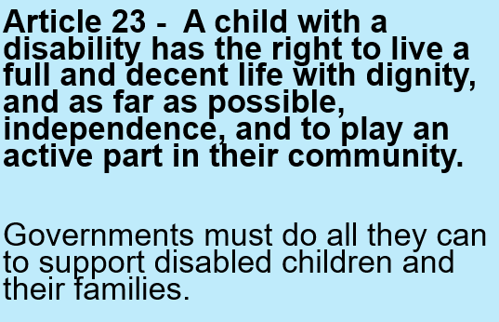

In your work books, write the date, title and draw the thought bubble. Write your ideas all around it.

**Exploring Article 23**



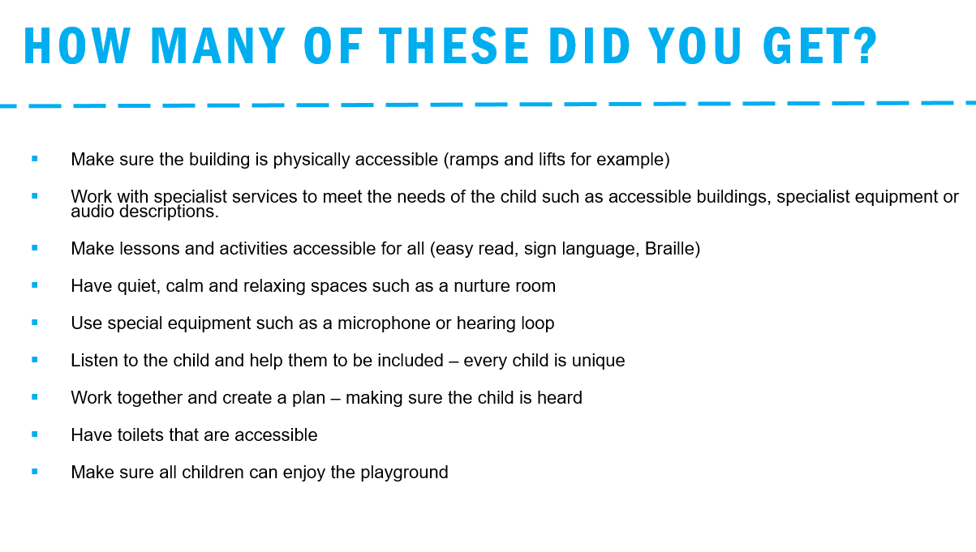

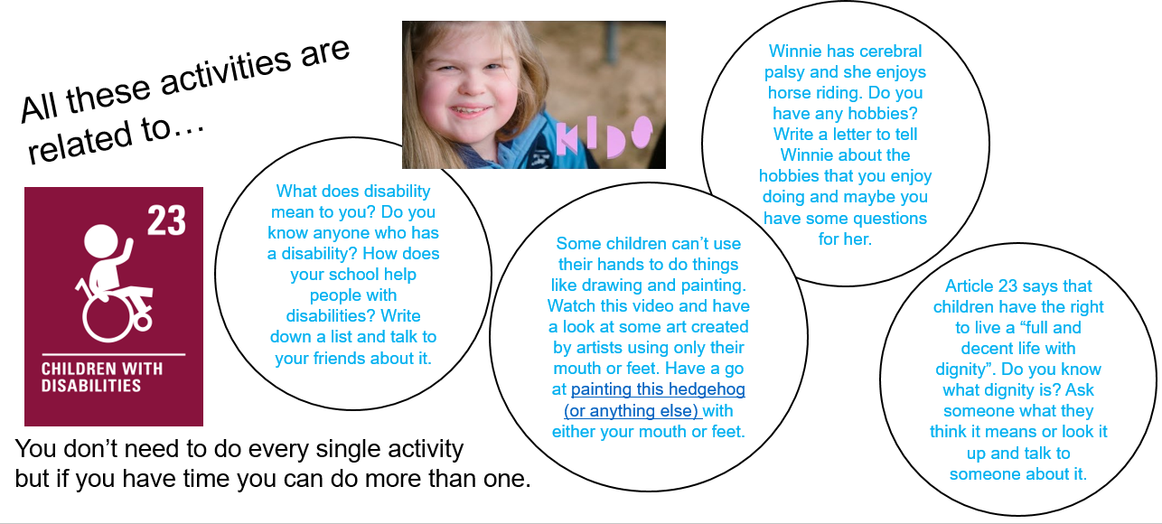

Remember not everyone’s bodies work – that’s okay! You are lucky if you have a healthy body! ☺

#allinthistogether #teamalexandra