Hello home learners! We are back with a new theme and ready to explore….
This week’s theme is: Space

Monday 13th July 2020
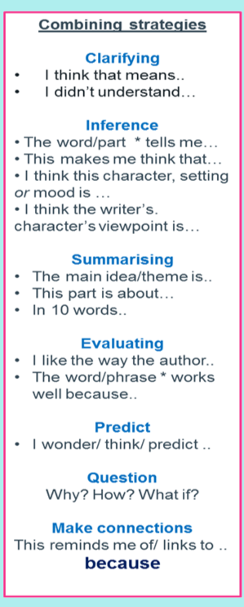
I really hope you haven’t forgotten your Destination Reader stems, here they are just in case!

Read the text below, check the glossary for any key vocabulary and make notes if you need to.
Activity One:
In your books, using a DR stem or two, summarise the text. What’s the most important information?
Activity Two: Write and answer the following questions
1. How fast is the ISS travelling?
2. How was the experiment kept a fair test?
3. 'Generally the space seed grew less well'
This suggests that...

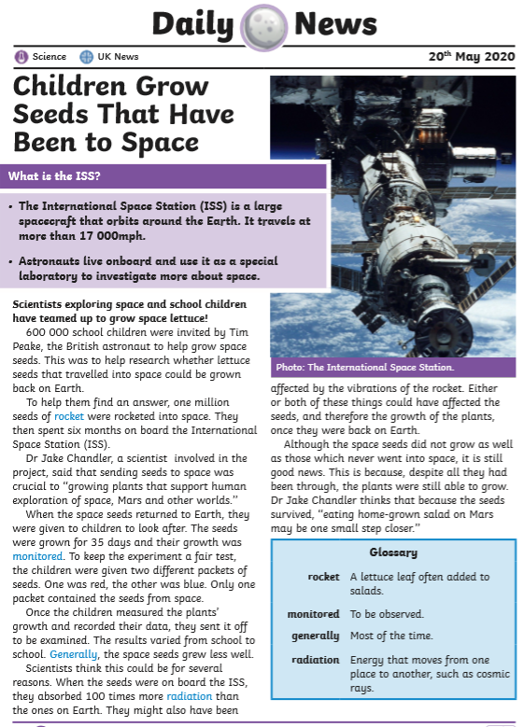
This week we are going to research and write a newspaper report, we are going to look into the mission and if Mars is habitable. What does that mean?

https://www.bbc.co.uk/news/science-environment-51761833

Watch this as an introduction and write down in your books any questions you would like to research regarding this. Then fill out this statement:

Without researching I think Mars is/is not habitable and....

Tuesday 14^{h} July 2020
Today we need to research Mars and the Perseverance rover mission. Is Mars habitable? Do you think the Perseverance rover mission will be successful, WE NEED FACTS!!
First and foremost, we need the 5ws for our newspaper introduction. https://mars.nasa.gov/mars2020/ add in the information under your date and sub-heading.

Headline
Think of at least three catchy headlines for your article.

Introduction (5ws)

Research...here are some suggest sub-heading for you research, please edit or add any you think are better.

Perseverance Rover

Is Mars Habitable

Personally...

https://www.space.com/topics/spacex

https://spaceplace.nasa.gov/mars-adventure2/en/

https://www.planetary.org/blogs/guest-blogs/2017/20170921-mars-isru-tech.html

https://www.natgeokids.com/uk/discover/science/space/facts-about-mars/

What do you think now after doing some research? Complete the statement:
Now I have done some research I believe ....

Wednesday 15th July 2020
What features do newspaper articles have? Remember to be formal and feature as many as you can!

Here's the start of my newspaper report, what do you think? What can I improve? What features can you see?

Perseverance or a Waste of Time?
Elong Musk, American billionaire and entrepreneur, is on a mission to send a tourist shuttle into Space. He aims to send this 'creation' in July 2020. Using NASA's launch site. The countdown is on but the question is: is this safe? Would you holiday on Mars?  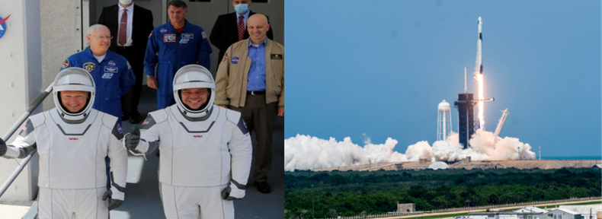  Trump stated: "Today we once again proudly launched American astronauts on American rockets - the best in the world - from right here on American soil."  Musk, 48-years-old, sent another shuttle (pictured above) SpaceX into Space with the aim of | launching cargo, and eventually people, to low-Earth orbit. If this mission is successful Musk plans to build a launch pad in Texas for the Starship Mars Rocket. Are you going to book your ticket?

We are going to write for two days, so quality over quantity, use your thesauruses on your iPads.

Fold your paper in half, draw a line down the middle so you write in columns (like we have done before Year 6).

Thursday 16th July
Today we are going to carry on our writing. Finish the sections about Mars being habitable and then your final paragraph is your personal opinion. Here is my personal section, what do you think?

After conducting research myself and understanding the circumstances in greater depth, I believe there could be the potential - in years to come - for there to be life on Mars. I am hopeful that this may be because humans are mistreating planet Earth and I am unsure how much longer the planet will survive. Therefore, my new question to you all is this: will mankind ruin another planet? | Send us your thoughts via socials:  @missmackeygroundbreakingnews

Friday 17th July 2020
Please take some time to read your work through and edit it. Up-level words, check it's formal, does it flow?

It’s Friday…you must know what we are going to do now? Here’s some inspiration: https://www.youtube.com/watch?v=aO8Lk05NY8k

Get you news reporter voice ready. You may want some introduction music!

