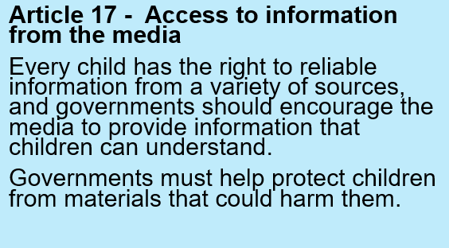

In your work books, write the date, title and draw the thought bubble. Write your ideas all around it.

Exploring Article 17
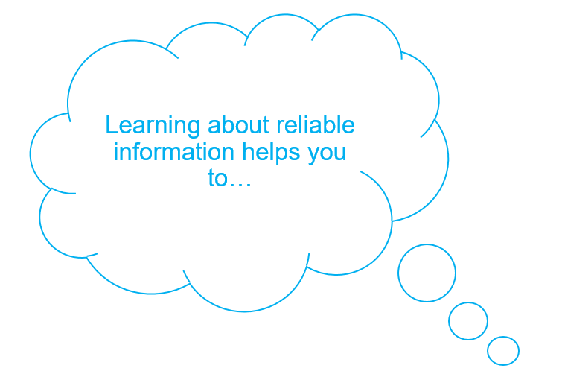

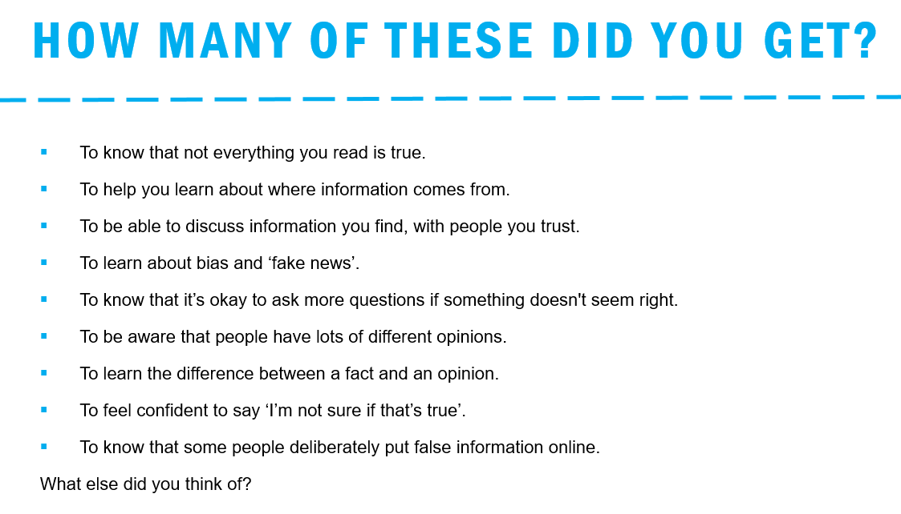

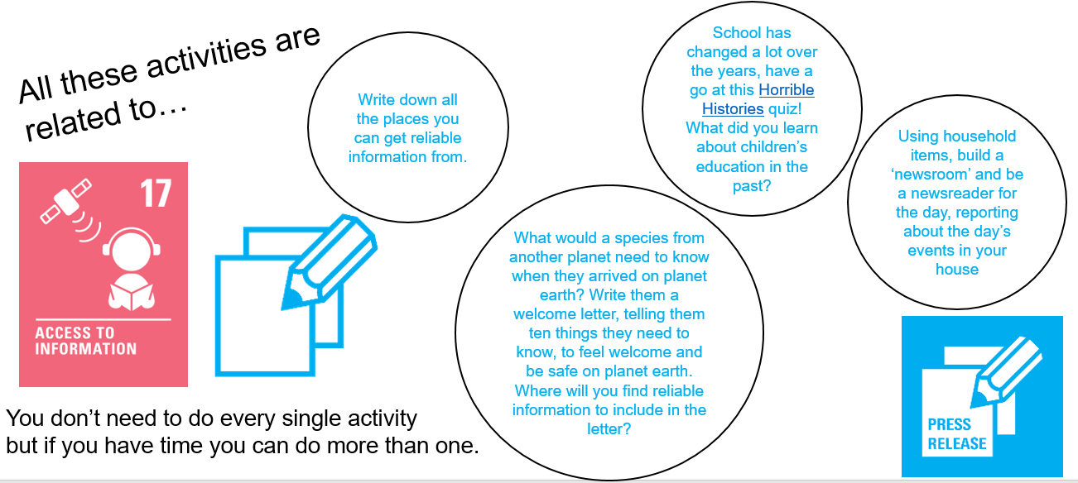

We love that you love learning at Alexandra! You are also so great at researching and teaching each other. Keep accessing information and learning from it but make sure you are doing it in a safe way

#allinthistogether #teamalexandra

