Monday 6th July 2020
We are going to make a class book of memories. Here is one from a couple of years ago. So everyone will have their picture and own page.
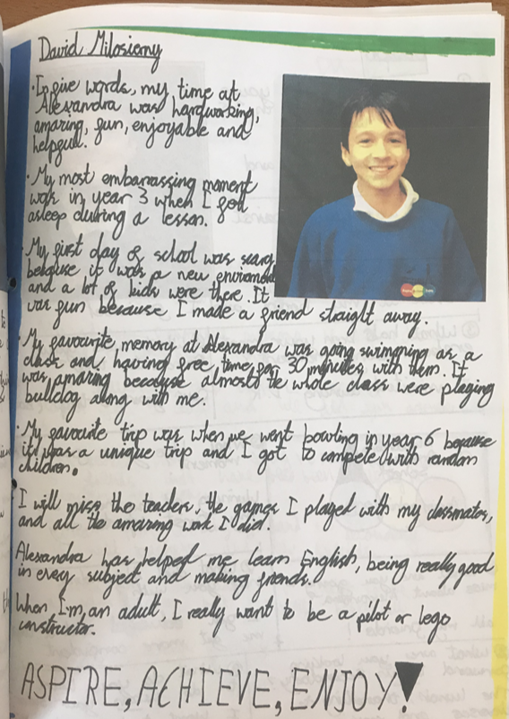

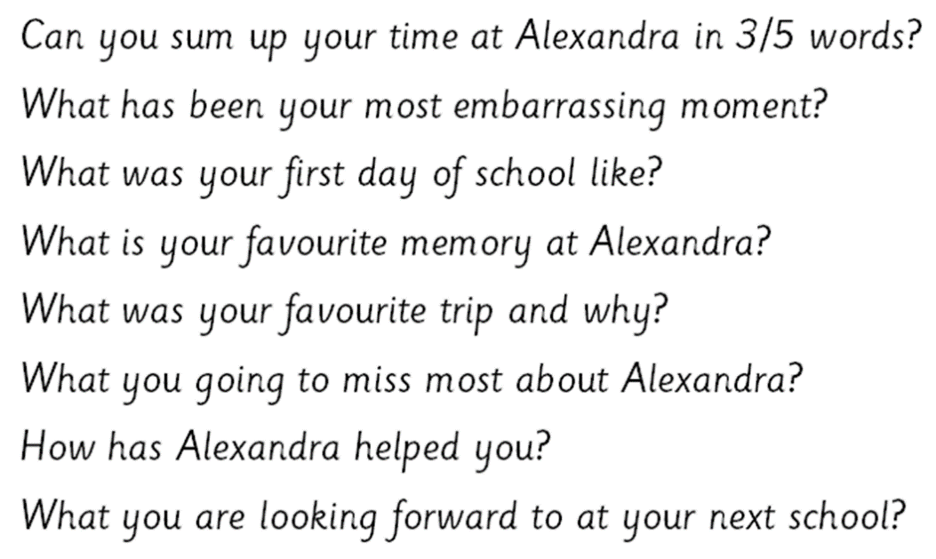
So we need to think back…all the way to the beginning, your favourite memory from Alexandra may be from Year 2 (remember the trip to the beach?!).

Plan and draft
What do you want your page to look like?
- picture (where will you place it?)
- how will you arrange the questions?
- what colours?

Write a sub heading for each question and write up to five bullet points for each one.

Why do we look back? Why is it important to remember?
Memories are important because...

Tuesday 7th July 2020
Using your plan, pick out the best memories. The ones that make you smile the most or laugh the hardest!

We really need detail now. Please show off your SPAG. I will be showing your booklets to classes in years to come (just like the example we saw yesterday)

Here’s the start of my example…

Miss Mackey
When I first started Alexandra Primary School seven years ago I was so nervous. I had never worked in a school before - or worked full time! I remember learning the teachers first names and then not knowing their teacher names and not wanting to offend anyone by calling them the wrong thing.

My Favourite Memories
- Soon after I started, I was sent to Year 4 to get some lesson resources and I felt scared to go in and thought the children were so big and scary! They all stared at me and I just knew I was bright red. I was so used to working with the Year 1s and 2s the Year 4s seemed massive. If only I knew. Year 6 is really where it’s at!
- Last year, I won the staff bake off with Miss Bruce. Even though I am ‘Healthy Schools’ lead and Miss Bruce led PE we decorated our cake with a zillion sweets knowing that sugar – along with our charming personalities - would sway the judges!
- On world book day two years ago, Mrs Cannon, Miss Bruce and I danced like snakes to the Jungle Book songs. Everyone came to Espana class in the morning to get snake-ified!! Mrs Kennedy was a lion and had some of the best dance moves I have ever seen!
- When I heard I was going to work with Miss Corrales this year I was over the moon. I can’t pick one thing in particular because she is so funny and makes me laugh every single day, along with our amazing Year6 classes.

Using my example and your plans write your own.
Just write it, enjoy the memories, I feel like I could have written for hours! You will be publishing and putting it into a layout once we have edited.

Wednesday 8th July 2020
I cannot wait to make our book. Let's make sure our editing is brilliant because I want our books to be amazing.

Get that dictionary and thesaurus. Check your sentences make sense. Can you add: parenthesis, colons, semi colons, fronted adverbials, speech….. COME ON YEAR 6.

Thursday 9th July 2020
Please use one piece of A4 paper to write up your memories. You can decorate it however you want. Just remember, certain colours don’t come up very well for example: yellow.

For your photo please wear a school jumper and just take a photo of your head and shoulders.

You will then need to send this to the school office so we can print it. Any problems, email or call and ask for Mrs Spencer.

Friday 10th June 2020
It is so important to look back but you must also look forward.
Write five things you are looking forward to in secondary school. Write down five things you are unsure of.

Home leaners, we are still here to support you. We are only an email or phone call away. If you want to share any worries or questions about moving on, email them to the office and we will do our best to put you at ease!

