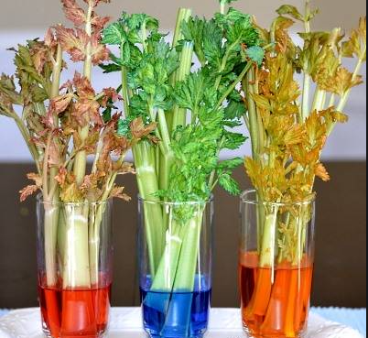
Science Summer 2 (wc 6th July 2020)
Recap from last lesson

Can you how water is transported within plants?

LO: To research and investigate the different parts of a flower and explain their role in pollination and fertilisation.
Vocabulary
roots
flower
stem
leaf or leaves
function
reproduction
light
air
water
nutrients
space
stamen
pollen

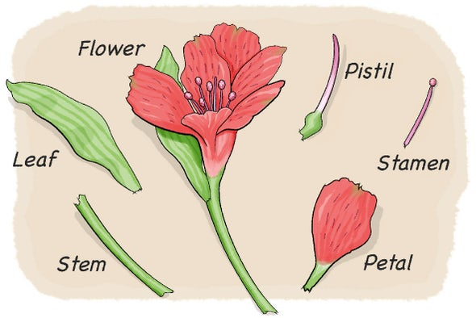

Success Criteria 1: I can identify the different parts of a flower
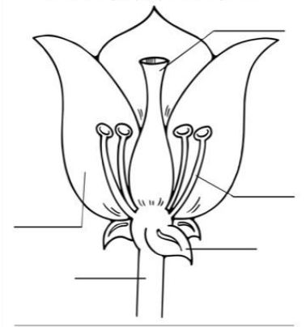
Watch this video: https://www.youtube.com/watch?v=493WeySyf-8
Activity 1
Try to draw the flower and have a go at labelling the different parts of the flower.

Success Criteria 2: I can explain what each part of a flower does.
Watch this video: https://www.youtube.com/watch?v=493WeySyf-8
Activity 2
Can you have a go at writing the function of each part of the flower
The function of the_______________ is ____________________________

Success Criteria 3: I can explain the process of pollination
Watch this video: https://www.bbc.co.uk/teach/class-clips-video/science-ks1-ks2-ivys-plant-workshop-what-is-pollination-and-how-does-it-work/zv4df4j
What did you find out?
Activity 3
In your own words have a go at explaining the process of pollination.
The process of pollination begins with___________________

Challenge:
Have a go at writing a non-fiction report on plant reproduction or the process of pollination.

