Science Summer 2 (wc 13th July 2020)
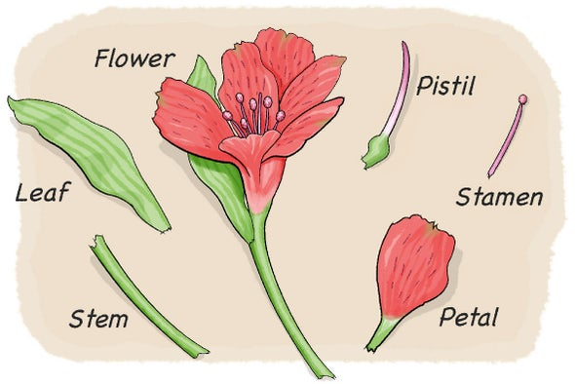
Recap from last lesson

Can you remember the different parts of a flower and their functions?

LO: To explore the part that flowers play in the life cycle of flowering plants, including pollination, seed formation and seed dispersal by understanding pollination and fertilisation.
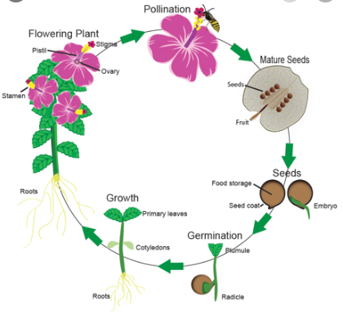
Vocabulary
roots
flower
stem
leaf or leaves
function
reproduction
light
air
water
nutrients
pollination
stamen
pollen

Activity 1- seed dispersal
Use this web page to explore the part that flowers play in the life cycle of flowering plants, including pollination, seed formation and seed dispersal. https://www.bbc.co.uk/bitesize/topics/zxfrwmn/articles/z28dpbk
Try to explain each method of seed dispersal in your own words and draw a diagram to go with each method.
Plants disperse their seeds in lots of different ways:
- transported
- the flowing water
- explode
- animals to carry

Activity 2 – life cycle
Use this web page to explore the part that flowers play in the life cycle of flowering plants https://www.bbc.co.uk/bitesize/clips/zc234j6
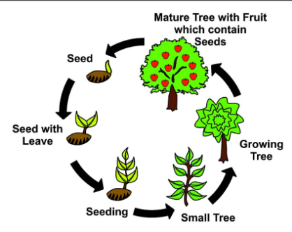
Explore this section and can you have a go at writing and drawing the life cycle of flowering plants.

Challenge:
To write a diary entry from the perspective of a bee, including your scientific understanding about the life cycle of a flowering plant.
Reflection
Do you think you are similar to plants? What things do you need to survive? Are they the same things that plants need? Write a list of the things you think you need to survive.
I think I need the following things to survive:

