Geography Summer 2 (wc 6th July 2020)
LO: To understand the climate of India
Today, we will learn about the climate of India and how this affects the people living there.

Activity 1
https://www.facts-about-india.com/climate-of-india.php
Use this webpage to write down three factors affecting the climate of India.
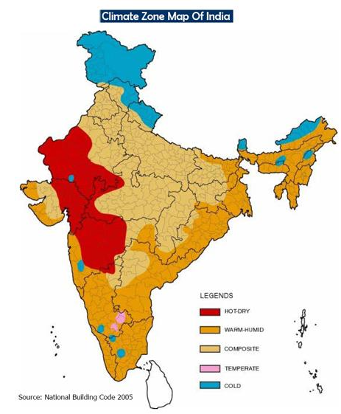
Can you research each physical feature and write down two facts for each feature?

[Grab your reader’s attention with a great quote from the document or use this space to emphasize a key point. To place this text box anywhere on the page, just drag it.]

Activity 2
https://kids.britannica.com/students/article/India/275043#202391-toc
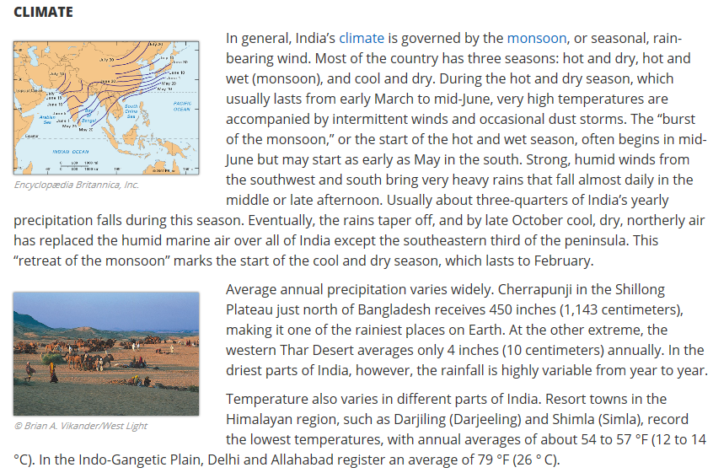
Use this web page to read further about the climate of India and write down 5 facts that you have discovered.

Activity 3
https://www.kids-world-travel-guide.com/india-for-kids.html
Use this page to read all about India and create a fact sheet to describe India to someone that might not know about.
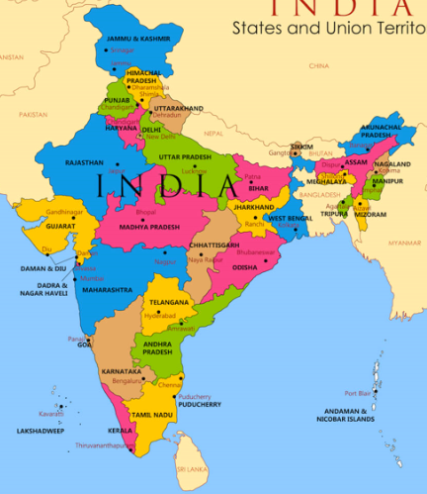

Challenge
Can you draw a map of India and colour code the climate?
Can you also draw some of the things you have just learned about from the web page?

