Geography Summer 2 (wc 13th July 2020)
LO: To understand the climate of India
Today, we will learn about the climate of India and how this affects the people living there.

Activity 1
https://www.youtube.com/watch?v=Sv7OHfpIRfU
Watch this video clip describing climate change around the world. Answer the following questions in your own words.
- What is climate change?
- How does it affect the world?
- What can we do?

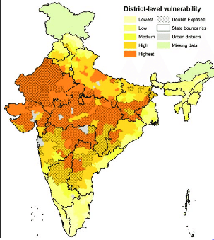
[Grab your reader’s attention with a great quote from the document or use this space to emphasize a key point. To place this text box anywhere on the page, just drag it.]

Activity 2
https://www.worldbank.org/en/news/feature/2013/06/19/india-climate-change-impacts
Use this web page to read and learn about the different climate changes.
- Extreme heat
- Changing rainfall patterns
- Droughts
Write a fact file for the three climate changes and its effects on India.
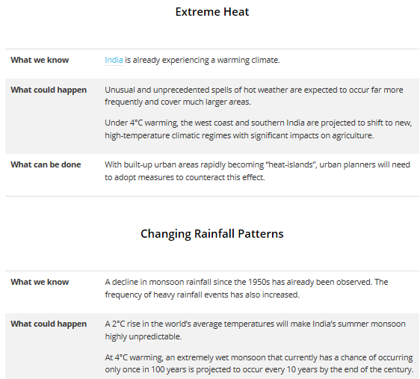

Activity 3
https://www.bbc.co.uk/news/world-asia-india-45949323
Look at the news report by BBC regarding climate change and the effects on India. Use the report as an example to write your own news report regarding the changes and its effects on India and its people.
