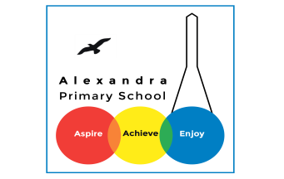
Home learning Summer Term Year 5 w/c 29. 06.2020

Geography- Trade Routes

Today we are going to read about Beshey’s story. Whilst reading about a day in the life of Beshey, think about how his day is different to yours.
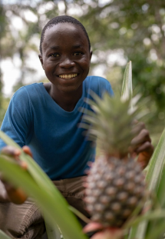

This is Beshey Sesay. He is 14 years old. Beshey lives in a small town called Gorahun in Sierra Leone. This is Beshey’s house. Most houses in rural Sierra Leone are built with a timber frame and mud bricks and thatch or grass roofs. These can be easily damaged in the rainy season and usually have to be repaired every year. Beshey's house uses concrete bricks and has a corrugated iron roof. This makes it much more sturdy so it can withstand the heavy rains of the rainy season. Beshey’s family keep chickens to help provide themselves with food. They also keep goats. Each morning, Beshey fills a pot with water in order to wash himself and brush his teeth. Beshey and his family collect water from a standpipe that is shared with other families in their town. Beshey joins his friends and family to say their prayers before school. Beshey and his family are Muslim. He then walks fifteen minutes to school on the other side of town. From Monday to Friday, Beshey goes to this primary school with his friends. Beshey's family spend much of the day carrying out everyday household tasks. Washing clothes is time consuming when done by hand. In his spare time, Beshey enjoys playing football. At the weekend, Beshey goes with his dad, Sidie, to the family's cocoa farm.
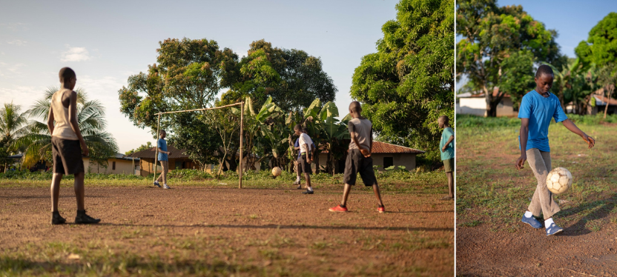
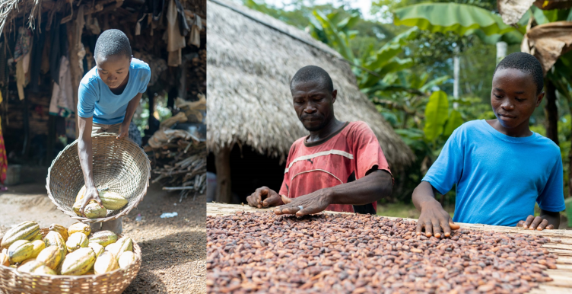

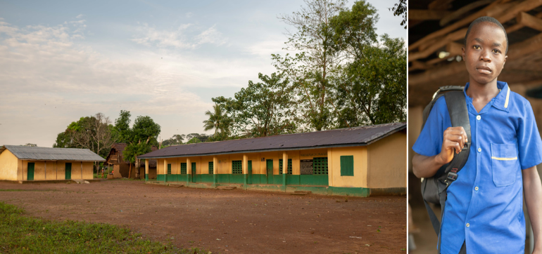
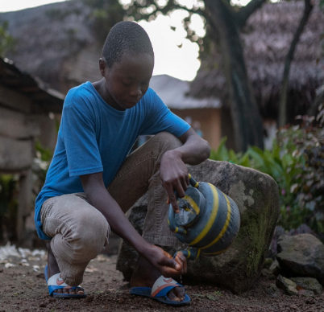
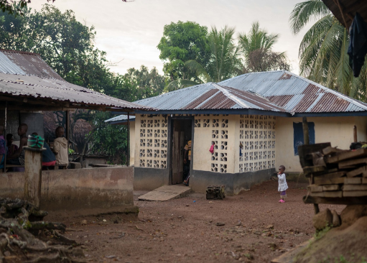

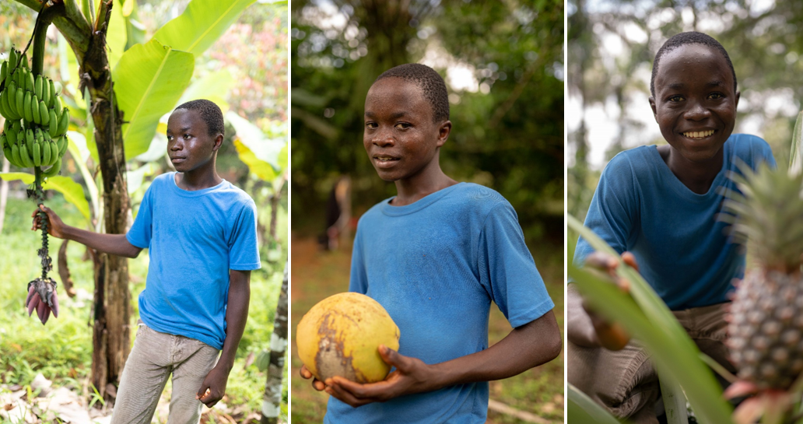
Task 1

Their family farm is a cocoa farm, but they grow many other crops too. Can you guess what these three fruit crops are? _________________(Answer: banana, coconut, pineapple)
These crops are called 'subsistence crops' because they are grown to feed Beshey’s family, not to sell. Crops that are grown to sell for money are called 'cash crops'.
Is cocoa a subsistence crop or a cash crop? ____________________ (Answer: cash crop)
NB The coconut above doesn't look like the ones we see in the UK. It is a 'green coconut', harvested for its water and soft flesh. As they grow older, they become browner, with less water and crunchier flesh. The outer husk is removed before they are shipped to places like the UK, revealing the hairy husk inside.
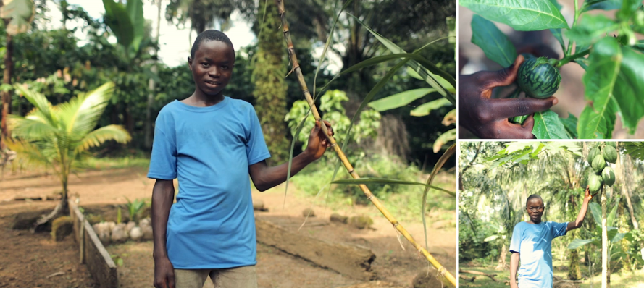
Task 2

What do you think these subsistence crops are? (Answer: sugar cane, garden egg, papaya)
'Garden eggs' are a small round variety of aubergine from West Africa. They were used in the UK 400 years ago when they were known as 'Guinea squash', before falling out of fashion.

Task 3: Draw a picture or write a poem about a typical day in the life of Beshey

