Summer Reading home learning Year 4

Over the summer, we would like you to continue to read regularly and practice your phonics sounds.

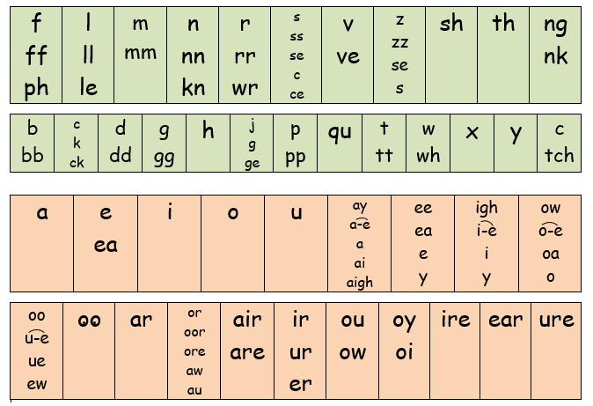

**Summer Reading Challenge**

Over the summer it is important that you continue to read. Can you get through these 6 books as a summer reading challenge?!

How to Train Your Dragon is a series of twelve children's books, written by British author Cressida Cowell. The books are set in a fictional Viking world and focus on the experiences of protagonist Hiccup as he overcomes great obstacles on his journey of Becoming a Hero, the Hard Way.

<https://www.youtube.com/watch?v=DyUNZa7_Gjo>

1. 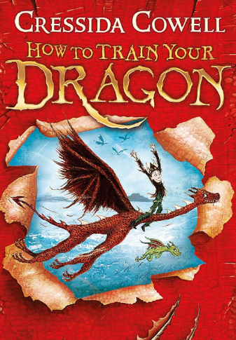
2. 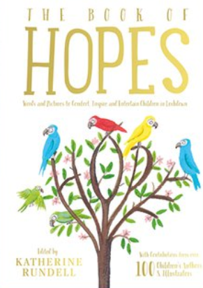

The Book of Hopes aims to comfort, inspire and encourage children during lockdown through delight, new ideas, ridiculous jokes and heroic tales. There are true accounts of cats and hares and plastic-devouring caterpillars; there are doodles and flowers; revolting poems and beautiful poems; and there are stories of space travel and new shoes and dragons.

<https://literacytrust.org.uk/family-zone/9-12/book-hopes/>

1. 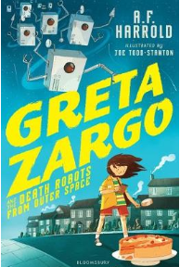

Greta may be orphaned but she is clever, bold and brave - which is handy since she has to keep saving the Earth. This is fast paced, funny and exciting storytelling and the lively illustrations add to the appeal

1. 

Did you know that NASA will be launching a new space mission to Mars in July 2020? Yes, that’s right! They will be sending a rover called Perseverance Rover to Mars to explore signs for past life. Any research will help scientists and astronauts to find out if Mars can be habitable in the future. What do you think?

<https://www.oxfordowl.co.uk/api/digital_books/1290.html>

(Note- e-book is free but you need to make a **free** account)

1. 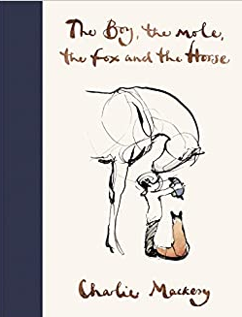

Enter the world of Charlie's four unlikely friends, discover their story and their most important life lessons. The conversations of **the boy, the mole, the fox and the horse** have been shared thousands of times online, recreated in school art classes and hung on hospital walls.

<https://www.youtube.com/watch?v=81b4i9jQhck>

If there was anything in the world better than playing baseball, Marcenia Lyle didn't know what it was. One sunny day in the 1930s, Marcenia and the boys she plays ball with learn that Gabby Street, a famous baseball manager, is scouting children for a baseball summer camp sponsored by the St. Louis Cardinals. Eager to earn a spot, Marcenia plays her best, but is discouraged when Mr. Street tells her there are no girls in his camp. Determined that baseball is her destiny, Marcenia won't give up

<https://www.storylineonline.net/books/catching-the-moon-the-story-of-a-young-girls-baseball-dream/>

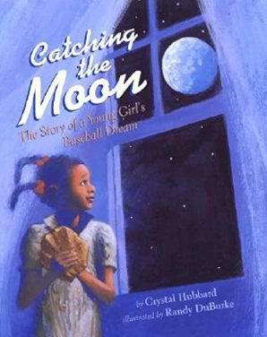

Complete the book review for your favourite story.

