Summer Reading home learning Year 3

Over the summer, we would like you to continue to read regularly and practice your phonics sounds.

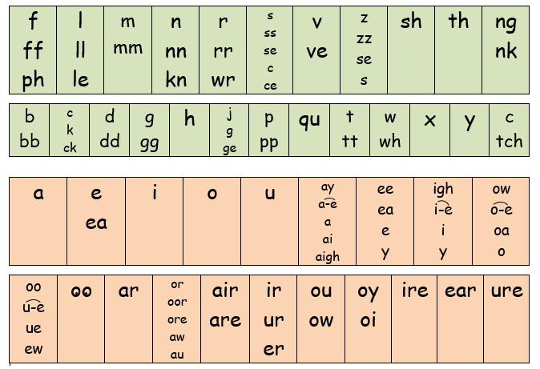

**Summer Reading Challenge**

Over the summer it is important that you continue to read. Can you get through these 6 books as a summer reading challenge?!

Meet a proud lion, a hungry hyena and a greedy lizard, who all learn very important lessons. These stories from Africa will make you both laugh and think.

<https://www.oxfordowl.co.uk/for-home/find-a-book/library-page/>

(Note- all e-books are free on this site but you will need to make a **free** account)

1. 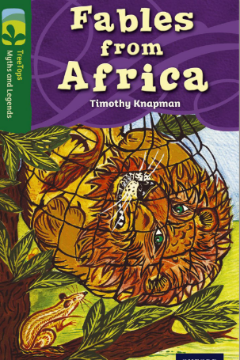

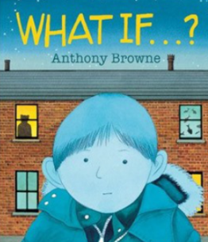

Joe is nervous about his first big party, and as Mum walks him along the darkening street to his friend's house, his imagination starts to run wild. They search for the right place, looking through the windows, wondering "What if...?" while making surprising discoveries along the way.

<http://www.anthonybrownebooks.com/new-page>

1. 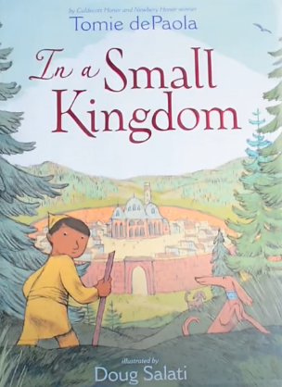

In a small kingdom along an ancient road, a bell rings out. The beloved king has died, leaving his magnificent and powerful Imperial Robe to his heir, the young prince.  
  
But when the prince’s jealous older half-brother steals the Imperial Robe, slashing it to bits, the prince can no longer rule—and the small kingdom is in great danger. Now the young prince must find another source of power and of strength—and he finds it in a surprising place.

<https://www.youtube.com/watch?v=gtLacYr-Y1c>

1. 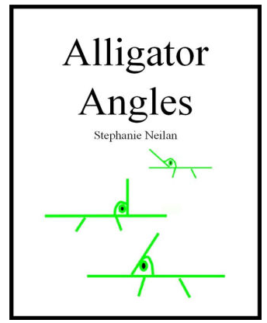

An alligator comes to visit, but what kind of alligator is it?

A short story to help kids remember what acute, right, and obtuse angles mean

<https://www.barnesandnoble.com/w/alligator-angles-stephanie-neilan/1114972586?ean=2940044392526>

1. 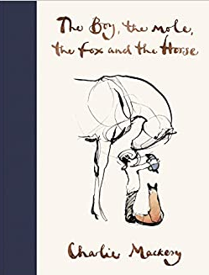

Enter the world of Charlie's four unlikely friends, discover their story and their most important life lessons. The conversations of **the boy, the mole, the fox and the horse** have been shared thousands of times online, recreated in school art classes and hung on hospital walls.

<https://www.youtube.com/watch?v=81b4i9jQhck>

If there was anything in the world better than playing baseball, Marcenia Lyle didn't know what it was. One sunny day in the 1930s, Marcenia and the boys she plays ball with learn that Gabby Street, a famous baseball manager, is scouting children for a baseball summer camp sponsored by the St. Louis Cardinals. Eager to earn a spot, Marcenia plays her best, but is discouraged when Mr. Street tells her there are no girls in his camp. Determined that baseball is her destiny, Marcenia won't give up

<https://www.storylineonline.net/books/catching-the-moon-the-story-of-a-young-girls-baseball-dream/>

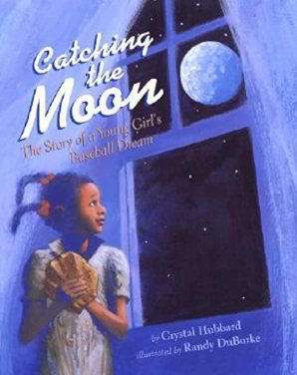

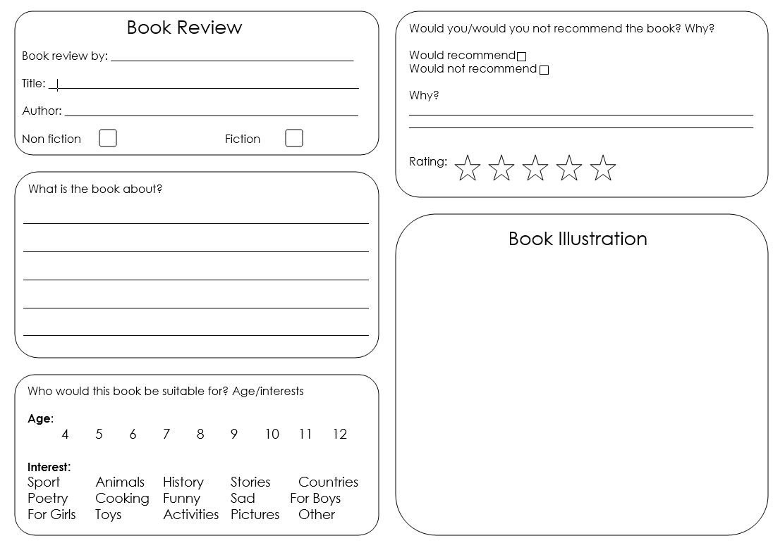

Complete the book review for your favourite story.