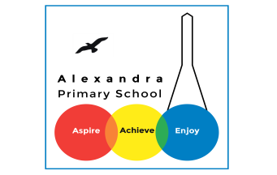
Year 3 Reading
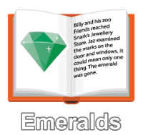
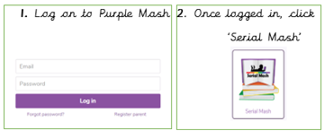
Log in to your Purple Mash account. Visit Serial Mash, Emeralds, and find the book ‘Replica Face’.

Monday 6th July: Read Chapter 1. The PDF text for Chapter 1 is here. Then complete the quiz for Chapter 1.

Challenge Question
(Answer these in your exercise books- write the date and the title of the text).
If you had a mask that could change you into whoever you wanted to be, who would you change into? Why?

Tuesday 7th July: Read Chapter 2. The PDF for Chapter 2 is here.
Challenge question
?
What do you think Safia and Rob will plan next? Can you make a prediction. Remember to use the predicting sentencee stems.

Wednesday 8th July: Read Chapter 3. The PDF is here. Complete the Chapter 3 quiz.
Challenge question
School Rules for One Day
If you could set the rules for the day at school, what rules would you make?

Thursday 9th July: Read Chapter 4. The PDF for Chapter 4 is here. Complete the Chapter 4 quiz.
Challenge question
Imagine you are a parent of a child at the school. It is the day where they have been told they can do whatever they like and you are very cross. Can you write a letter of complaint to the head teacher?

Friday 10th July: Read Chapter 5. The PDF for Chapter 5 is here. Complete the Chapter 5 quiz.

Challenge question
I really enjoyed this book, did you? Can you write a review of it saying why you did or didn’t like it. Would you recommend it to a friend?
If this story is too hard to follow, some of you have also been assigned an alternative reading book ‘Watch out! River Running Wild’. You should do this instead.

Daily Activity
You should be reading for at least 30 minutes daily.
If you cannot access Purple Mash, choose a book of your own and use your Destination Reader stems to record your thoughts in your Exercise books. This should be done each day.

Date: 06.07.2020
Name of Book:
Prediction: I wonder if…
Inference: The word __ tells me…
Summary: The key idea is…

Daily Activity
You should be reading for at least 30 minutes daily.
If you cannot access Purple Mash, choose a book of your own and use your Destination Reader stems to record your thoughts in your Exercise books. This should be done each day.

Date: 20.04.2020
Name of Book:
Prediction: I wonder if…
Inference: The word __ tells me…
Summary: The key idea is…

Fun Activity of the Week
Could it rhyme?
Take a book / story you have read or know.
Can you write a poem about a character or the book?
It could be a rhyming poem, an acrostic poem, a limerick or any type of poem!
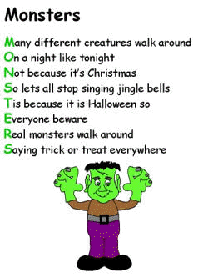

Story Time Ideas
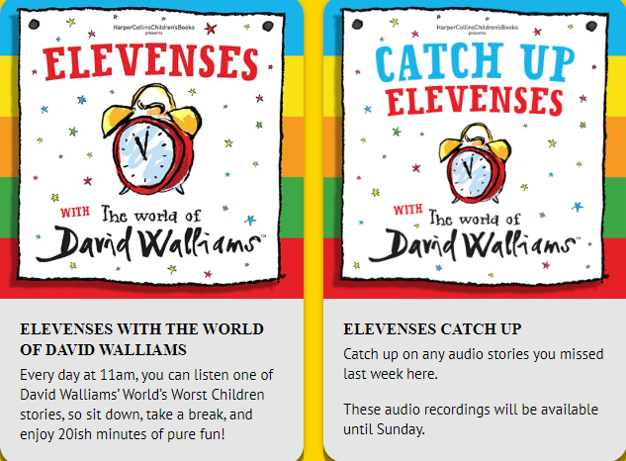
There are lots of different ways you can access books and stories on-line. Here are some.
https://www.worldofdavidwalliams.com/elevenses/
Story Time Ideas

Audiobooks and eBooks are available to borrow for free from Hackney library, using these apps; Overdrive and Borrowbox. You will need to download these apps to a tablet, phone or computer. To use these apps, you will need a library card number from any London library. If you are not a member of the library, you can join for free here: https://hackney.gov.uk/libraries#join. You won’t need to go into the library to provide proof of address as you normally would, but can do everything online
There are also a lot of websites where you can watch authors read their books for free:
- Storytime Online has hundreds of videos: Click here to view
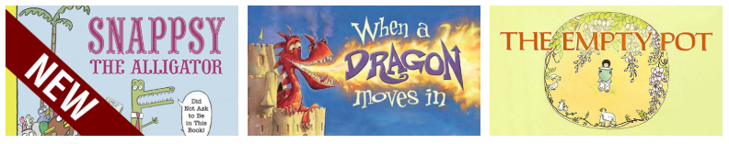

- You can also find stories at this website: https://www.getepic.com

Select, “Have an account? Log in” then click “Students and Educators”. Log in with the class code: mxy1661

