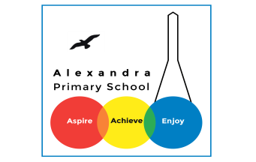
Year 3 Reading
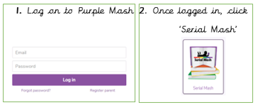
Log in to your Purple Mash account. Visit Serial Mash, Emeralds, and find the book ‘Replica Face’.

Monday 13th July: Read Chapter 1 and Chapter 2. The PDF text for Chapter 1 is here and the for Chapter 2 is here. Then complete the quiz for Chapter 1 and 2.
Challenge Question
(Answer these in your exercise books- write the date and the title of the text).
At the end of Chapter 2, the princesses sleep under the apple tree in order to try to catch the thief. What is the most unuusal place you have slept? Can you describe what you did?

Tuesday 14th July: Read Chapter 3 and Chapter 4. The PDF for Chapter 3 is here and the PDF for Chapter 4 is here. Then complete the quizzes for both chapters.
Challenge question
?
Where do you think the dragon is taking the king and the apple tree? What do you think the princesses will do to save their father? Can you make a prediction? Remember to use the predicting sentencee stems.
Wednesday 15^{h} July: Read Chapter 5. The PDF is here. Complete the Chapter 5 quiz.
Challenge question
In this chapter, the princesses were pulled along in their boat by dolphins. If you were in trouble and needed help, what animal would you like to come and help you? Why?

Thursday 16th July: Read Chapter 6. The PDF for Chapter 6 is here. Complete the Chapter 6 quiz.
Challenge question
Princess Archeria was really angry with her father but then was able to forgive him. Do you ever feel really angry with someone? Have you been able to forgive them?

Friday 17th July: Read Chapter 7. The PDF for Chapter 7 is here. Complete the Chapter 7 quiz.
Challenge question
I loved this story, did you? Can you write a review of it saying why you did or didn’t like it. Would you recommend it to a friend?

If this story is too hard to follow, some of you have also been assigned an alternative reading book ‘Little Red’. You should do this instead.

Daily Activity
You should be reading for at least 30 minutes daily.
If you cannot access Purple Mash, choose a book of your own and use your Destination Reader stems to record your thoughts in your Exercise books. This should be done each day.

Date: 13.07.2020
Name of Book:
Prediction: I wonder if…
Inference: The word __ tells me…
Summary: The key idea is…

Daily Activity
You should be reading for at least 30 minutes daily.
If you cannot access Purple Mash, choose a book of your own and use your Destination Reader stems to record your thoughts in your Exercise books. This should be done each day.

Date: 20.04.2020
Name of Book:
Prediction: I wonder if…
Inference: The word __ tells me…
Summary: The key idea is…

Fun Activity of the Week
Feel an emotion!
Think of a book you have read or a book you are reading. Choose 3 emotions that you felt and draw/ write about them. Why did you feel that way and how did the author do this?
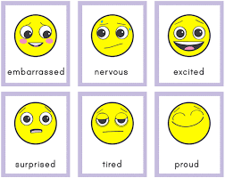

Story Time Ideas
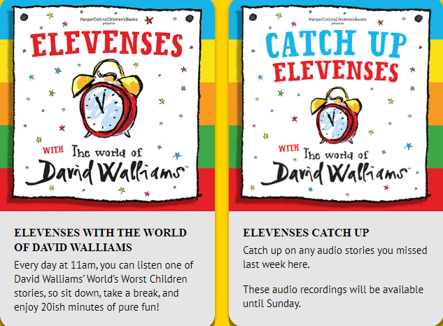
There are lots of different ways you can access books and stories on-line. Here are some.
https://www.worldofdavidwalliams.com/elevenses/
Story Time Ideas

Audiobooks and eBooks are available to borrow for free from Hackney library, using these apps; Overdrive and Borrowbox. You will need to download these apps to a tablet, phone or computer. To use these apps, you will need a library card number from any London library. If you are not a member of the library, you can join for free here: https://hackney.gov.uk/libraries#join. You won’t need to go into the library to provide proof of address as you normally would, but can do everything online
There are also a lot of websites where you can watch authors read their books for free:
- Storytime Online has hundreds of videos: Click here to view
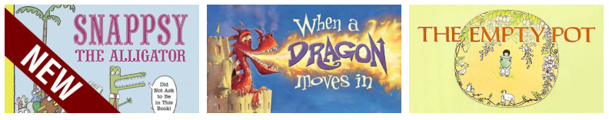

- You can also find stories at this website: https://www.getepic.com

Select, “Have an account? Log in” then click “Students and Educators”. Log in with the class code: mxy1661

