Maths Home Learning Year 3
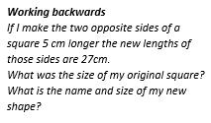
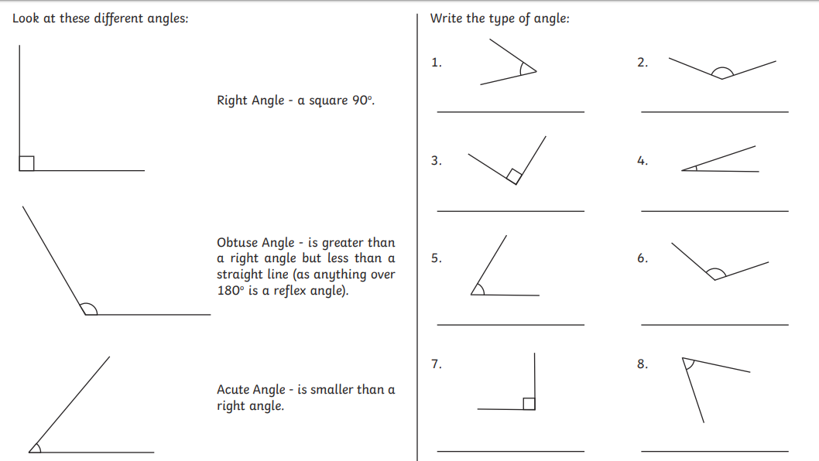
Recognise angles as a property of shapes - Summer 2- 13.07.2020
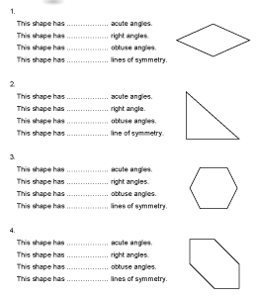

Maths- No Problem
Worksheet 9- Pages 125-126
Worksheet 10- Pages 127-128

Purple Mash
New learning has been set on you on Purple Mash also.

TT Rockstars
New learning has been set on TT Rockstars! Get practising on here!

