For our final week of the year we will be looking at Lifecycles.
We will look at frogs and butterflies but you can also learn and talk about the life cycles of humans, chickens, plants etc.
Have a lovely week!
Watch information clips on lifecycles https://www.bbc.co.uk/bitesize/topics/zgssgk7/articles/zwn6mnb  Life cycle of frogs  https://www.youtube.com/watch?v=wAcwjWi6I9Y  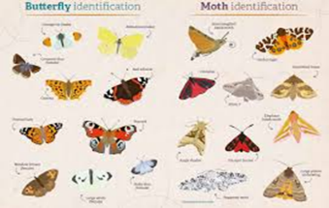  Life cycle of butterflies https://www.youtube.com/watch?v=jivWeOrCaeI  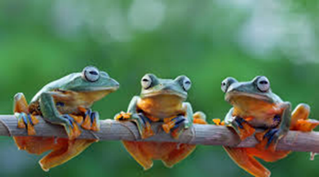 | Reading  Monkey puzzle by Julia Donaldson  https://www.youtube.com/watch?v=_GzMWFZPqw4  The Hungry Caterpillar- Eric Carle https://www.youtube.com/watch?v=75NQK-Sm1YY  Elmer and the butterfly https://www.youtube.com/watch?v=b-GM3QJ1qkk  The cautious caterpillar ebook  https://www.twinkl.co.uk/resource/t-l-526204-the-cautious-caterpillar-story-powerpoint
Art  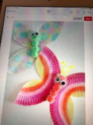  Make symmetrical patterns by folding a piece of paper in half after painting on one side.?  What do you notice  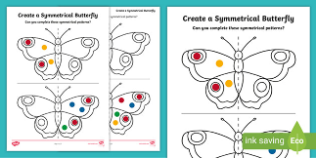  Make some paper plate butterflies.  Make a symmetrical butterfly painting using finger painting.  Make some collage pictures of Emer. Use tin foil, sweet wrappers or coloured paper. | Science  Find out about the life cycles of both Butterflies and frogs by watching the video clips.  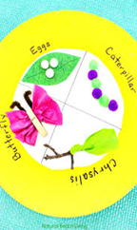  Can you pretend you are a naturalist explaining what you know about these changes to a reporter. You could even film yourself explaining these changes and post on Tapestry.  Make a life cycle wheel.
Movement  Crawl like a caterpillar, and hop like a frog!  Jump like frogs https://www.youtube.com/watch?v=KfoXOxUgENE | Maths  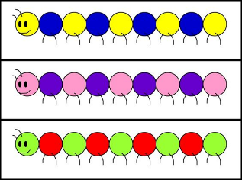  Practice forming all your numbers from 0 to 20 correctly.  Make repeating patterns with colours or numbers. Predict what will come next.  Using a small mirror explore symmetry and reflection.
Writing  Practice your letter formation. It is so important to start from the correct point. Make sure you know where that is.  Draw and label a life cycle of a butterfly and frog.  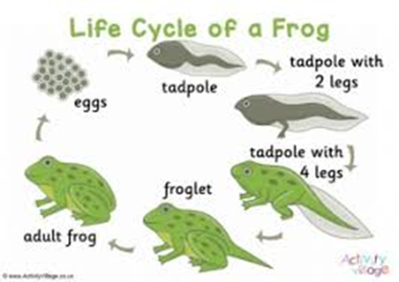 | 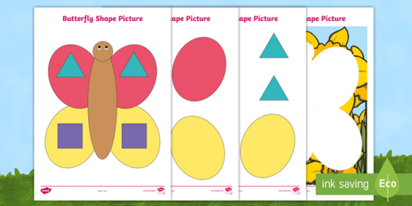  Fine motor skills  Cut out a range of shapes and use them to make butterfly pictures.
Music  Sing five little speckled frogs  https://www.youtube.com/watch?v=WSC-gHBU_d0  I went to the cabbages one day  https://www.youtube.com/watch?v=shybVatCDKg | Have fun!

