Question time
Create a quiz of 10 questions or more to test your friends, family or teacher on ancient Greece.

Research
Research Greek myths and summarise each myth that you read.

Story
Write a Greek story based on a myth: Zeus, Theseus and the Minotaur or King Midas.
History Takeaway Homework Menu

Takeaway homework guidelines
- It is up to you to choose what task to complete.
- The task should always be focused on the topic you are studying (if unsure, ask your teacher)
- Choose a task that is appropriate – but remember, the more you push yourself the more of a historian you will become!
.

Advert
Create a poster persuading the public to buy tickets to the Olympics in ancient Greece.

Democracy
Create your set of rules that show that power should be given to the people.

Sketch
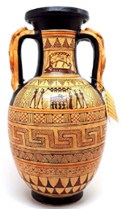
Research ancient Greek pottery and sketch out your own example.

3D map
Create a 3D map of Greece.

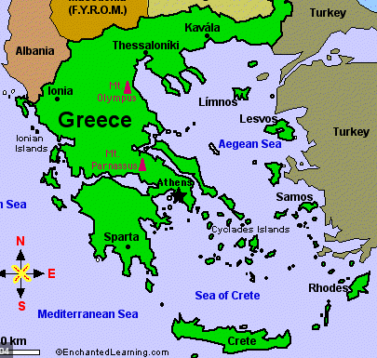

Pottery
Create your own 3D Greek pottery using different materials.

Athens vs. Sparta
Create a shield and/or helmet from the ancient Greek times.

