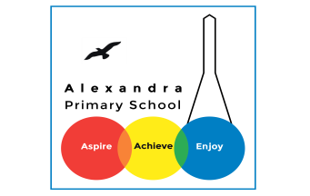**Science Home Learning**

This term is based on: **Electricity!!!**

**Activity 1:**

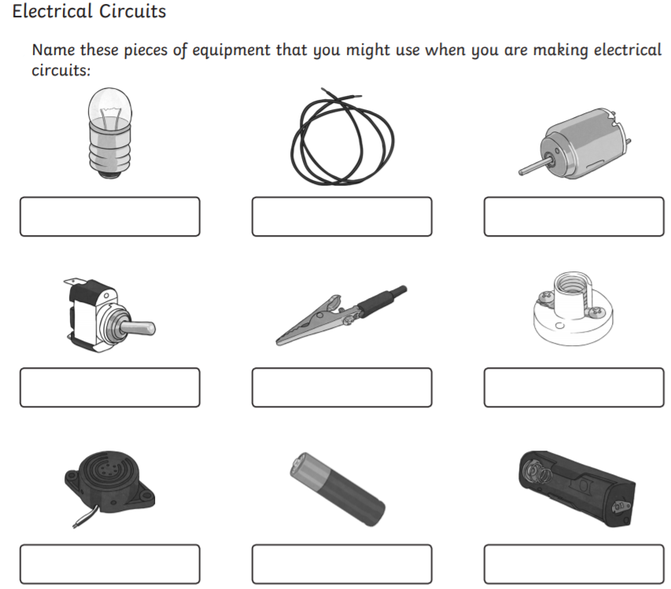

**Activity 2: Electrical Investigation**

