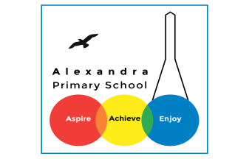
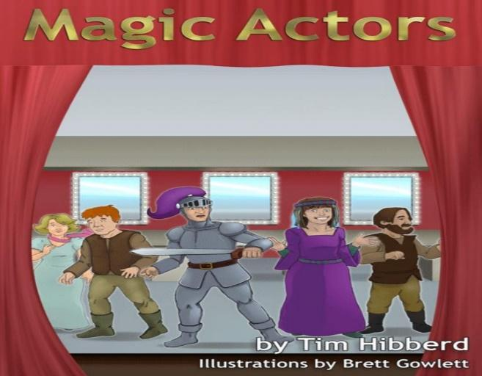
Year 4 Reading: Magic Actors By Tim Hibberd

Log in to your Purple Mash account. Visit the page for Animal Boy. If you have trouble signing in, you can access the PDF text if you click here https://www.purplemash.com/mashcontent/applications/serialmash/MagicActors_Ch1/ch1/MagicActors_Ch1.pdf
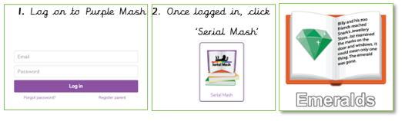

Monday 06th July : Read Chapter 1 and complete Chapter 1 Quiz
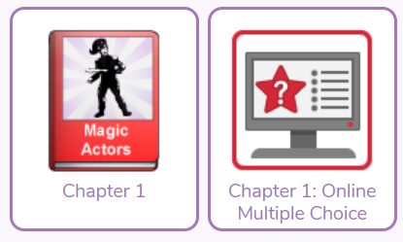
Challenge
There are lots of reasons why people move to a new country. Why might Mama and her family be moving? Imagine you are Mama and write a list of reasons for moving.

Tuesday 07th July : Read Chapter 2 and complete the Chapter 2 quiz
Challenge
In this chapter, Mama is telling a story about a group of actors who are performing a play. Think about a time when you have performed in a play. Maybe it was a school Christmas play or an assembly. Write about how you felt before you went on stage.
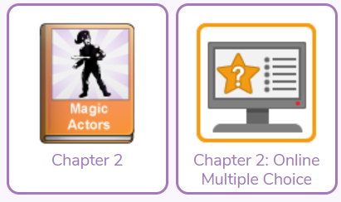

Wednesday 08th July: Read Chapter 3 and complete the Chapter 3 quiz
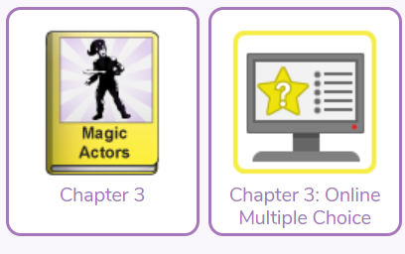
Challenge
In this chapter we were introduced to Sir Richard, the Red Knight. Matilda said that he is the cruellest man in the whole county. Pretend that you are Matilda. Write a list of all the cruel things that Sir Richard has done since you have known him.

Thursday 09th July : Read Chapter 4 and complete the Chapter 4 quiz
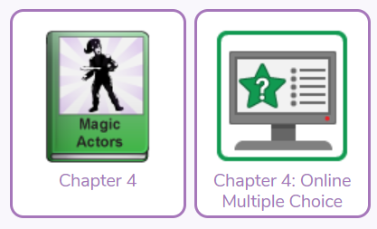
Challenge
The chapter ends with Sam dramatically falling to the floor. Who do you think will be the next character to speak? What will they say? Will all the characters react in the same way? Write down the conversation between the characters.

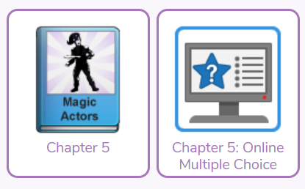
Friday 10th July : Read Chapter 5 and complete the chapter 5 quiz
Challenge
Write the next part of the story. Sam needs to be cured quickly but the Red Knight and his soldiers are preventing the group from getting to the witch's cottage. What will happen next? Will Sam recover, or will his condition get worse?

Get Creative!
Find a picture that you like either by a famous artist or a book illustration or a photo
Can you write about it?
It could be a story/ newspaper/ poem/ fact file
Bonus!
Read about the illustrator/ artist

Daily Activity
You should be reading for at least 30 minutes daily.
If you cannot access Purple Mash, choose a book of your own and use your Destination Reader stems to record your thoughts in your
Name of Book:
Prediction: I wonder if…
Inference: The word __ tells me…
Summary: The key idea is…

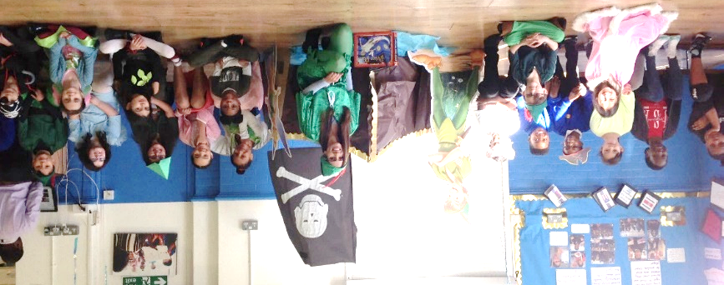

www.worldofdavidwalliams.com
Story Time Ideas

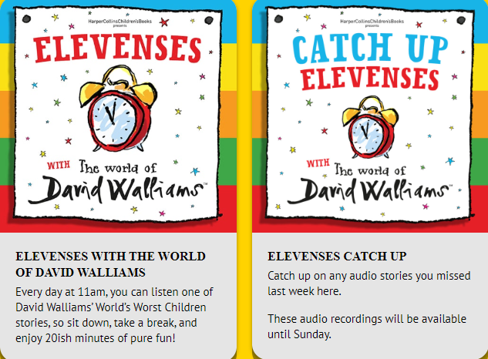

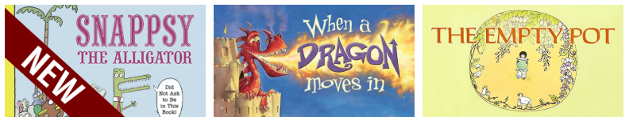

Audiobooks and eBooks are available to borrow for free from Hackney library, using these apps; Overdrive and Borrowbox. You will need to download these apps to a tablet, phone or computer. To use these apps, you will need a library card number from any London library. If you are not a member of the library, you can join for free here: https://hackney.gov.uk/libraries#join. You won’t need to go into the library to provide proof of address as you normally would, but can do everything online
There are also a lot of websites where you can watch authors read their
books for free:
- Storytime Online has hundreds of videos: Click here to view
- For a challenge, Neil Gaiman has posted videos of himself reading his award-winning books The Graveyard Book and Coraline. You could read listen to a chapter a day! Click here to view
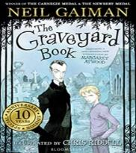
- https://www.getepic.com

