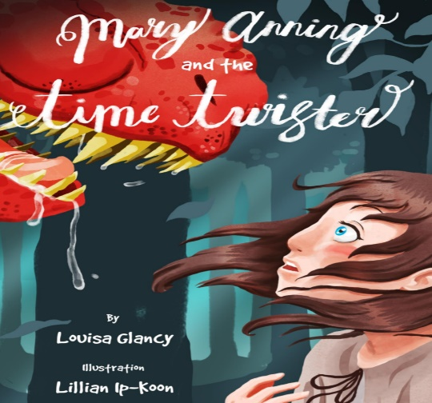
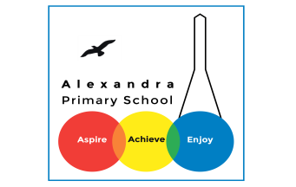
Year 4 Reading: Mary Anning and the Time Twisted by Louisa Glancy

Log in to your Purple Mash account. Visit the page for Animal Boy. If you have trouble signing in, you can access the PDF text if you click here https://www.purplemash.com/mashcontent/applications/serialmash/mary_anning_and_the_time_twister_ch1/ch1/Mary_Anning_And_The_Time_Twister-ch1.pdf
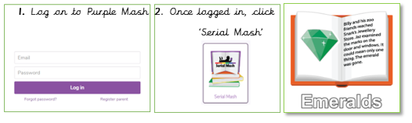

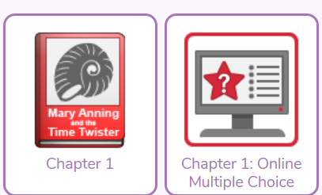
Monday 13th July : Read Chapter 1 and complete Chapter 1 Quiz
Challenge
Write about a trip that you have been on with your class.

Tuesday 14th July : Read Chapter 2 and complete the Chapter 2 quiz
Challenge
Where will the time travelling ammonite take the characters next?
Write the next part of Jasmine and Kyle’s adventure.
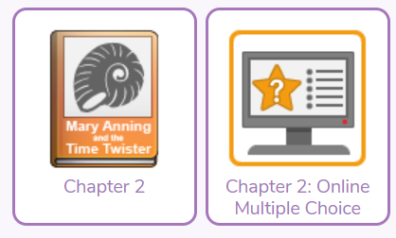

Wednesday 15th July: Read Chapter 3 and complete the Chapter 3 quiz
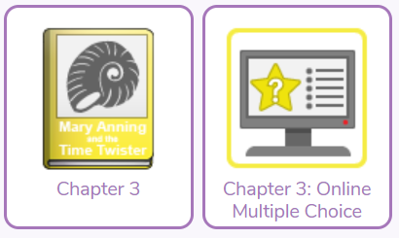
Challenge
Write a list of similes that could be used to describe the dinosaur that terrified the children in this chapter.

Thursday 16th July : Read Chapter 4 and complete the Chapter 4 quiz
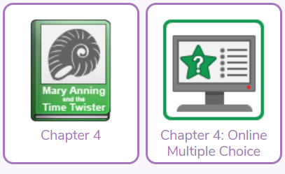
Challenge
It is 2030. You have become famous. Write an article about your rise to fame.

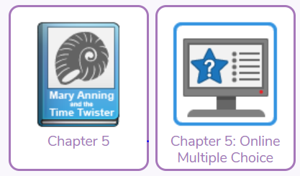
Friday 17th July : Read Chapter 5 and complete the chapter 5 quiz
Challenge
Now that you have finished reading Mary Anning and the Time Twister, write a review about the story.

Could it rhyme?
Take a book / story you have read or know.
Can you write a poem about a character or the book?
It could be a rhyming poem, an acrostic poem, a limerick or any type of poem!
Bonus!
Could you read about a topic or an event/ person from the past and do the same?
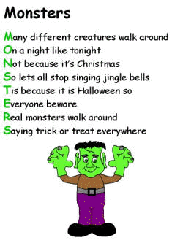

Daily Activity
You should be reading for at least 30 minutes daily.
If you cannot access Purple Mash, choose a book of your own and use your Destination Reader stems to record your thoughts in your
Name of Book:
Prediction: I wonder if…
Inference: The word __ tells me…
Summary: The key idea is…

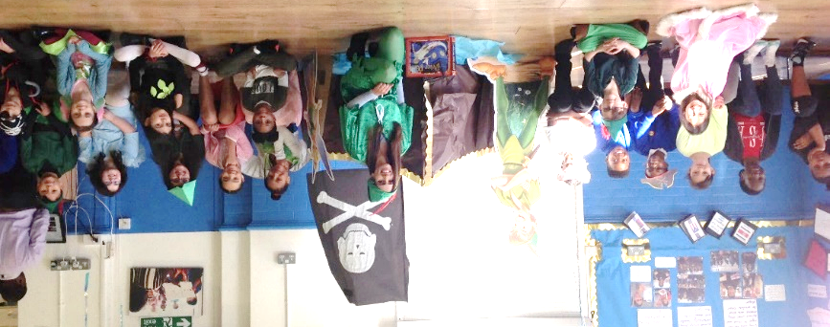

www.worldofdavidwalliams.com
Story Time Ideas

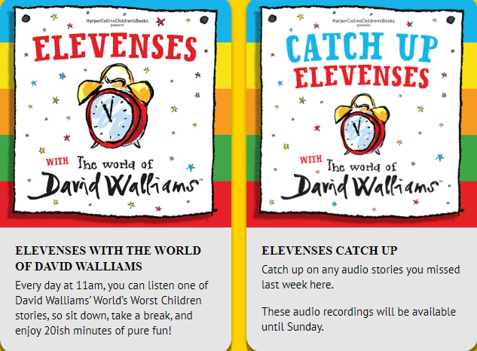

Audiobooks and eBooks are available to borrow for free from Hackney library, using these apps; Overdrive and Borrowbox. You will need to download these apps to a tablet, phone or computer. To use these apps, you will need a library card number from any London library. If you are not a member of the library, you can join for free here: https://hackney.gov.uk/libraries#join. You won’t need to go into the library to provide proof of address as you normally would, but can do everything online
There are also a lot of websites where you can watch authors read their
books for free:
- Storytime Online has hundreds of videos: Click here to view
- For a challenge, Neil Gaiman has posted videos of himself reading his award-winning books The Graveyard Book and Coraline. You could read listen to a chapter a day! Click here to view
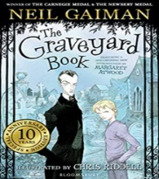
- https://www.getepic.com

