Home learning: Maths – Summer 2 Week 6 – Week Beg: 06.07.2020
Below are some activities you can use when learning at home.

Monday – 1s,10s,100s,1000s -Addition & Subtraction

Red
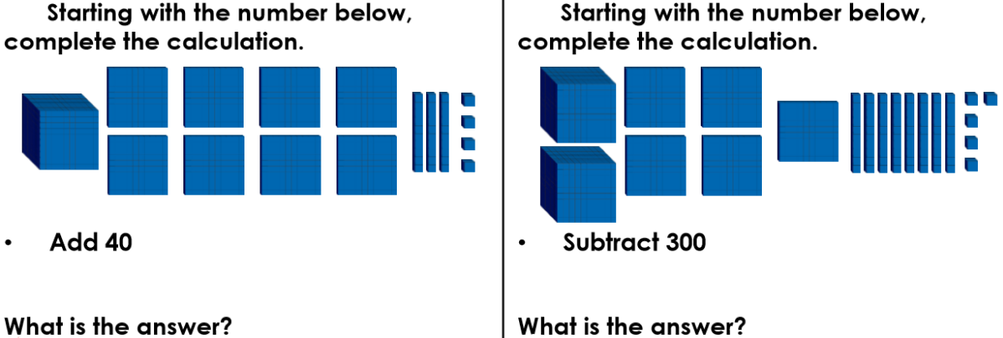

Orange
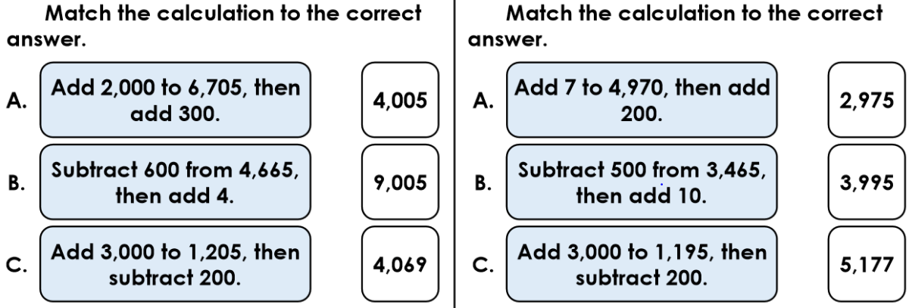

Green
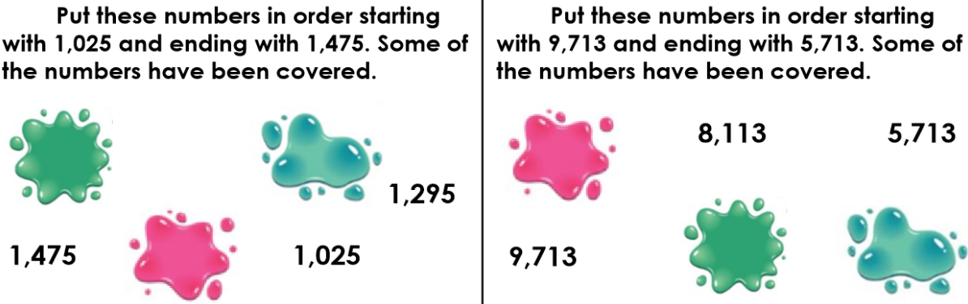

Reasoning & Problem Solving:
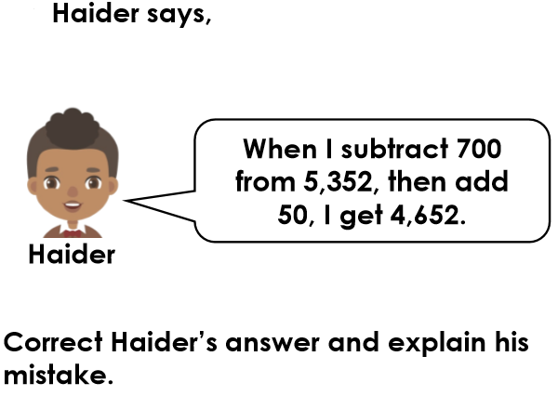

Tuesday –Add Two 4-Digit Numbers

Red:
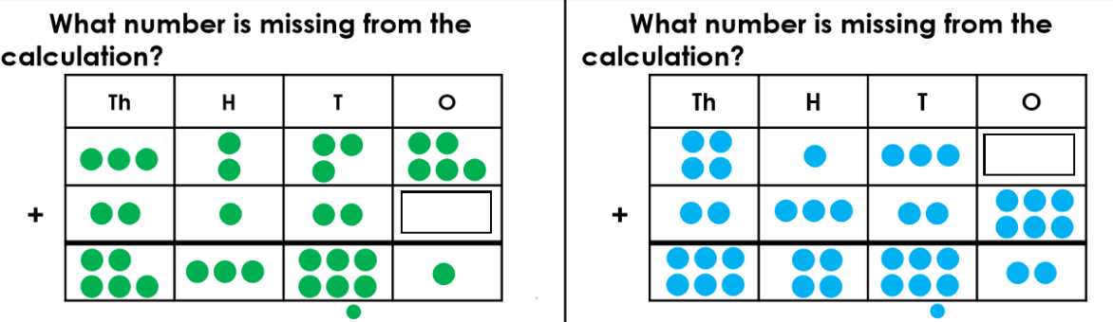

Orange:
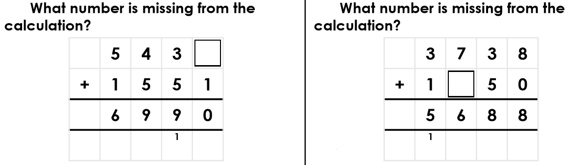

Green:
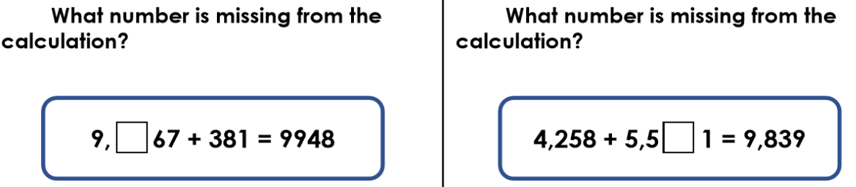

Reasoning & Problem Solving:
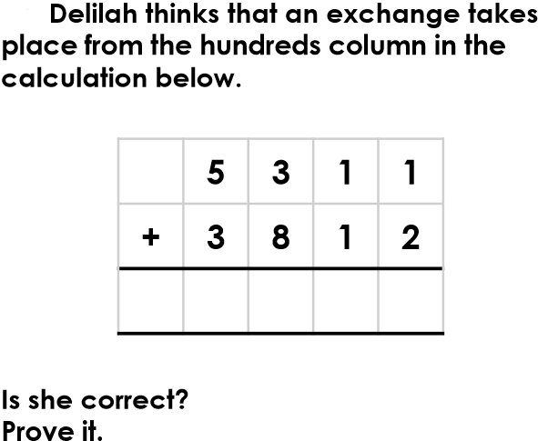

Wednesday-Subtract Two 4-Digit Numbers

Red:
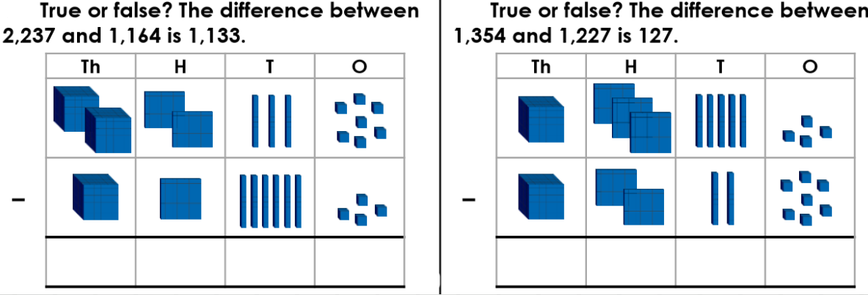

Orange:
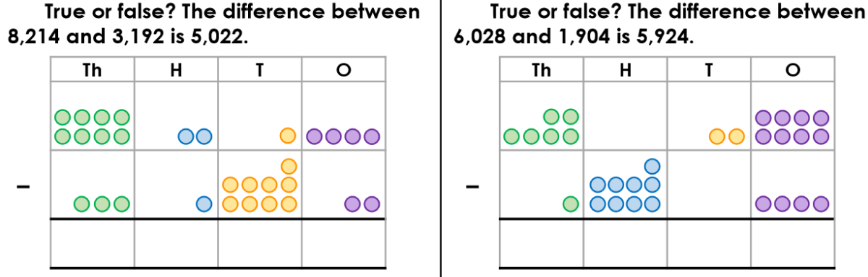

Green:
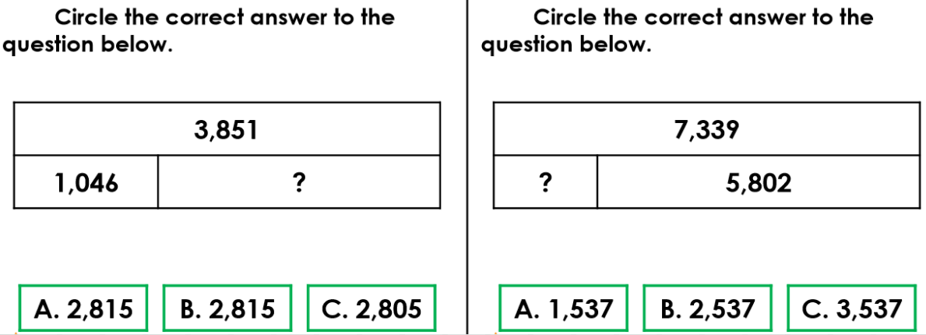

Reasoning & Problem Solving:
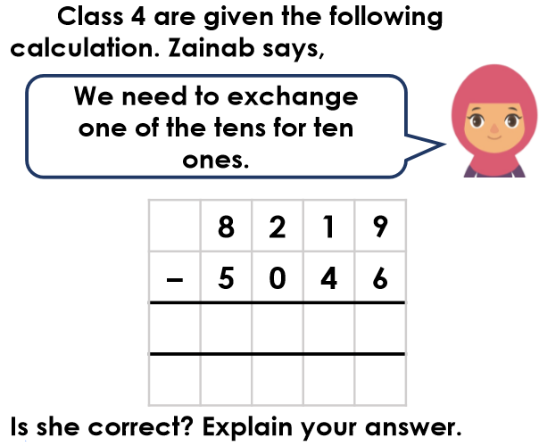

Thursday-Add Two 4-Digit Numbers

Red:
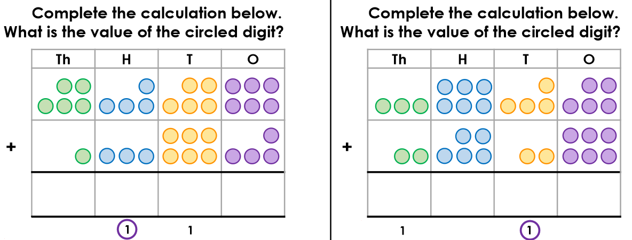

Orange:
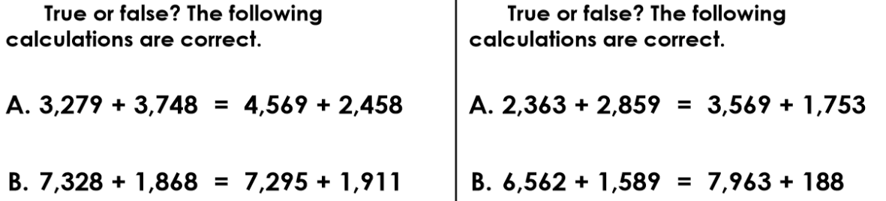

Green:

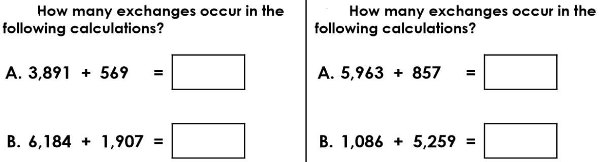

Reasoning & Problem Solving:
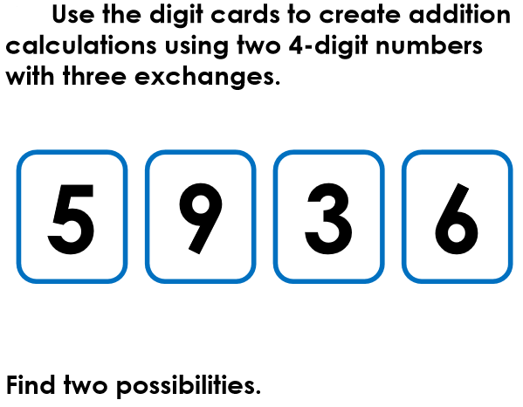

Friday –Subtract Two 4-Digit Numbers
Red:
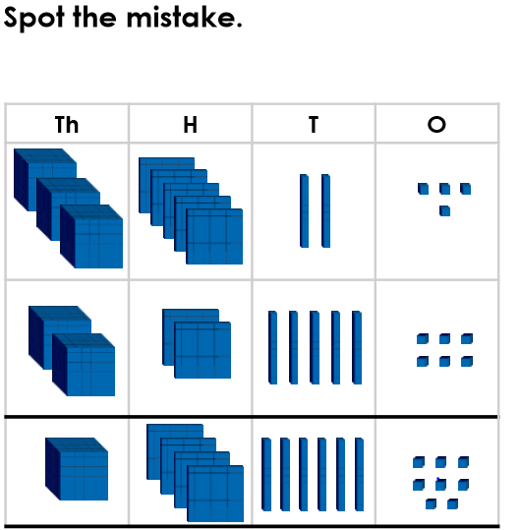

Orange:
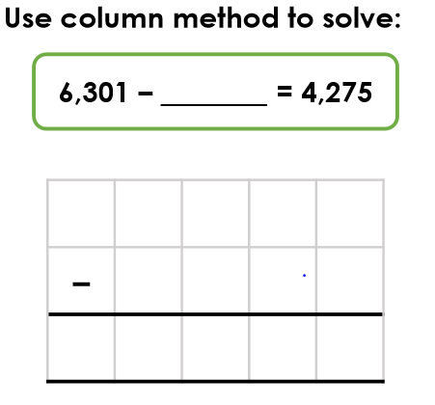
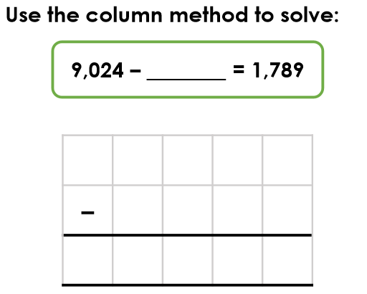

Green:
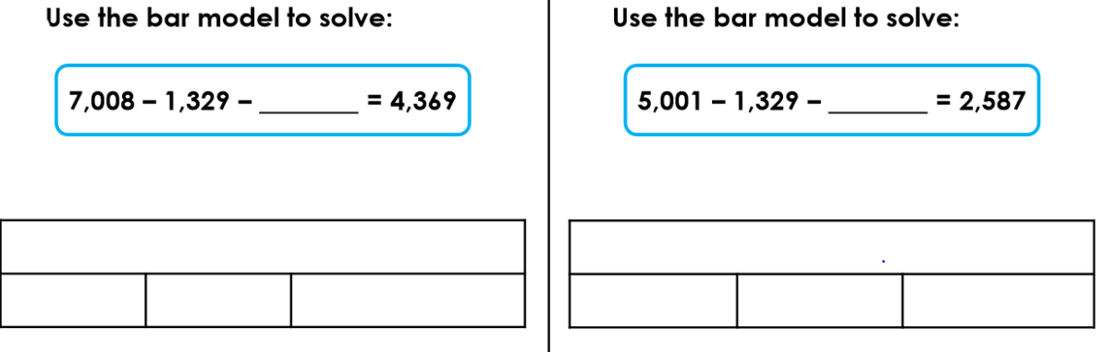

Reasoning & Problem Solving:
