Home learning: Maths – Summer 2 Week 7 – Week Beg: 13.07.2020

Monday –Multiply 2-Digits by 1-Digit
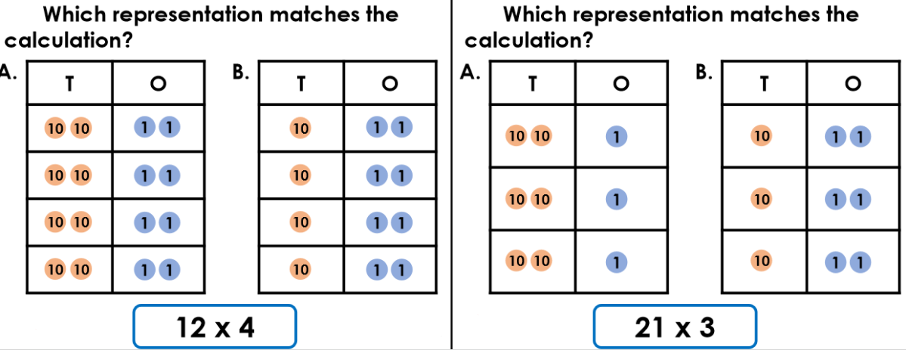
Red

Orange
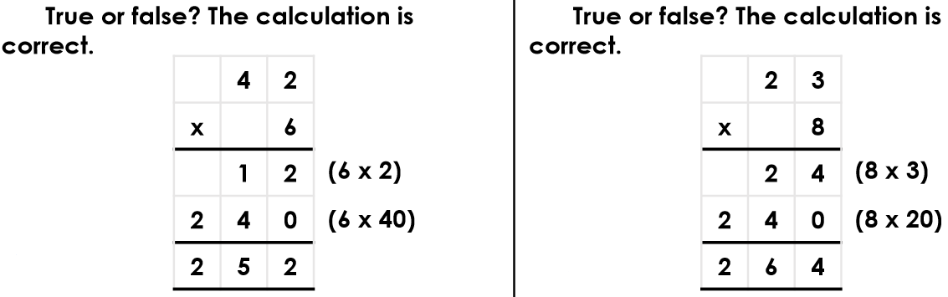

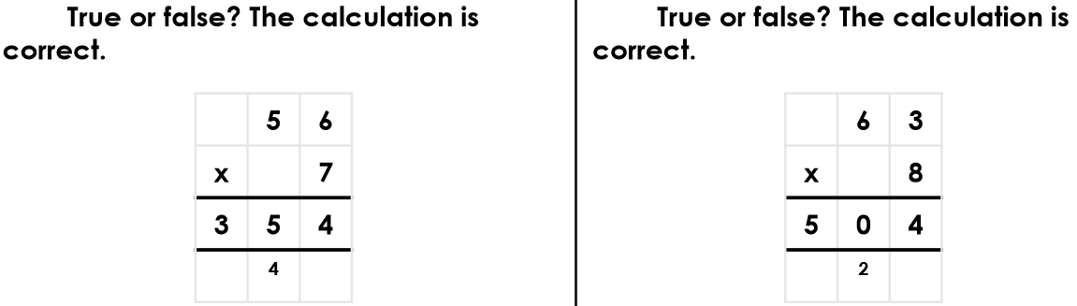
Green

Reasoning & Problem Solving:
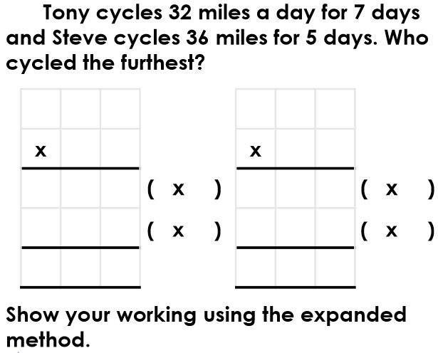

Tuesday – Multiply 3-Digits by 1-Digit
Red:
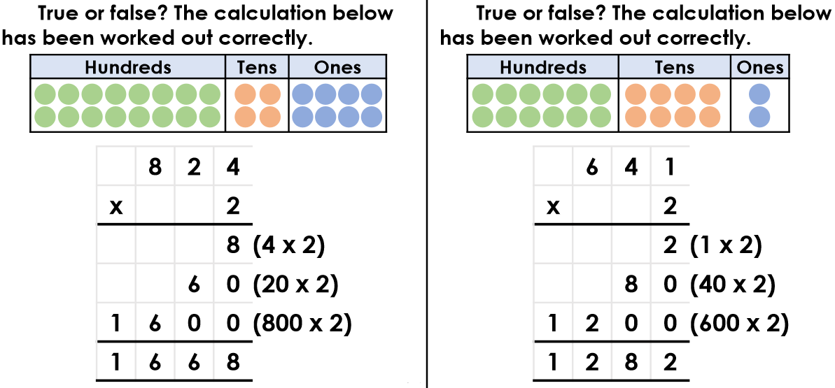

Orange:
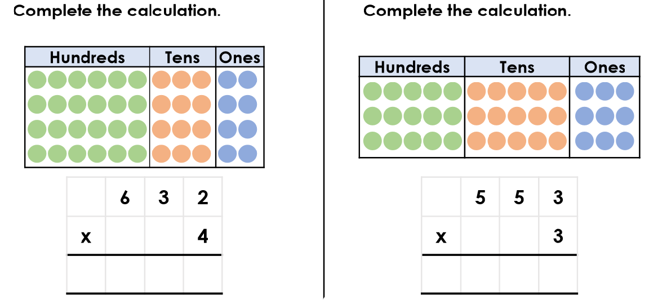

Green:
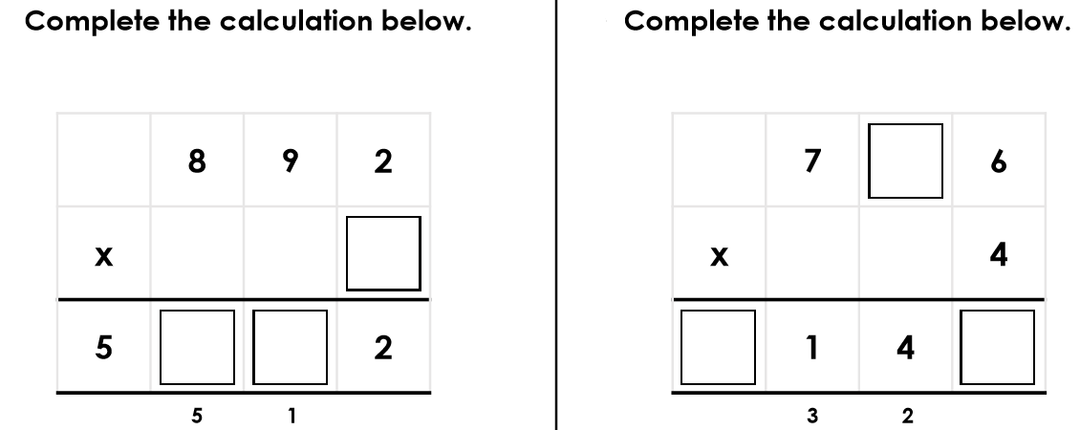

Reasoning & Problem Solving:
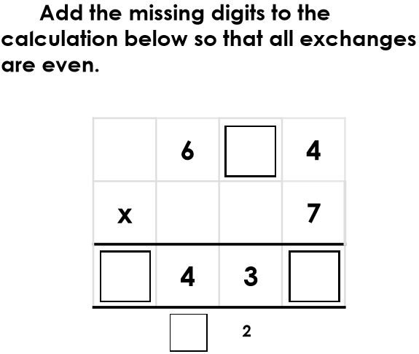

Wednesday- Divide 2-Digits by 1-Digit

Red:
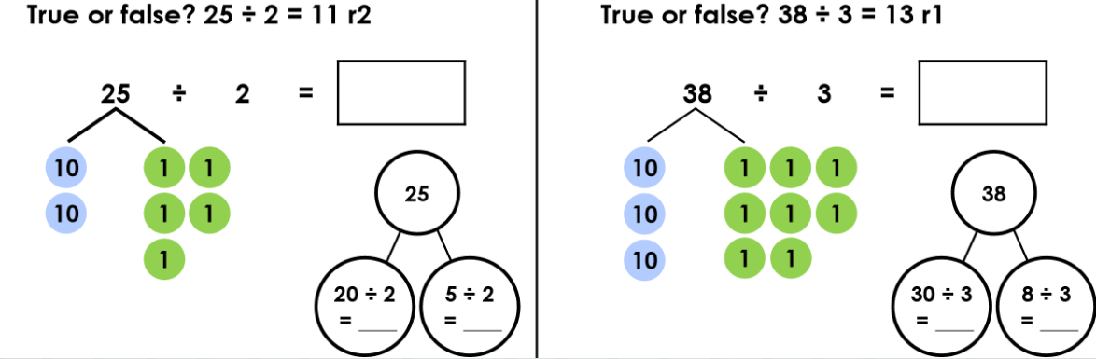

Orange:
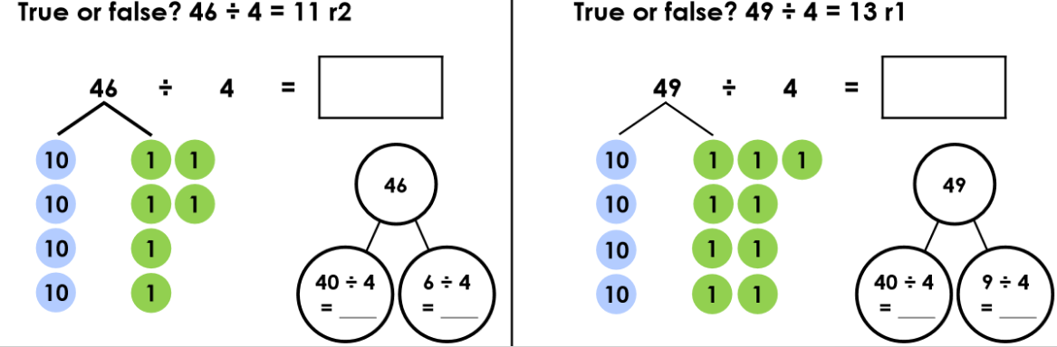

Green:
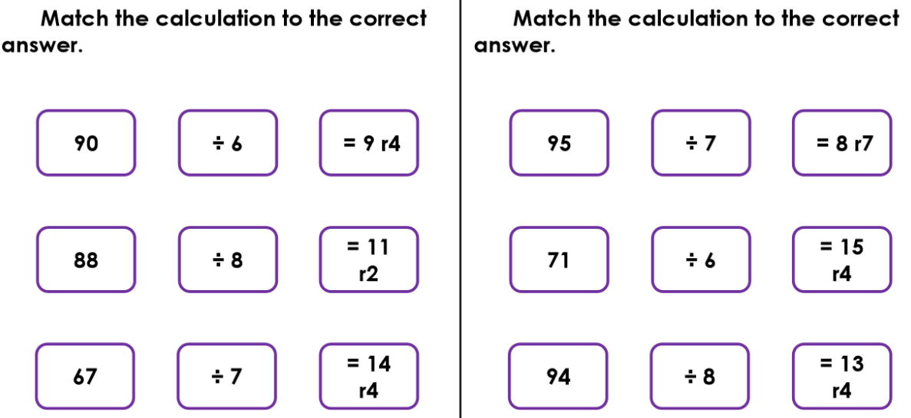

Reasoning & Problem Solving:
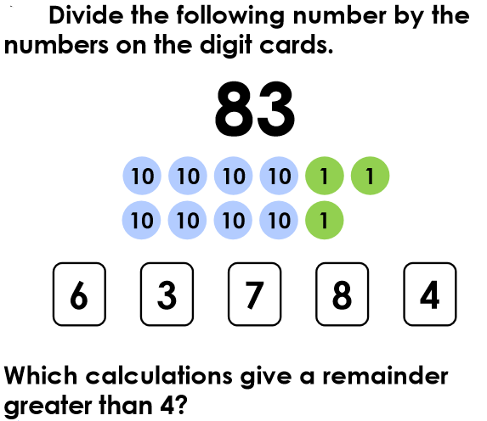

Thursday- Divide 3 Digits by 1 Digit

Red:
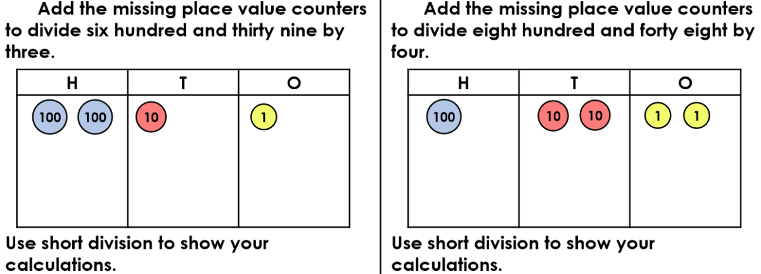

Orange:
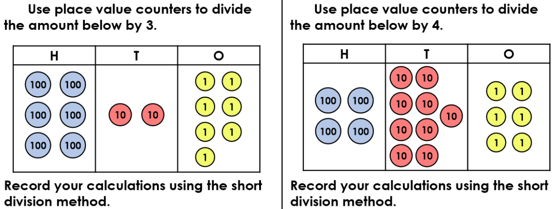

Green:

Reasoning & Problem Solving:
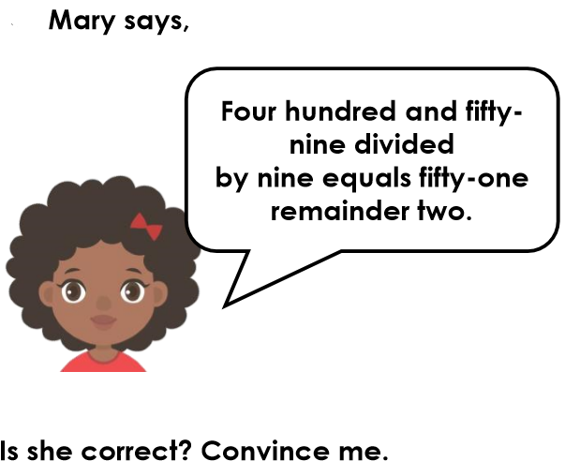

Friday – Factor Pairs

Red:
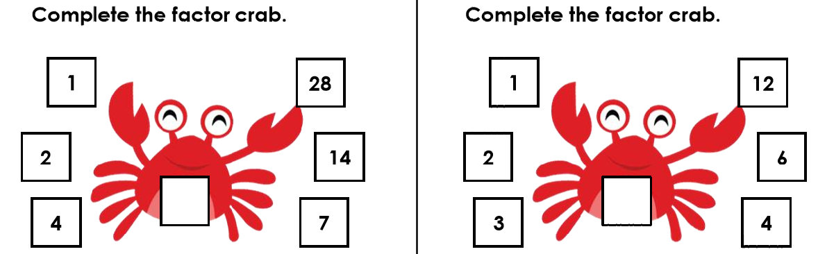

Orange:
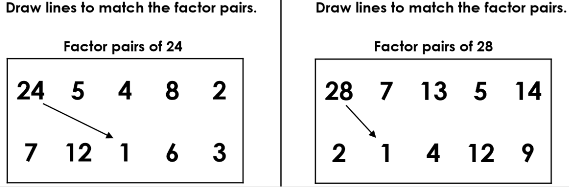

Green:
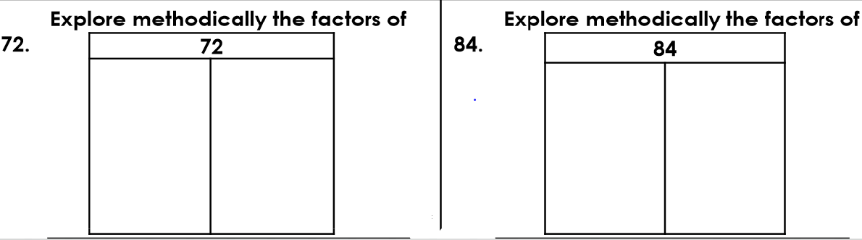

Reasoning & Problem Solving:
