**Geography Home Learning**

This term is based on: **Biomes and Vegetation Belts in Brazil!**

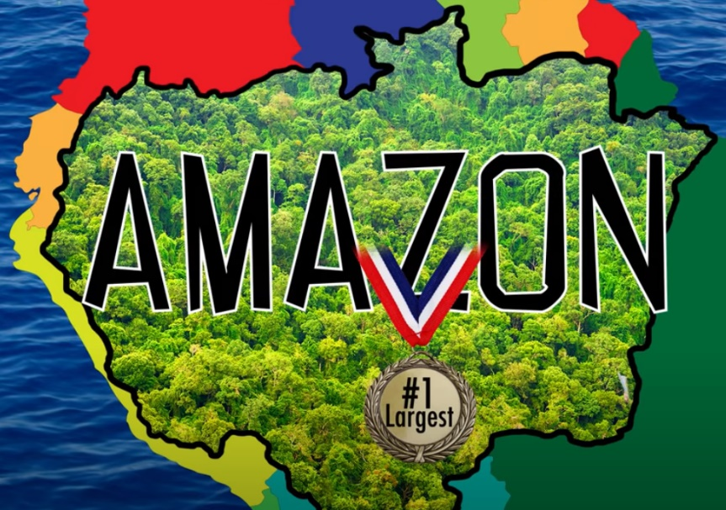

**Activity 1:**

Watch the video and write down 10 interesting facts you found about the amazon rainforest.

<https://www.youtube.com/watch?v=DgU7gsBOhUI>

Did you know that…

An interesting fact about the amazon rainforest is…

Surprisingly,

There are over…..

**Activity 2:**

Create your own animal fact file on a specific animal you might find living in the Amazon Rainforest in Brazil.

*What is unique about the appearance?*

*Where do they live?*

*What does their habitat consist of?*

*Are they endangered animals?*

*What foods do these animals survive off? What does their diet consist of?*

*What interesting facts are there about them?*

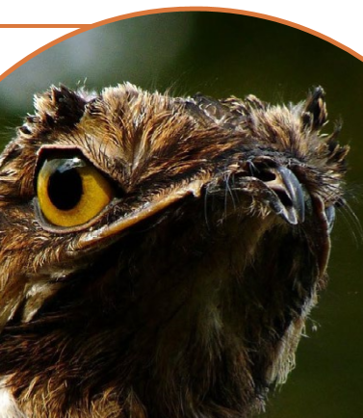 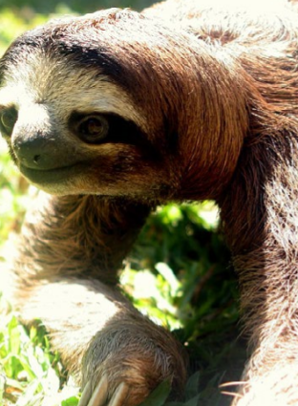 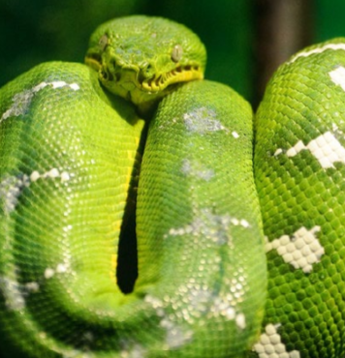

Potoo Sloth Emerald Tree Boa

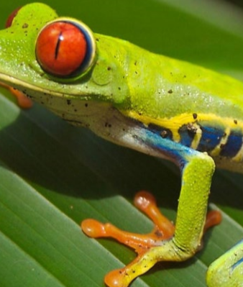 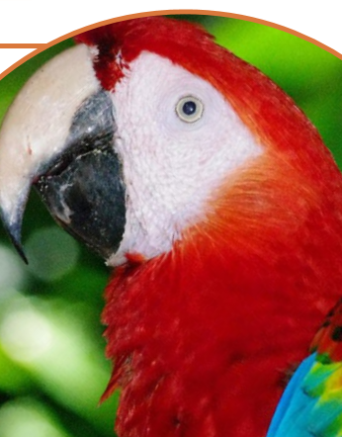 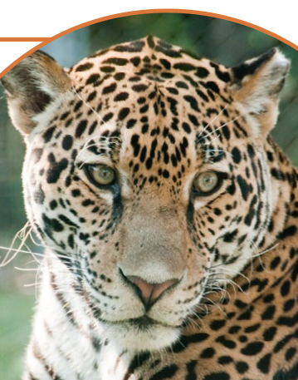 Red-Eyed Tree Frog Scarlet Macaw Jaguar

