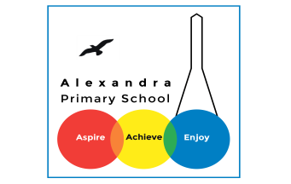
Geography Home Learning
This term is based on: Biomes and Vegetation Belts in Brazil!
Focus: Amazon Rainforest
Activity 1: Read the text and answer the questions.
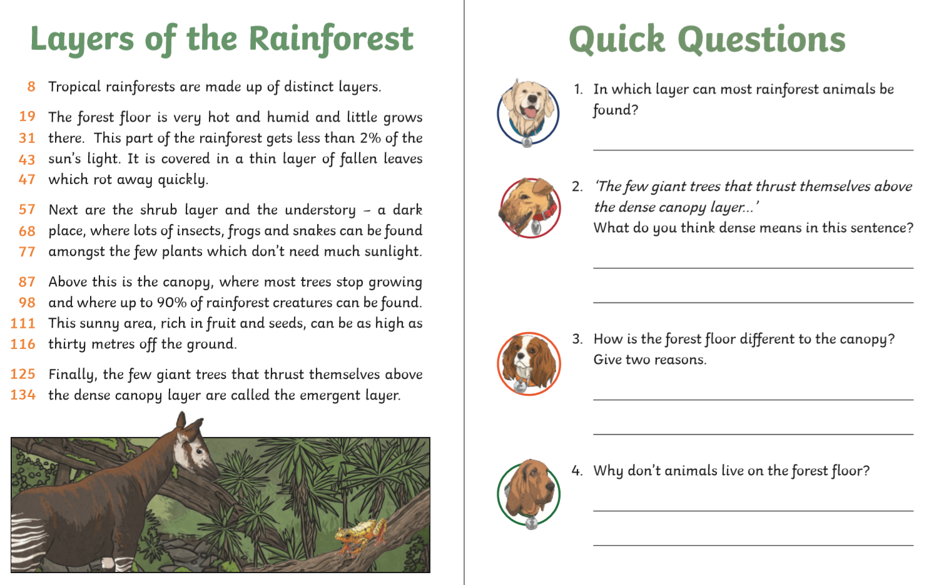
Activity 2: Read the text and answer the questions.
