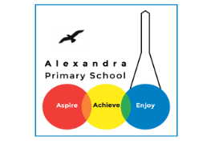
Home learning - Summer Term - Week 6- Year 4 WC: 06.07.2020
Writing
This week is based on: Morals and Life Lessons

Monday 06.07.2020
LO: To understand the meaning of words using a dictionary.
Word | Meaning
Moral
Fable
Equality
Justice
Virtuous
Problem
Solution
Protagonist
A fable is a short story that teaches a lesson or conveys a moral. Aesop is quite possibly the most famous fable writer of all time. Many of the morals in his fables revolve around equality, justice, and virtuous behaviour.

Main Task:
Find the meaning of these significant words using a dictionary:
- Moral
- Fable
- Equality
- Justice
- Virtuous

Challenge: Create sentences using these words.
Can you find a fable that you particularly like?

Tuesday 7th July 2020
LO: To understand the meaning behind fables.

The Dog and his Reflection.
Listen: https://www.bbc.co.uk/teach/school-radio/english-ks1--ks2-aesops-fables-the-dog-and-his-reflection/zdddcqt
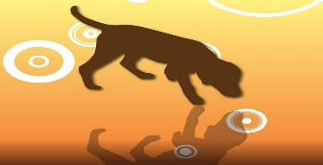

Main Activity: What is the moral of this story?

The Hare and the Tortoise.
Listen: https://www.bbc.co.uk/teach/school-radio/english-ks1--ks2-aesops-fables-the-hare-and-the-tortoise/zbmj92p

Main Activity: What is the moral of this story?

The Bundle of Sticks.
Listen: https://www.bbc.co.uk/teach/school-radio/english-ks1--ks2-aesops-fables-the-bundle-of-sticks/zbynxyc
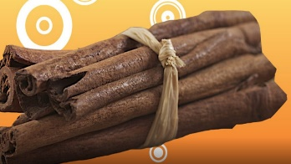

Main Activity: What is the moral of this story?

Once you have read this fable, create a cartoon strip retelling the fable of The Bundle of Sticks.

Wednesday 8th July 2020
LO: To create a fable web.
Main Activity: Select a focused fable out of the two you have read. Focusing on the main areas below complete your fable web.

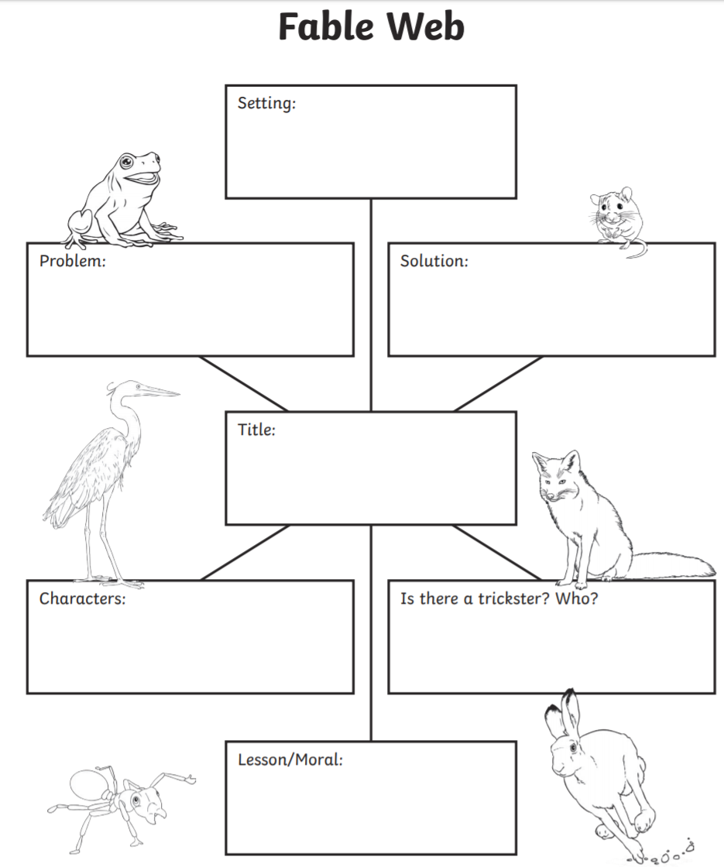

Thursday 9th July 2020
LO: To plan our writing

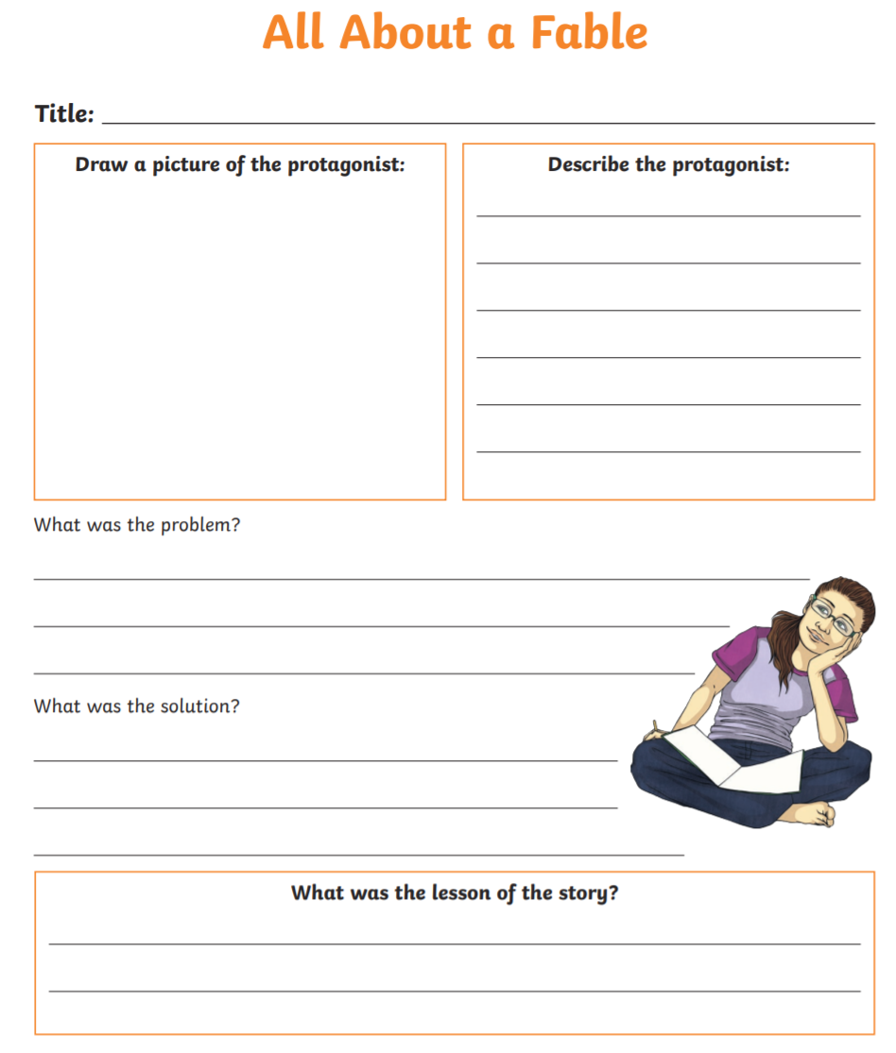

Friday 3rd July 2020
LO: To retell a fable.

Friday 10th July 2020
LO: To retell a fable.

Main Activity: Using your fable plan and web retell your own version of your selected fable.

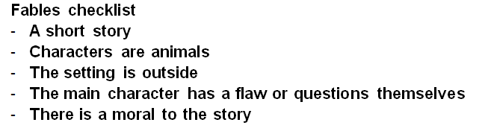

The Bunny
Once there was a bunny. He had a big problem. He didn’t think he was special. He wanted to be someone different. He went for a walk.
First he met a lion. The lion said, “What are you doing, little rabbit? It is a lot of work watching my kingdom.”
“Well, then, I’ll be on my way,” said the little rabbit. He thought, “I don't want to be a lion!”
Then he met a turtle. The turtle said, “What are you doing, little bunny? I have a long way to go and I’m really slow.”
“Well, then, I’ll be off.”
The last animal he saw was a mouse. The mouse said, “I’m on the run from a cat.”
“Then I’ll leave you alone,” said the little bunny. The bunny thought, “I’m fine the way I am.” So the little bunny learned that he was fine the way he is.

