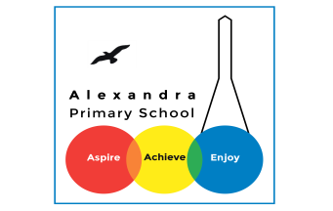
Home learning - Summer Term - Week 7- Year 4 WC: 13.07.2020
Writing
This week is based on: Comics

Monday 13th July 2020
LO: To create a fictional character.

What is a comic? Can you think of any examples?

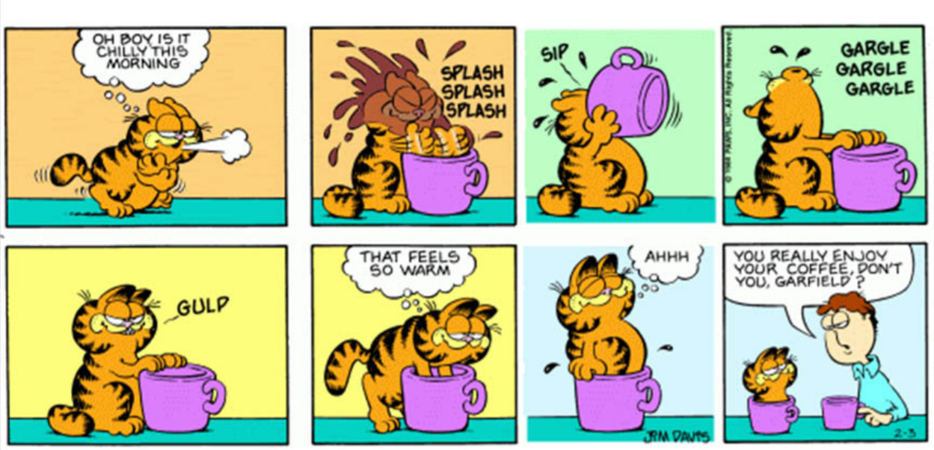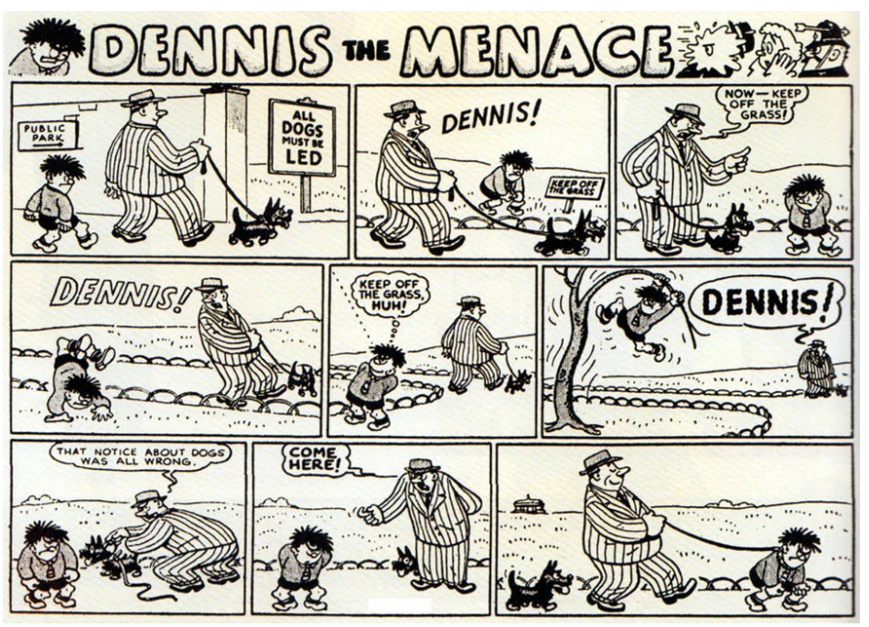

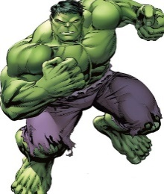
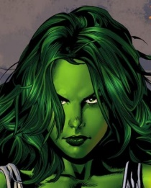
Main Task:

Draw two characters.
One resembling a hero and one resembling a villain.
What do they look like?
How are they different?
How are they similar?

My characters are similar because…
My characters are different because…

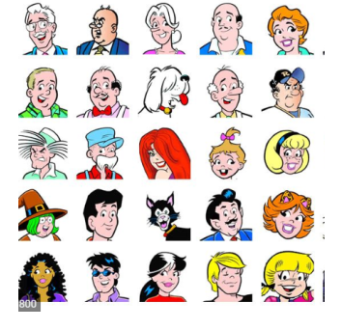

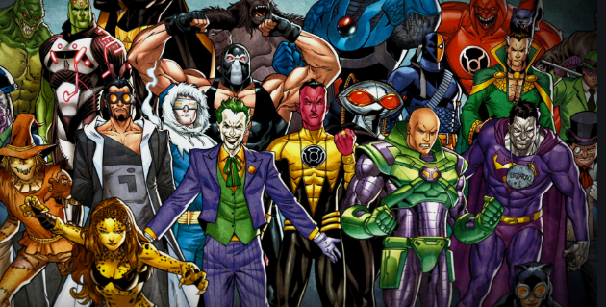

Tuesday 14th July 2020
LO: To build a varied and rich vocabulary.

Word bank:
Main Task:
Brainstorm key words and phrases that best describe your more heroic character and your character that resembles a villain.

Use word classes:
- Verb
- Adjectives (Appearance and Personality)
- Adverbs
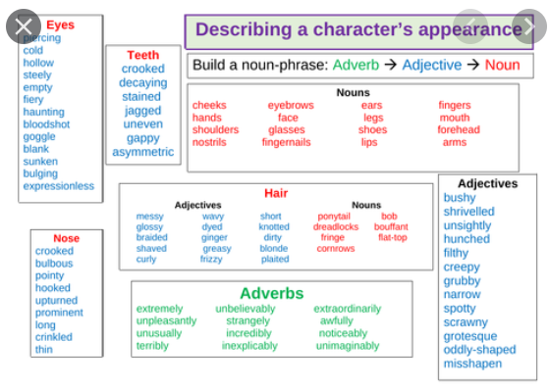

Character’s name: | Verbs
Adjectives | Adverbs

Character’s name: | Verbs
Adjectives | Adverbs

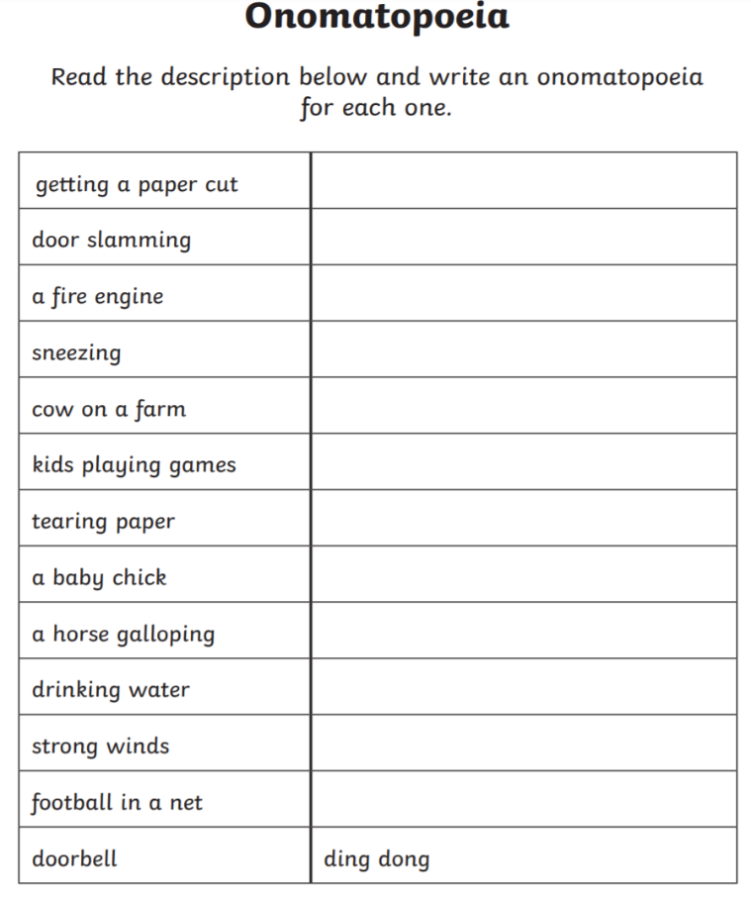
Wednesday 15th July 2020
LO: To use powerful vocabulary.

In comics, they use onomatopoeia to create
suspense and drama.

What is onomatopoeia?

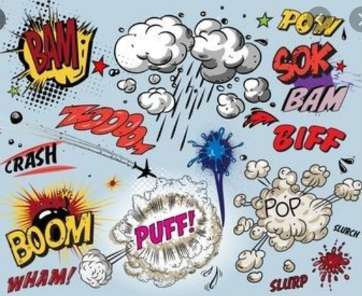

Main Activity: Create your own table and write an onomatopoeia for each example.

Thursday 16th July 2020
LO: To plan our writing by using direct speech.

Speech in comic strips are usually in speech bubbles:
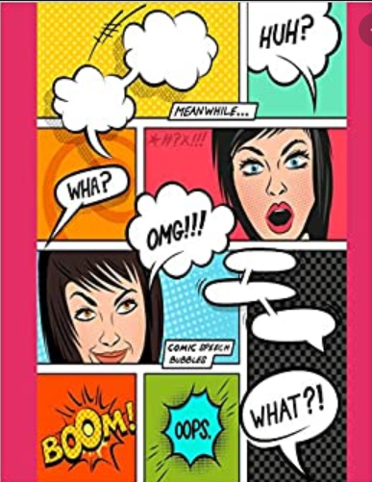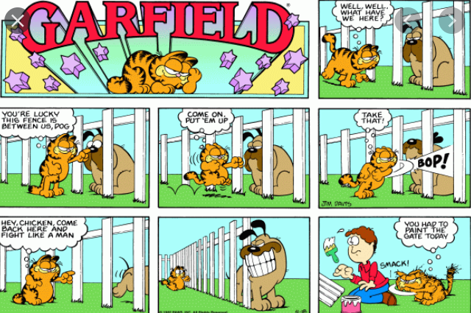

Think of a short storyline for your characters. Create speech bubbles for one picture.

Challenge: Create speech with onomatopoeia.

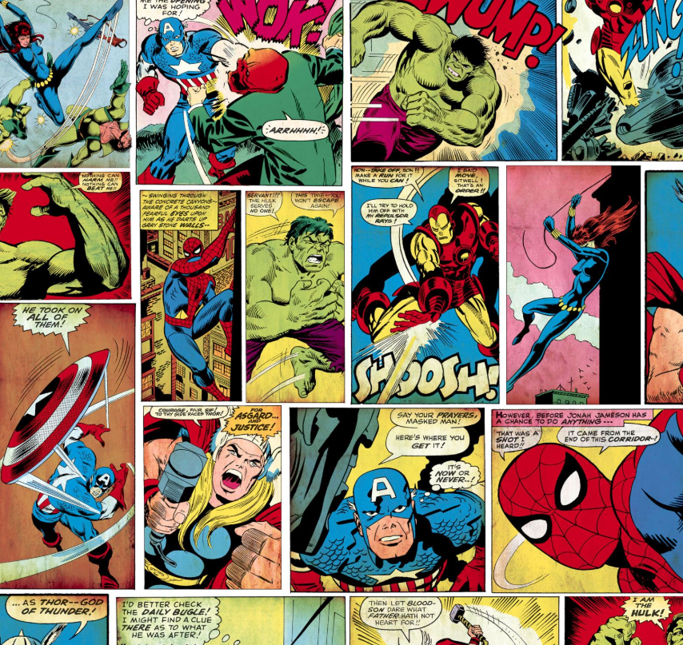
Friday 17th July 2020
LO: To create a comic strip.
Main Task:
Design your own comic strip using direct speech from your characters to create dialogue.
Use images and speech bubbles when laying out your playscript.
Draw animated images of your characters and setting.
Only use direct speech. Don’t use ‘he said, she said’

You can use this format below:

