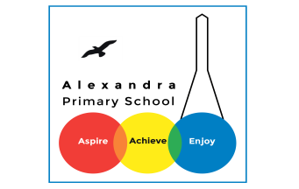

History

Summer Holiday Takeaway Homework



**Question time**

Create a quiz of 10 questions or more to test your friends, family or teacher on Ancient Egypt.



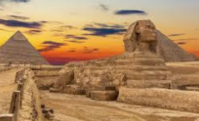

**Art**

Draw a picture of an Ancient Egyptian pharaoh.

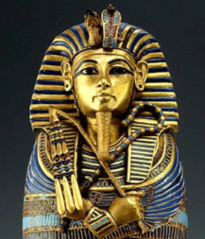

Takeaway homework guidelines

* It is up to you to choose what task to complete.
* The task should always be focused on the topic you are studying (if unsure, ask your teacher)
* Choose a task that is appropriate – but remember, the more you push yourself the more of a historian you will become!



**Research**

Find out and write down 10 key facts about the river Nile.

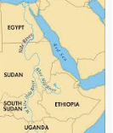

**Egyptian Gods**

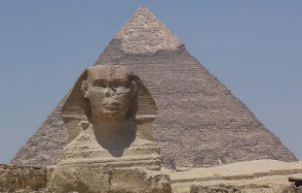Research Egyptian Gods to help you to design and create your own God. What would they be the God of and what would they look like?



**Leaflet**

Create a leaflet to persuade people to visit Ancient Egypt – try to make it as persuasive as you can.

**3D model**

Design and create a 3D model of the famous Ancient Egyptian pyramids.

**Fashion**

Design and create your own Ancient Egyptian outfit that would have been worn by a pharaoh. What materials would you choose to create each item of clothing?