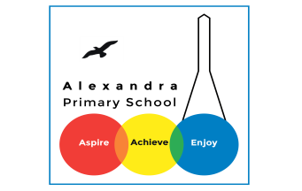
Home learning Summer Term - Year 3 wc 13th July 2020

Writing
Below are five writing activities for you to do every day. The videos on google
classroom will link to these activities.
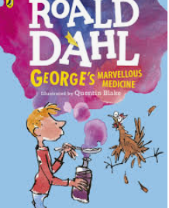
This week the writing will be based on the book: George’s Marvellous Medicine.
We will be writing persuasively this week!

https://www.slideshare.net/SharenGanesh/georges-marvellous-medicine
The story is here if you would like to read it.

This week:
We would like you to imagine you are George. And you want to package up the medicine you have created and sell it to everyone. You think this will be incredibly popular and people will spend a lot of money on it. Throughout the week, you will be creating different materials to help sell the medicine.
Put your creative hats on!

Monday 13th July
LO: To design packaging for the medicine.

Can you create packaging for your medicine? Imagine it will be put into a bottle, can you design a box that the medicine can go into. What colours would you include? What words would you use to describe it? What would it be called?

Here are examples of boxes of medicine:

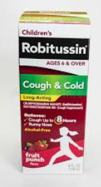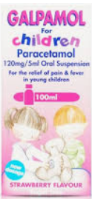

And here are examples of the marvellous medicine boxes:
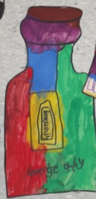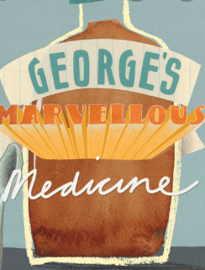

Tuesday 14th July
LO: To sell the medicine.

You have now created your packaging for the medicine. Now you are going to sell your medicine to people on television. Imagine you have 60 seconds to go on TV and try and sell this fantastic medicine to thousands of people.

How are you going to sell it to an audience?
What words will you include to best sell this product?

Write your ideas down like a brainstorm:
It will make you go whizz and bang!
remarkable

Marvellous Miraculous Medicine

Organic ingredients
It will pump you full of energy
It will give you a boost

You don’t need to write it down but if you can say it aloud to yourself or to a family member. Make sure you are SELLING it. They MUST buy it.

Try and use these words in your TV advert:
amazing
breathtaking
blissful
exciting
delight
jaw-dropping
mind-blowing

Wednesday 15th July
LO: To know what persuasive writing is.

You will be writing an advert to sell your medicine. You need to PERSUADE your audience to buy the medicine.
The features of persuasive writing (advert) are:

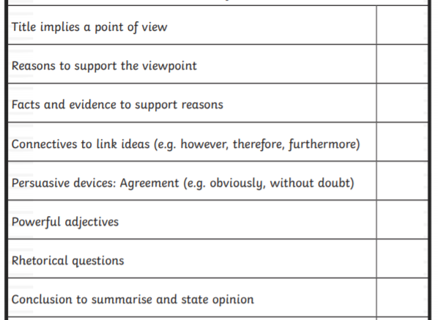

Can you find these features in this piece of writing:
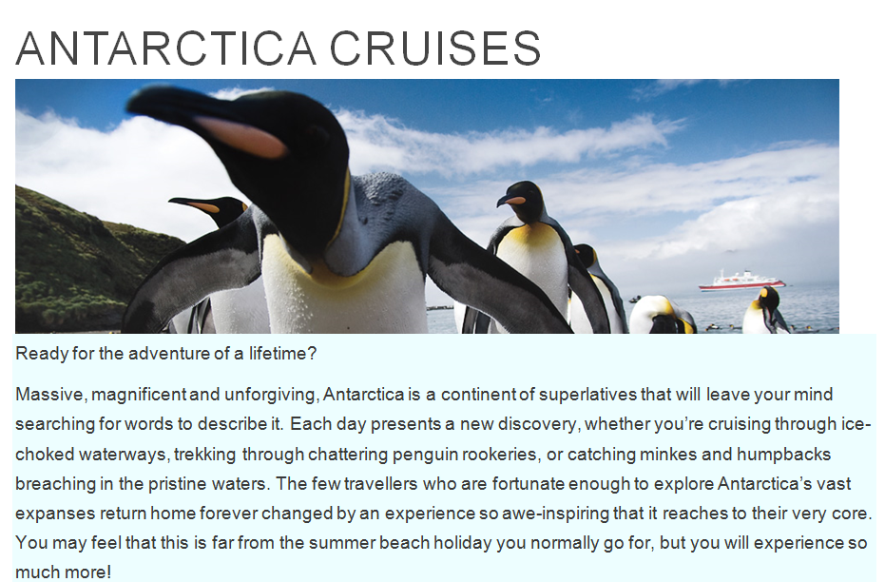

Thursday 16th July
LO: To plan a persuasive piece of writing.

Today you will be planning your advert. You need to include the features of an advert and include your ideas from Tuesday’s lesson.

Name of product: | Rhetorical questions:
Powerful adjectives: | What is the medicine?
Reasons to buy the medicine: | Facts and evidence to support:

Friday 17th July
LO: To write a persuasive piece of writing.

Using your planning sheet and ideas from the week, now you will be writing your persuasive advert.

The famous Marvellous Miraculous Medicine
Do you want a medicine to not just take your headache or toothache away? Do you want a medicine that gives you a skip in your step? A boost in your boots? Then this medicine is for you.
The new powerful mind-blowing medicine is here for you to get your hands on. This medicine has been created by hand and uses organic produce to create a medicine that will make you feel better than you did when you were born. It is a medicine that will truly make you leave your body, go to space and swim through the freezing ocean 20 times.
If you have aches and pains, groans and grumps, feeling old and angry or just purely needing a lift. Then this medicine is for you. It is pure and will give you the boost you have always needed.
The 3 people who have tried it so far give it 5 stars and say ‘it is the best thing since sliced bread’.
It’s over to you now.

