W/C: 06.07.2020
Newspaper Articles-
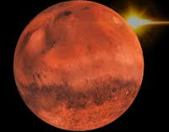
Will Mars be Habitable?
MARS (The Red Planet)

In July, NASA plan to launch a new rover called Perseverance Rover to Mars. The aim of this mission is for the Perseverance rover to seek signs of ancient life and collect rock and soil samples for possible return to Earth. All this research will help astronauts in deciding whether Mars could be habitable in the future (there can be life on mars).
Monday 6th July 2020
Task
Read the information sheet (Monday resource) about the Perseverance Rover and answer the following questions to learn more about rovers.
1) What is the purpose of the rover?
2) Why is this such an important mission for space exploration?
3) Why do you think the rover was called ‘Perseverance’?
4) Which part of Mars with the rover be visiting?
5) What method will the rover be testing?

Tuesday 7th July: Descriptive writing

How long will it take to get to Mars?
The rover is due to land on the surface of Mars on 18 February 2021, meaning that NASA is expecting the mission to take around seven months to reach Mars.

How big is NASA's Perseverance rover?
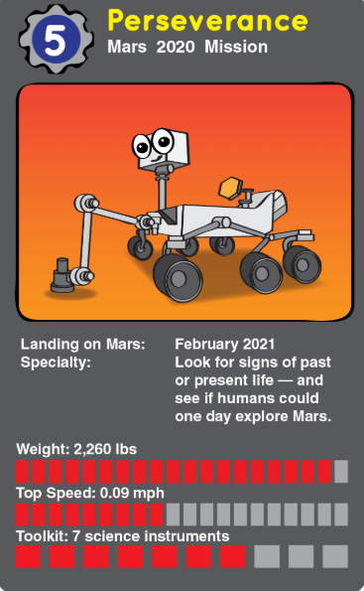
NASA's Perseverance rover, at 3 metres long and 2.7 metres wide, is about the size of a small car. It is similar in size to NASA’s Curiosity Rover, although it is about 150kg heavier.

Task:
Use the facts to create a poster for advertisement about the Perseverance Rover. You are creating this advertisement to make more people aware of this exciting space mission.

Wednesday 8th July: Research
Look at the example Newspaper article (Wednesday resource) and label/ find all the different features of Newspaper articles.
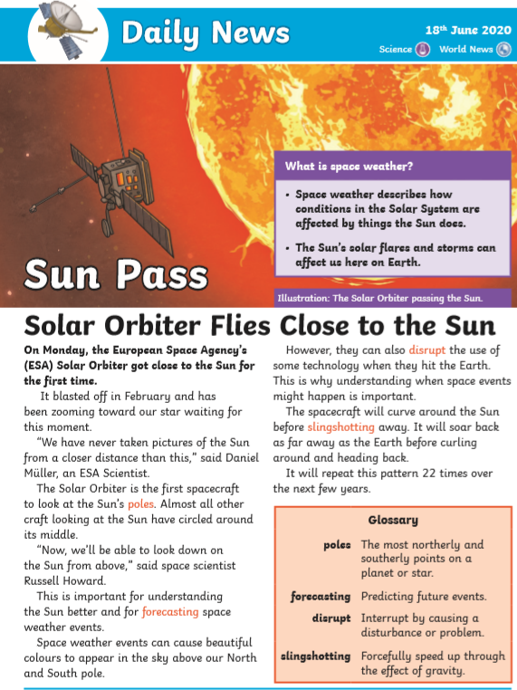
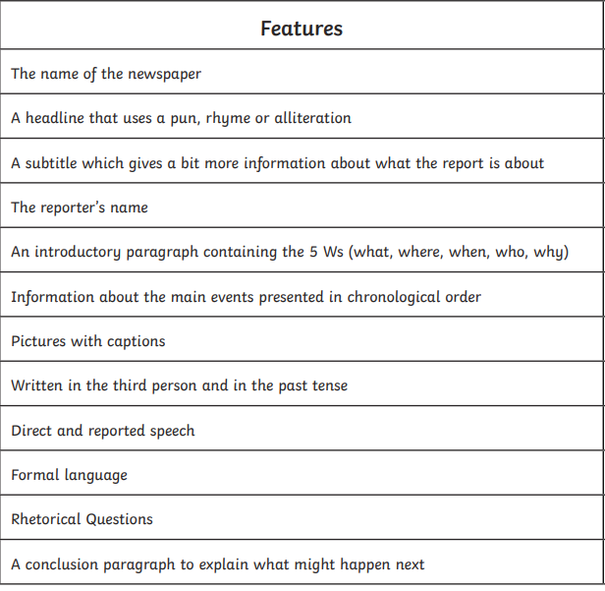

Thursday 9th July: Planning a newspaper report
Use the planning template to plan a newspaper article about the launch of Perseverance Rover to Mars.
Beginning/ Paragraph 1: The 5 W’s- Who, what, when, where and why? Answer the 5 W’s about the Perseverance rover.

Paragraph 2: Describe the rover and the features (length, weights, design)

Paragraph 3: Describe in detail what the Perseverance rover is going to Mars for? What will it collect and why?
Resolution: What do you think will happen next? Why is this such an important mission?
Friday 10th July: Writing a newspaper article
Watch the video for Friday and use your plan to write your newspaper articles.
Include:
- 5 W’s
- Facts
- Direct and reported speech
- Pictures and captions
- Use the template to help you write in columns (down the page) or you can do this in your books and take a picture.

