Year 1 Reading – Summer 2 Week 7

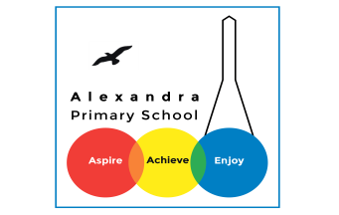
You should be listening to your child read for at least 25 minutes a day
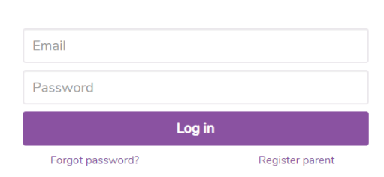
Purple Mash

- Log onto Purple Mash
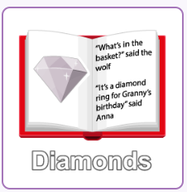
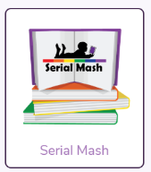

- Once logged on go to Serial Mash and click Diamond level
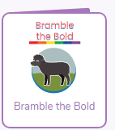

- Choose our text: Bramble the Bold

- Read one chapter each day and complete the quiz at the end

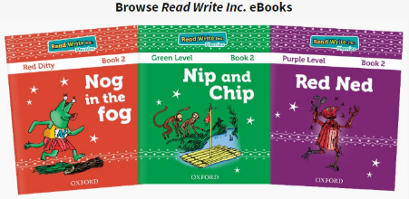
Oxford Owl are offering free online e-books and Phonics books that
you can read with your child daily.
www.oxfordowl. co.uk

Phonics: Practice these sounds daily with your child. You can find a link how to pronounce each sound. Visit our Year 1 page, and click the ‘Phonics’ Tab.
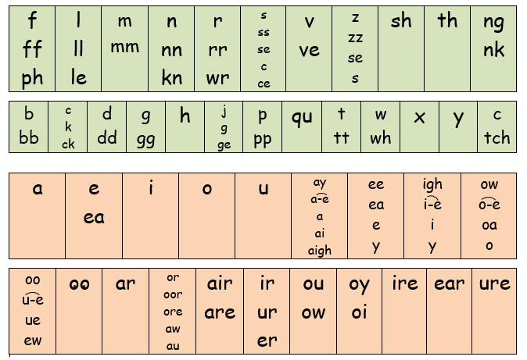
Practice reading the sound rhymes each day for both Set 2 and Set 3.

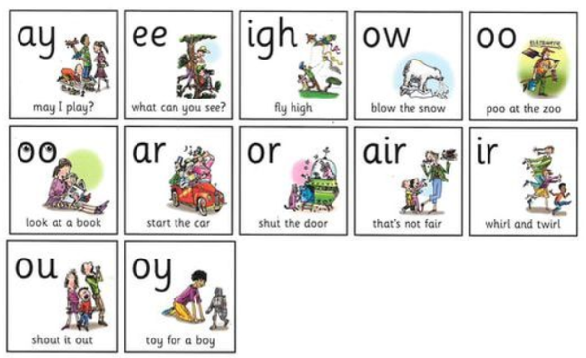
Set 2

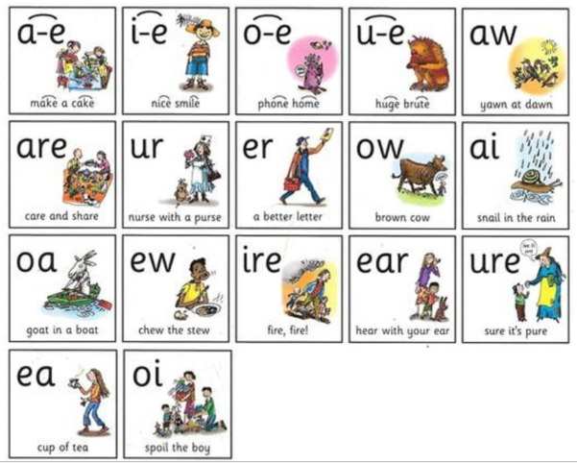
Set 3

Set 4
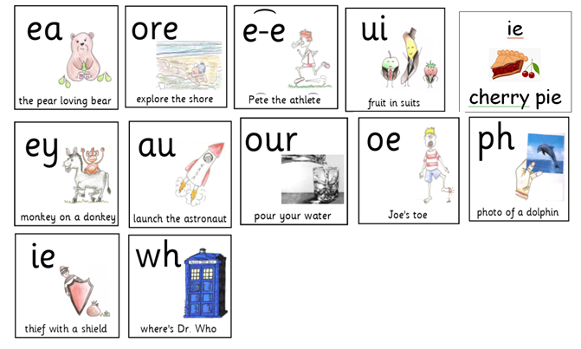

Monday
oe
Activity
Read this postcard and find all the oe words.
Can you write your own sentences with some of these words? 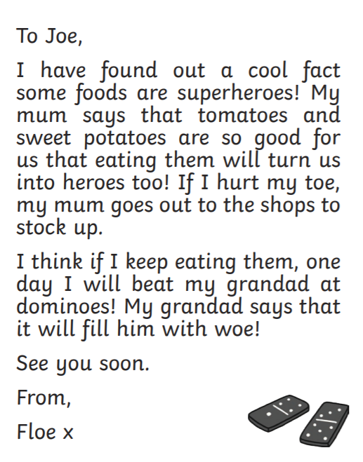

Tuesday
e_e
Activity
Read this postcard and find all the e_e words.
Can you write your own sentences with some of these words?

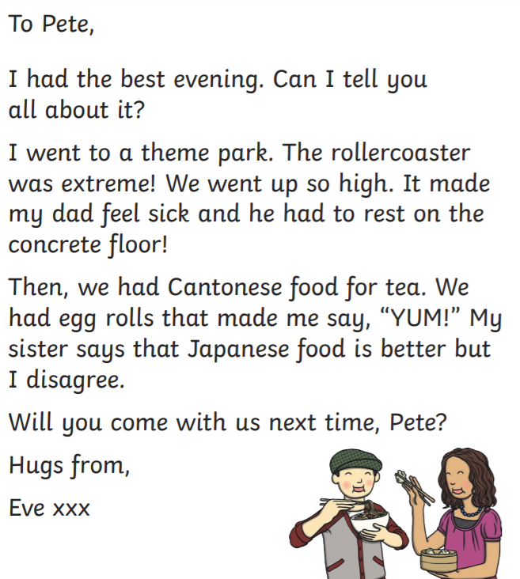

Wednesday

ey
Activity
Read this postcard and find all the ey words.
Can you write your own sentences with some of these words?
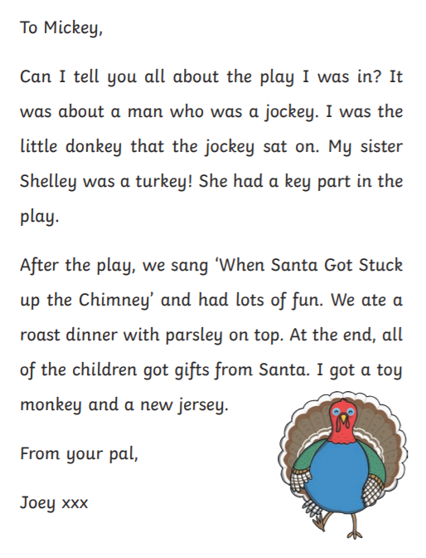

Thursday
ie
Activity
Read this postcard and find all the ie words.
Can you write your own sentences with some of these words?
Remember: ie can say cherry pie (igh sound)
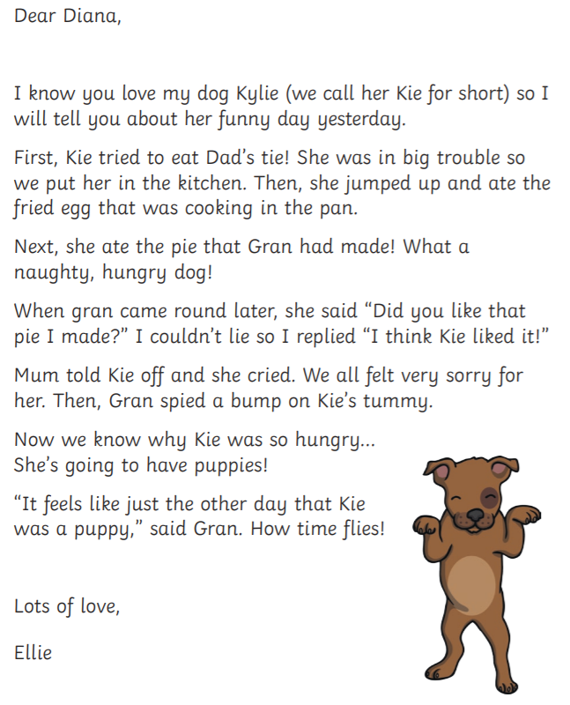
or ie can say thief with a shield (ee sound)

FUN FRIDAY!
Get Creative!
Find a picture that you like either by a famous artist or a book illustration or a photo
Can you write about it?
It could be a story/ newspaper/ poem/ fact file
Bonus!
Read about the illustrator/ artist

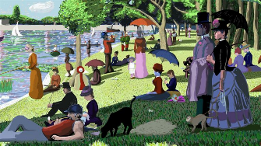

Story Time Ideas

- Year 1 love listening to stories. You can access free audio books from Audible (try ‘Littlest Listeners’)
https://stories.audible.com/discovery
- CBeebies Bedtime stories: Available on BBC iplayer or on television each day at 18:50

News for Parents

Go to youtube.com and search for RWI Phonics lessons at Home.

