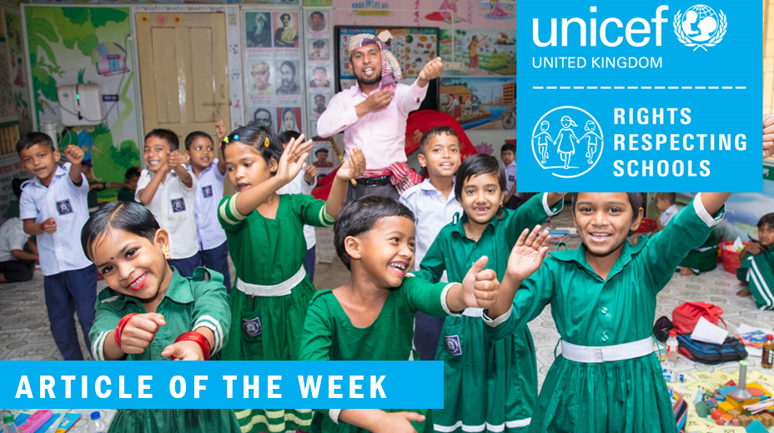
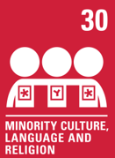

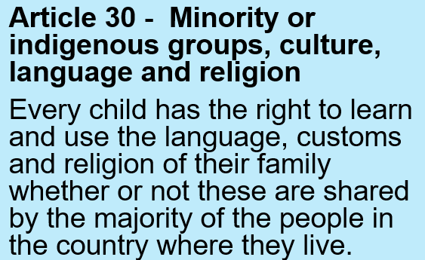

In your work books, write the date, title and draw the thought bubble. Write your ideas all around it.

Exploring Article 30
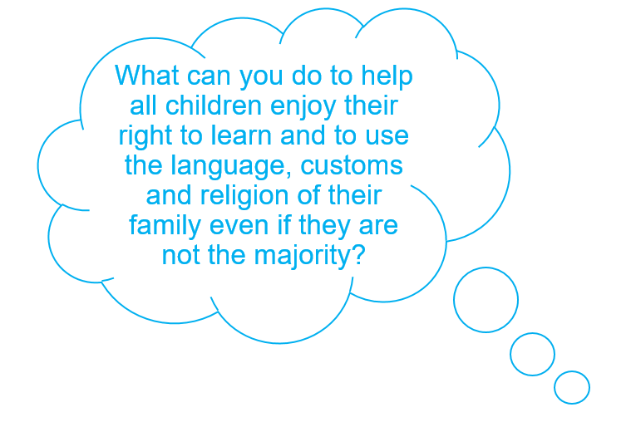

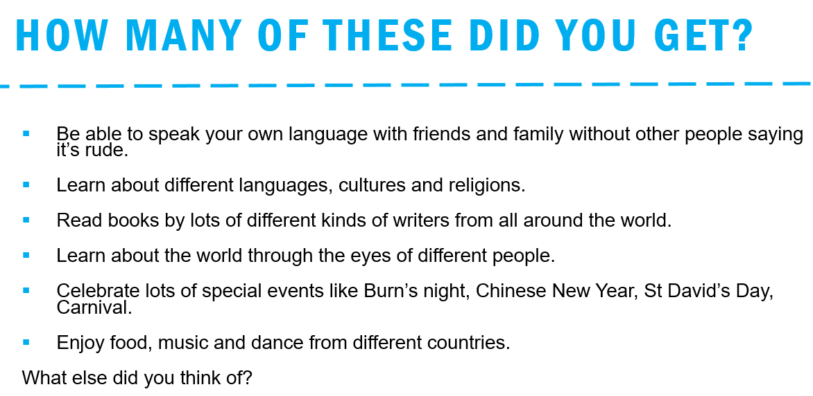

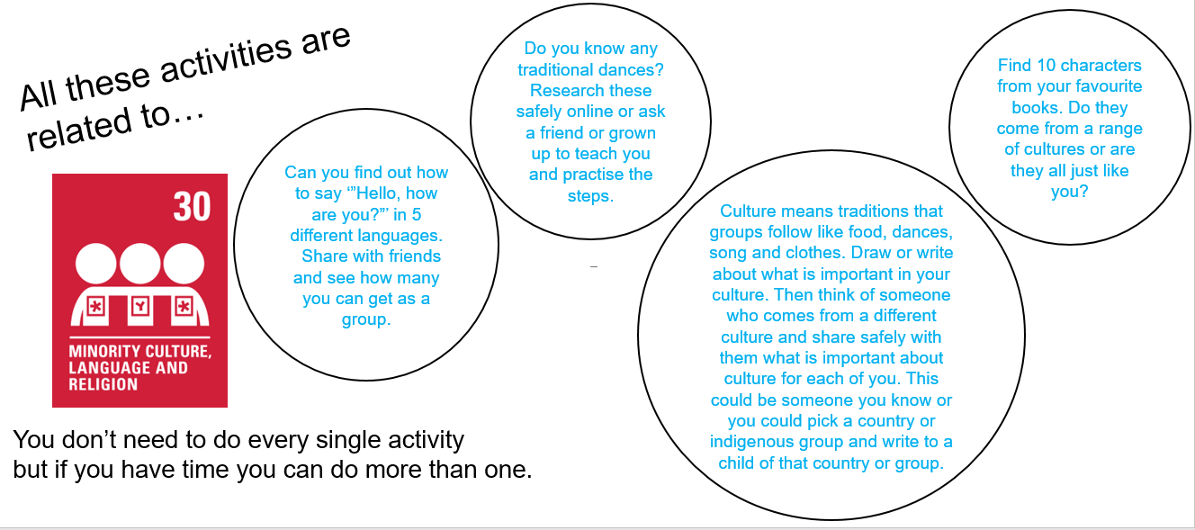

We love learning about you and your families at Alexandra. We celebrate differences and uniqueness and enjoy learning about different cultures, languages and religions.

#allinthistogether #teamalexandra

