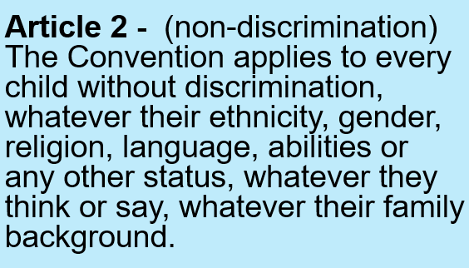

In your work books, write the date, title and draw the thought bubble. Write your ideas all around it.

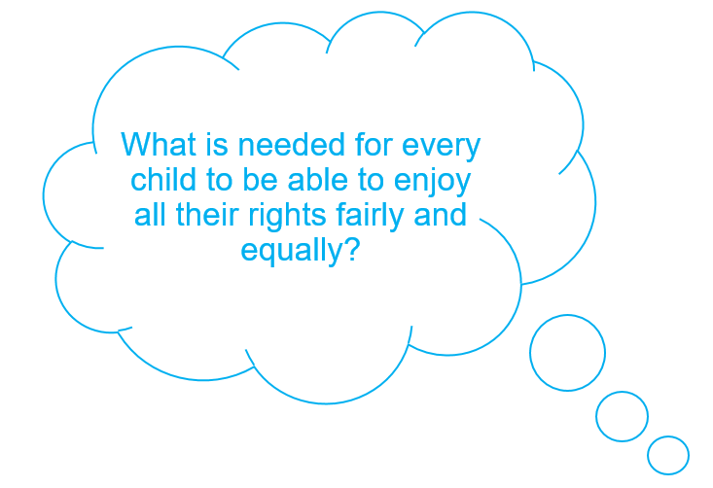
Exploring Article 2

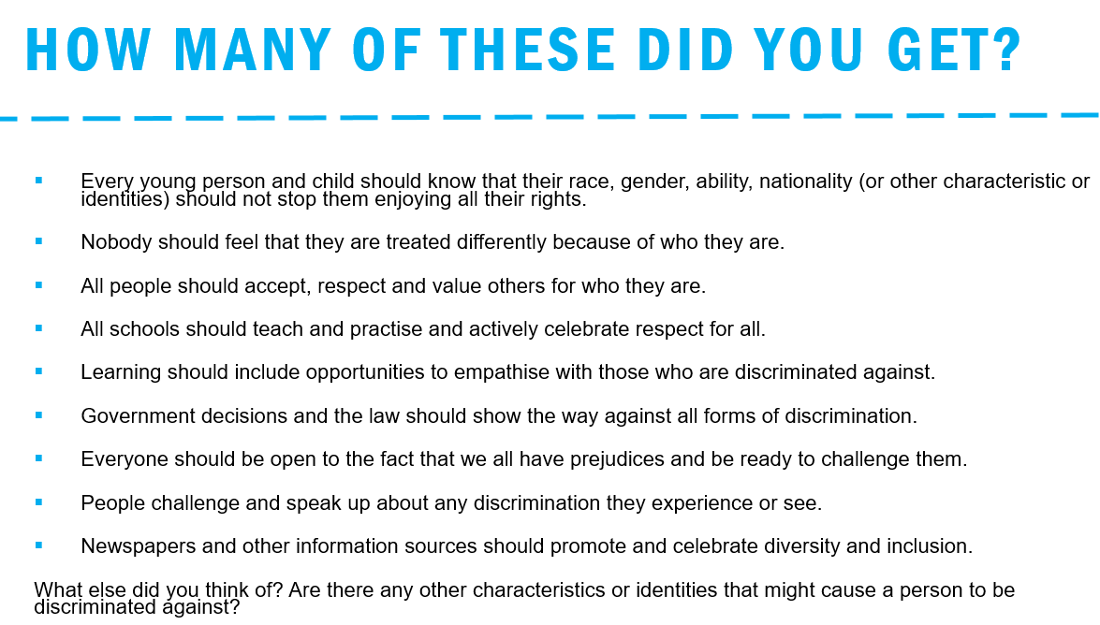

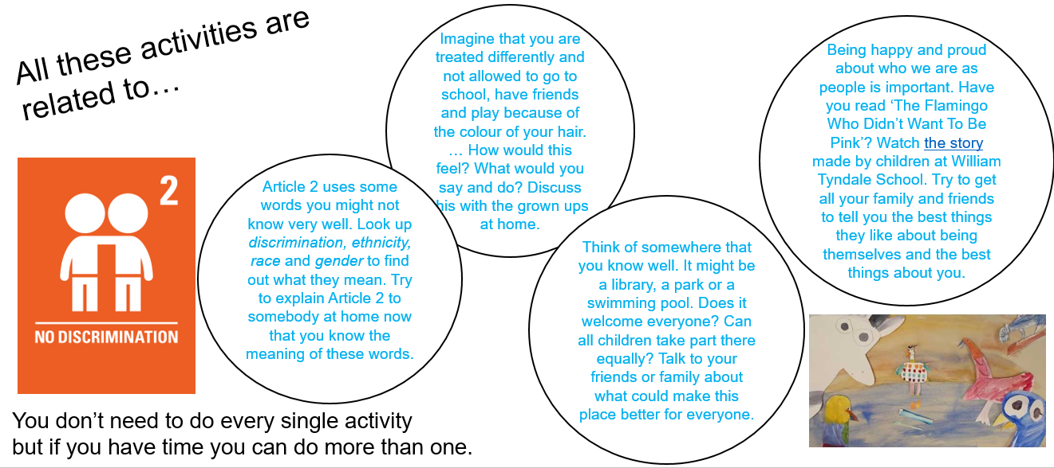

Discrimination of any kind is wrong and something we have zero tolerance for at Alexandra.
Don’t be a bystander. If you see or hear any kind of discrimination, what could you do about it?
How would you feel if you were discriminated against?
#allinthistogether #teamalexandra

