Science Summer 2 (wc 29th June 2020)
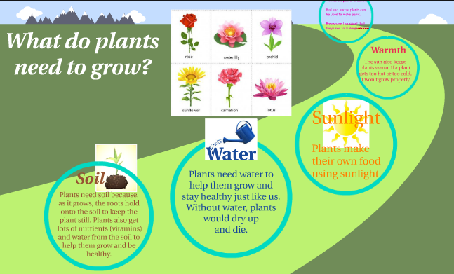
Recap from last lesson

Can you remember what plants need to grow well?

Watch this video. What five things do plants need to ensure they survive?

LO: To investigate and observe over time the way in which water is transported within plants by observing the transport of food colouring through a flower stem.
Vocabulary
roots
flower
stem
leaf or leaves
function
reproduction
light
air
water
nutrients
space
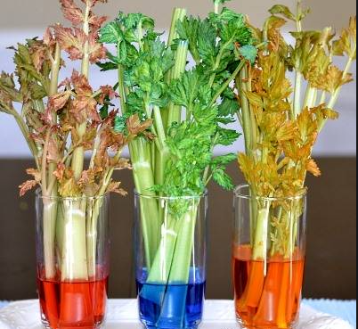

Success Criteria 1: I can make systematic and careful observations, taking accurate measurements using standard units
Watch this video: https://www.youtube.com/watch?v=KIug9Foou3s
How does water travel all the way up to the top?
Activity 1
In your own words can you write down a sentence to explain how water travels around the plant. Use a sentence starter like this:

The stem of a plant plays a big role in

Success Criteria 2: - I can explain the function of the stem.
Do plants survive if they do not have a stem? Explain your answer.
Watch this video: https://www.youtube.com/watch?v=Rz7zmSIvrtA
Activity 2
Can you make a prediction about what will happen to plants if the water did not go around plants. Use the sentence stem:
I predict that ____________________________________________

because _____

Success Criteria 3: I can write down my observations
Watch this video: https://www.youtube.com/watch?v=-pZ84vujdb4
What did you observe?
Activity 3
Write your observations and try to explain why these things happened. Use the sentence stem:

I observed that ___________________

I think this is because ______________

Challenge:
Could you set up an investigation at home? Ask the adult you live with. Experiment to see if the stem of your plant changes colour. Try to do something similar to what they do in the video.
Reflection
Do you think you are similar to plants? What things do you need to survive? Are they the same things that plants need? Write a list of the things you think you need to survive.
I think I need the following things to survive:

