Geography Summer 2 (wc 29th June 2020)
LO: To understand physical features.
Today, we will learn about different physical features of India.

Activity 1
Physical Features of India - Physical features in Geography are naturally occurring features, for example, a mountain.
Can you research each physical feature and write down two facts for each feature?

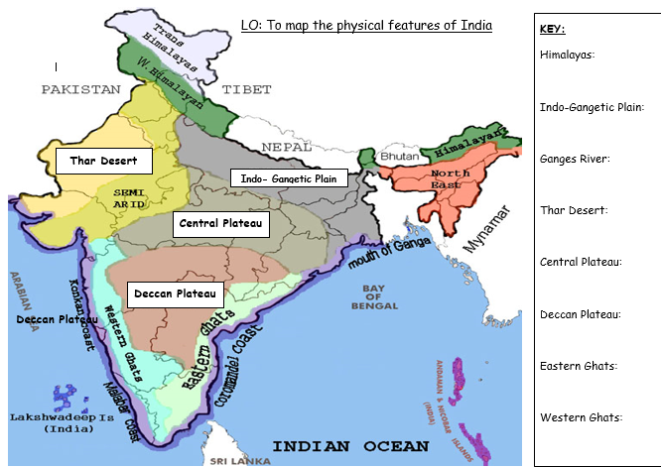
[Grab your reader’s attention with a great quote from the document or use this space to emphasize a key point. To place this text box anywhere on the page, just drag it.]

Activity 2
Human Features of India - Human features in Geography are something that is built by humans. Can you find out about five major human features in India?
Use this webpage to help you!
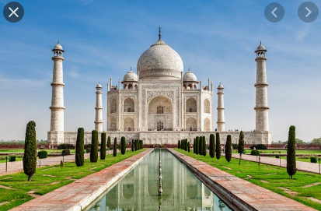
https://www.oddizzi.com/teachers/explore-the-world/country-close-up/case-study-india/india-landscape/human-features-2/

Activity 3
Have a go at drawing or building a 3D model one of the physical features of India.

Challenge
Can you draw a map of India and label the capital city?
Can you also draw some of the things you have just learned about from the video?

Reflection
If you visited India, where would you be most interested in visiting? Why?

