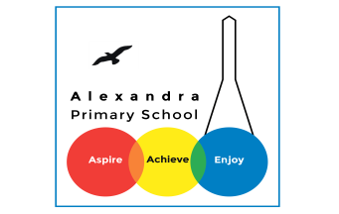
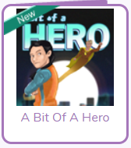
Year 5 Reading

Log in to your Purple Mash account. Visit the page for ‘A bit of a HERO’
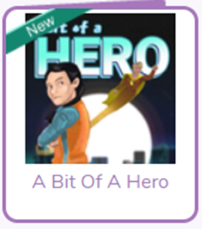
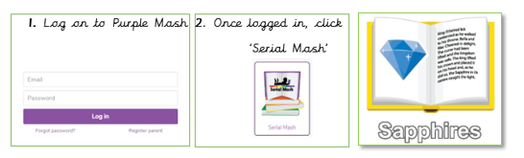

Monday 22nd June: Read Chapter 1 and complete Chapter 1 Quiz
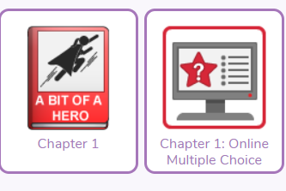

Challenge Question
(Answer these in your exercise books- write the date and the title of the text).
1. Look at the paragraph beginning: The sky-drone touched… Find and copy words and phrases that suggest the story is set in the future.
2. Look at the paragraph beginning: My name’s Beth… to the paragraph ending: …to see one. Why were sky-drones better for the environment than jet engines?
3. All around me, I could see the huge tower blocks rising into the sky. Each one was dripping with blossom-peppered foliage. What impression does the word dripping give you about the foliage?
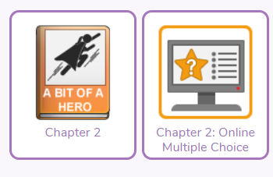
Tuesday 23rd June: Read Chapter 2 and complete the Chapter 2 quiz

Challenge questions
1. My arm had fused with the wall! It was as if I were a ghost and could pass through solid objects, but I had become stuck part way. Write down a synonym that could be used in place of fused in the sentence above.
2. Look at the paragraph beginning: I told my… to the paragraph ending: …designed my costume. Why didn’t Beth mind that it took her so long to pull herself free from the wall?
3. Look at the paragraph beginning: I went red… Why do you think Dad wouldn’t want to hear that Dave had bought Beth a bag?
Wednesday 24th June: Read Chapter 3 and complete the Chapter 3 quiz
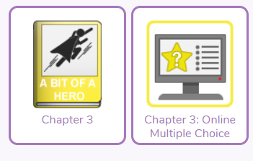

Challenge Questions
1. Before her, the robot dinosaur lifted one of its vast feet. Write down three synonyms that could be used for vast in the sentence above.
2. Look at the paragraph beginning: Andrea Rio pointed… to the paragraph ending: …on his chest. Why do you think Earth Man had an emblem of an earthworm on his chest?
3. Look at the paragraph beginning: As she grabbed… Why do you think the newsreader paused for so long before introducing the weather?
Thursday 25th June: Read Chapter 4 and complete the Chapter 4 quiz
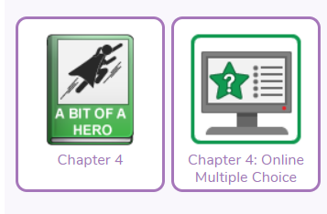

Challenge Questions
1. Look at the paragraph beginning: I threw both… Find and copy one word meaning the remains of a destroyed building.
2. Look at the paragraph beginning: “Your bag,” Dad… to the paragraph ending: …the balcony rail.” Why do you think Dad might have felt relieved to hear that the reason Beth had been holding the bag was because it had been stuck to her?
3. At which point during this chapter did Beth realise that being with her dad made her invincible?
Friday 26th June: Read Chapter (5) and complete the review.
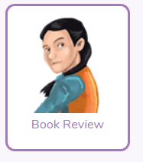
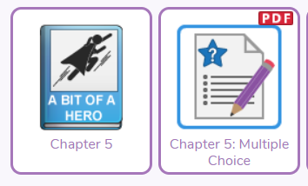

Challenge Questions
1. Look at the paragraph beginning: We should have… The author used the following simile: like being in a sky-drone that was caught in a hurricane. Write another simile to describe what it was like inside the moving beast.
2. Look at the paragraph beginning: Dad grabbed my… to the paragraph ending: …top of us. Why did Beth tip her head and scrunch her nose?
3. Look at the paragraph beginning: “Yes,” the creature replied… to the paragraph ending: …the planet ourselves. Why didn’t the creature know that humans had stopped harming their planet?

Daily Activity
You should be reading for at least 30 minutes daily.
If you cannot access Purple Mash, choose a book of your own and use your Destination Reader stems to record your thoughts in your Exercise books. This should be done each day.

Date:26.06.2020
Name of Book:
Prediction: I wonder if…
Inference: The word __ tells me…
Summary: The key idea is…

Daily Activity
You should be reading for at least 30 minutes daily.
If you cannot access Purple Mash, choose a book of your own and use your Destination Reader stems to record your thoughts in your Exercise books. This should be done each day.

Date: 20.04.2020
Name of Book:
Prediction: I wonder if…
Inference: The word __ tells me…
Summary: The key idea is…

Fun Activity of the Week

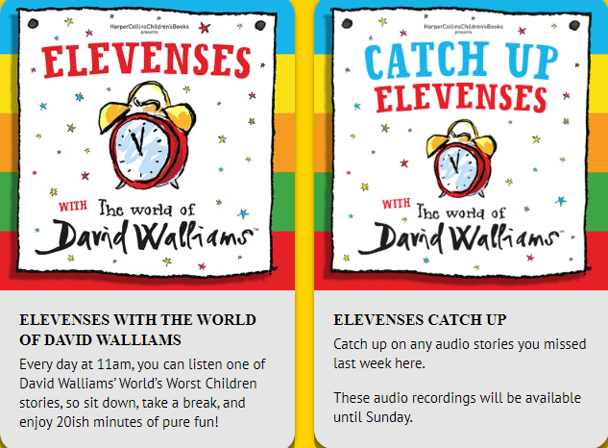
www.worldofdavidwalliams.com

Story Time Ideas

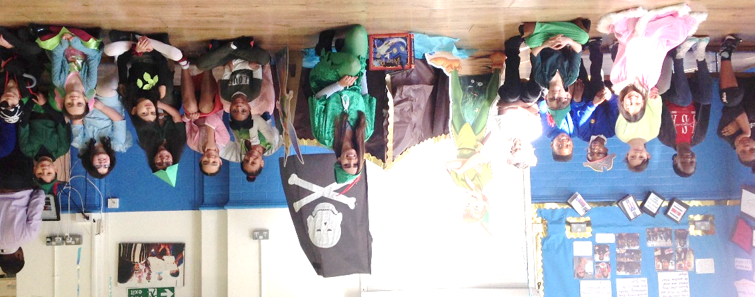
Story Time Ideas

Audiobooks and eBooks are available to borrow for free from Hackney library, using these apps; Overdrive and Borrowbox. You will need to download these apps to a tablet, phone or computer. To use these apps, you will need a library card number from any London library. If you are not a member of the library, you can join for free here: https://hackney.gov.uk/libraries#join. You won’t need to go into the library to provide proof of address as you normally would, but can do everything online
There are also a lot of websites where you can watch authors read their
books for free:
- Storytime Online has hundreds of videos: Click here to view

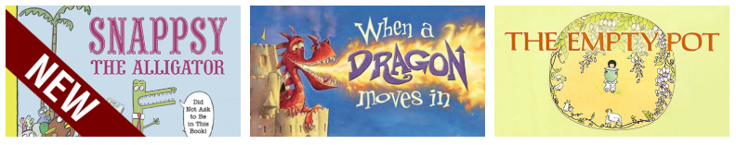

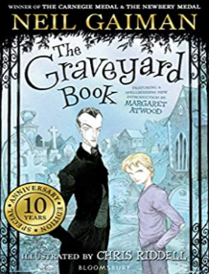
- For a challenge, Neil Gaiman has posted videos of himself reading his award-winning books The Graveyard Book and Coraline. You could read listen to a chapter a day! Click here to view

- https://www.getepic.com
Select, “Have an account? Log in” then click “Students and Educators”. Log in with your class code: mxy1661

