Home learning Summer Term Year 5 w/c 29. 06.2020

Geography- Trade Routes

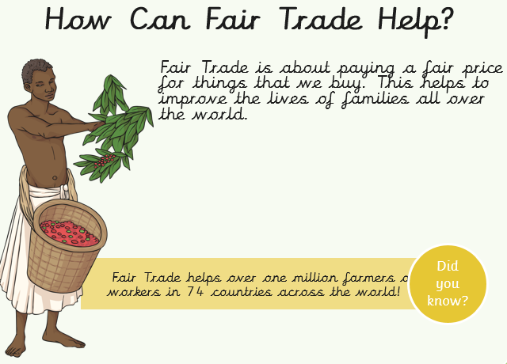
Recap: Last week, we learned about Fair Trade chocolate. Our focus continent is Africa.

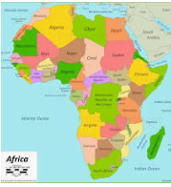

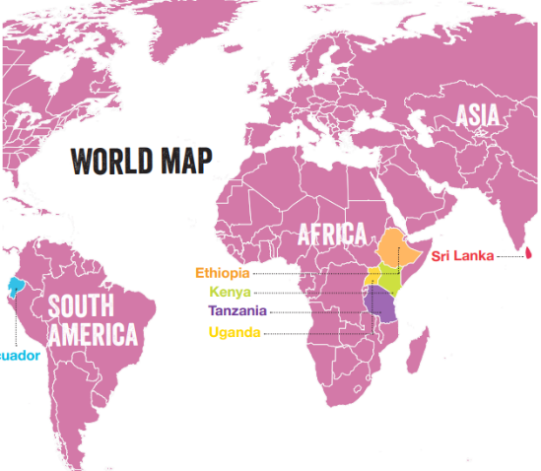
Almost all Fairtrade flowers come from East African countries including Kenya, Ethiopia, Tanzania, and Uganda. You can also find Fairtrade flower farms in Ecuador and Sri Lanka. 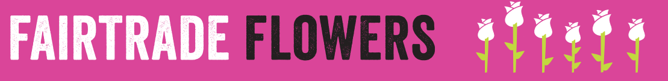

Task 1: Read all about Fairtrade flowers below.
Working on a Fairtrade certified flower farm has many benefits! Fairtrade have set a minimum wage for flower workers, which means they cannot be paid below a certain amount. The workers also receive a Fairtrade Premium for every flower stem they sell. This is an extra amount of money that can be used to benefit the whole community. The workers decide together what to spend the money on.

Grace works on a Fairtrade certified flower farm in Kenya. Grace and her community have used the Fairtrade Premium for buying medicine, school fees for the children, and cookers for their homes

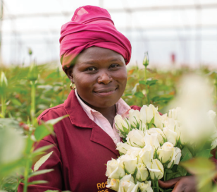

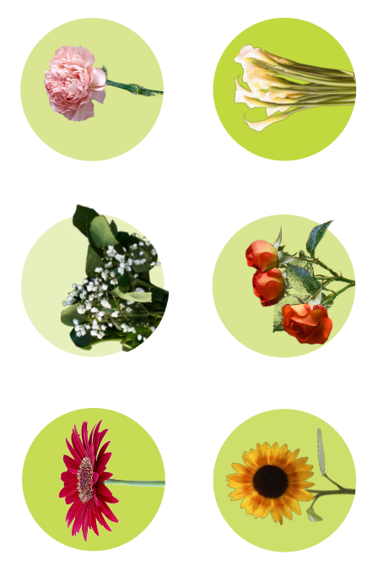
Task 2. Here are 6 types of Fairtrade flowers. Can you name them all?

Task 3: Answer the questions below.
1. How many flowers workers benefit from Fairtrade?
2. Name 4 countries in East Africa where you can find Fairtrade flowers.
3. What is the Fairtrade minimum wage for flower farmers?
4. How do the Fairtrade Standards help to protect the environment?
5. Which country produces less greenhouse gas emissions from the production of roses?
- □ Netherlands
- □ Kenya
6. Research about different types of Fairtrade flowers. Draw and label three types of Fairtrade flower

