Home learning Summer Term Year 5 w/c 22nd.06.2020

Geography- Trade Routes

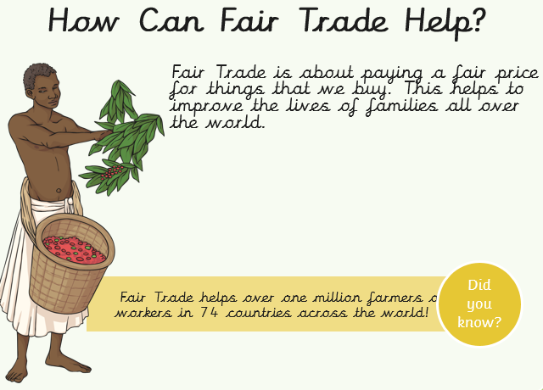
Recap: Last week, we learned what Fair Trade means. Our focus continent is Africa.

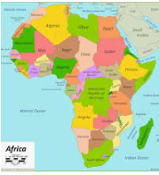

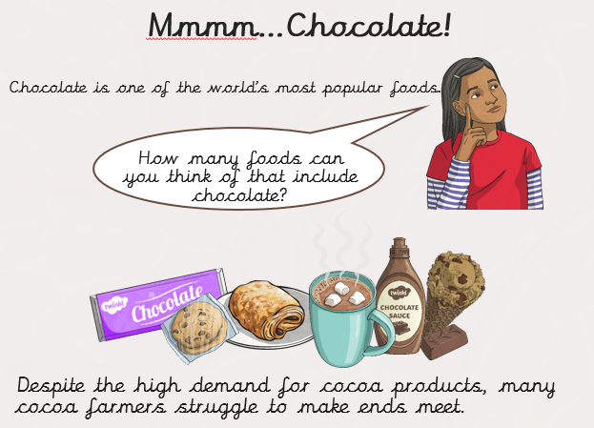
So where is cocoa grown?
6 million farmers on small family farms grow 90% of all cocoa. These farms are located in tropical climates, within 15 and 20 degrees. The hot, rainy climate favours lush vegetation, which gives shade to the cocoa trees and creates perfect growing conditions.
Task 1 Can you find 10 items in your house that have the Fair Trade logo on. Write out what the item is and where it comes from.

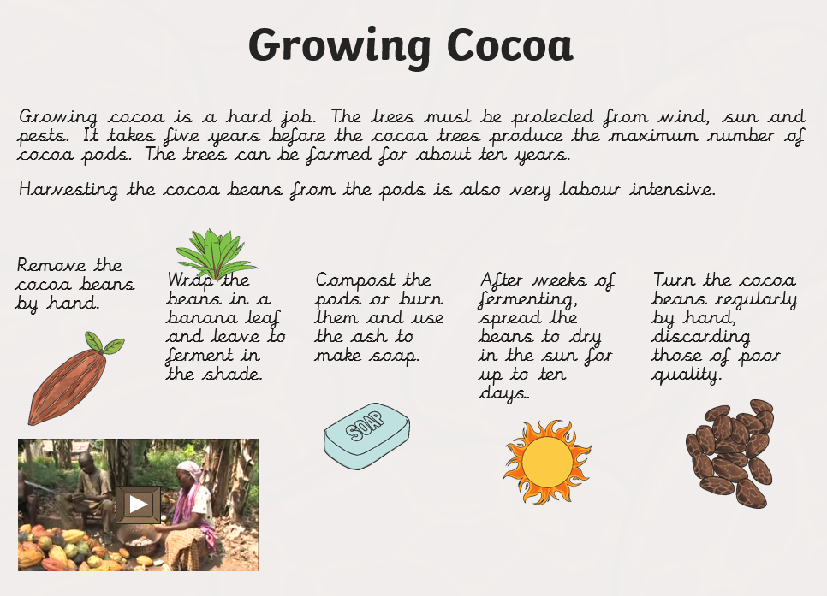
This is the process workers go through in Ghana in order to grow cocoa.

Task 2: Answer the following questions
1. How many bananas sold in the UK are Fairtrade? Tick one.
- two in three
- all of them
- one in three

2. Why is it important to buy Fairtrade products? Explain in your own words.
3. What does Fairtrade guarantee for cocoa bean farmers in Africa?
4. Farmers cannot make money unless… Tick one.
- they are given things for free.
- they are given a fair price.
- they are given lots of money.
Task 3: Persuasive speech
Write a persuasive speech about why we should buy products that are Fair Trade only.
Key words:
Bananas Cocoa Farmers Fair Trade equality products

