Year 4 Reading: Alien Street by Danny Pearson

Log in to your Purple Mash account. Visit the page for Animal Boy. If you have trouble signing in, you can access the PDF text if you click here https://www.purplemash.com/mashcontent/applications/serialmash/alien_street_ch1/ch1/alien_street_ch1.pdf
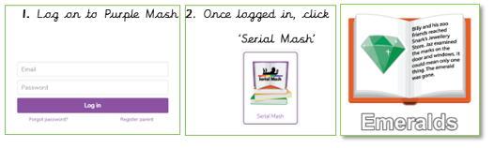

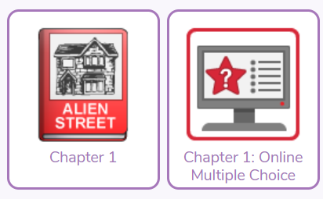
Monday 29th June : Read Chapter 1 and complete Chapter 1 Quiz
Challenge
Lucy felt frustrated; she did not want to move to a new house.
Write about a time when you have felt frustrated.

Tuesday 30th June : Read Chapter 2 and complete the Chapter 2 quiz
Challenge
Be like a detective and search through the first two chapters for information about Lucy.
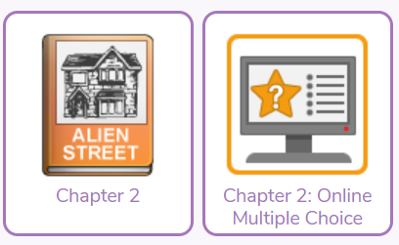

Wednesday 01st July: Read Chapter 3 and complete the Chapter 3 quiz
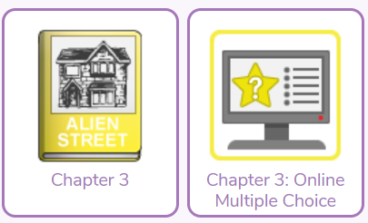
Challenge
What evidence will Ash show Lucy?
Write the next part of their conversation.

Thursday 02nd June: Read Chapter 4 and complete the Chapter 4 quiz
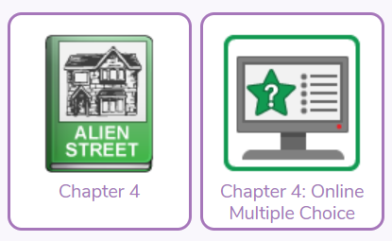
Challenge
Create an annotated diagram to describe Ash.

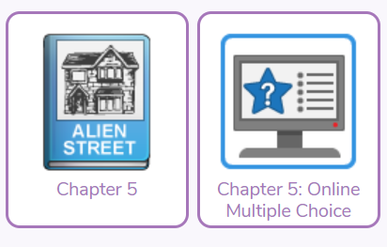
Friday 03rd June: Read Chapter 5 and complete the chapter 5 quiz
Challenge
A beam of light was shining in the children’s faces. Write the next part of the story.

A big wide world
Choose a country/ city in the world. Find out information about it and then make a leaflet/ non-fiction book. Think about buildings, people, places, life e.g. food etc.
Bonus!
Could you find out about a country in EVERY continent! You could use your information to write a story set in that country!

Daily Activity
You should be reading for at least 30 minutes daily.
If you cannot access Purple Mash, choose a book of your own and use your Destination Reader stems to record your thoughts in your
Name of Book:
Prediction: I wonder if…
Inference: The word __ tells me…
Summary: The key idea is…

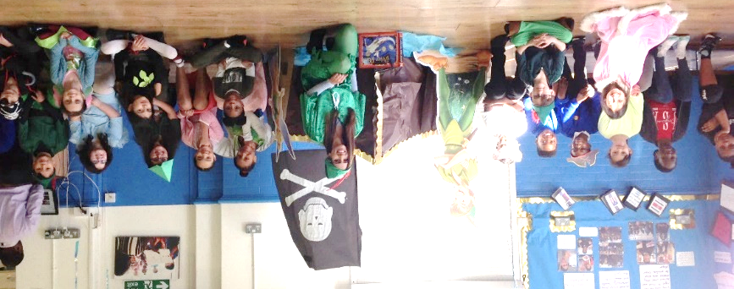

www.worldofdavidwalliams.com
Story Time Ideas

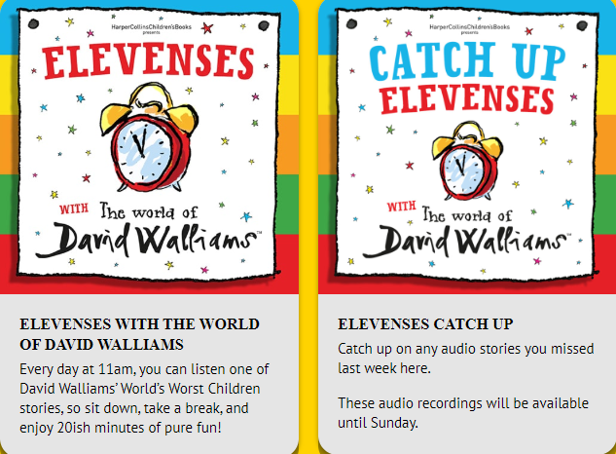

Audiobooks and eBooks are available to borrow for free from Hackney library, using these apps; Overdrive and Borrowbox. You will need to download these apps to a tablet, phone or computer. To use these apps, you will need a library card number from any London library. If you are not a member of the library, you can join for free here: https://hackney.gov.uk/libraries#join. You won’t need to go into the library to provide proof of address as you normally would, but can do everything online
There are also a lot of websites where you can watch authors read their
books for free:
- Storytime Online has hundreds of videos: Click here to view
- For a challenge, Neil Gaiman has posted videos of himself reading his award-winning books The Graveyard Book and Coraline. You could read listen to a chapter a day! Click here to view
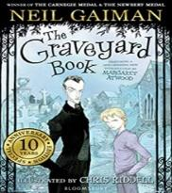
- https://www.getepic.com

