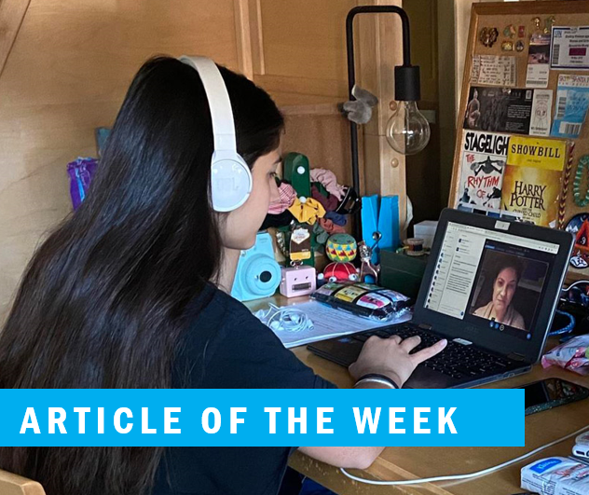

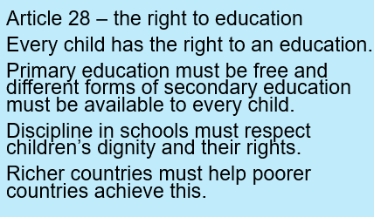

In your work books, write the date, title and draw the thought bubble. Write your ideas all around it.

Why is the right to education important?
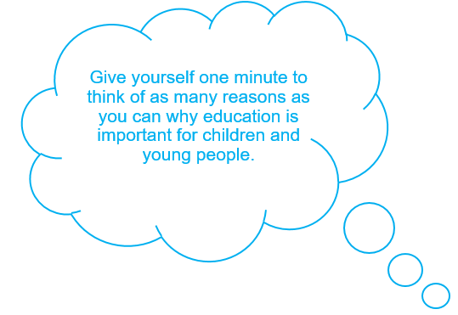

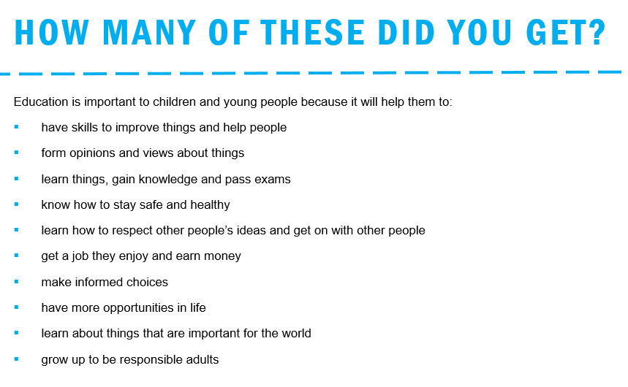

You can choose one activity or do all of them (if you would like to) in your work book.
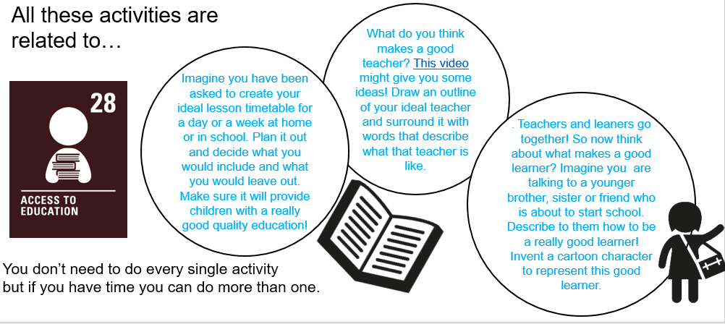

This article is really important right now, the way we are being educated is different. You have to be more self-motivated and a good self-manager and that’s difficult at times.

#weareinthistogether
#pushyourself

