Home learning: Maths – Summer 2 Week 5 – Week Beg: 29.06.2020
Below are some activities you can use when learning at home.

Monday – Identifying Angles

Red
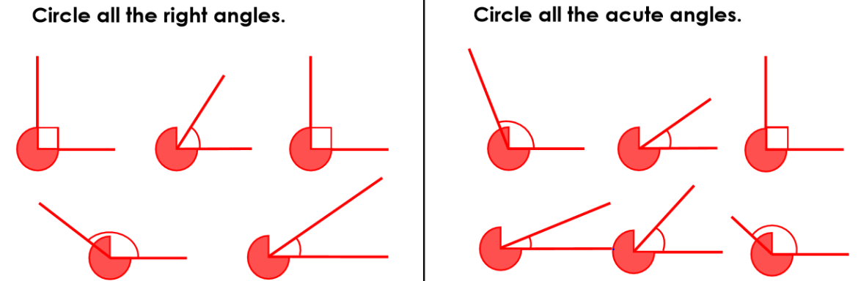

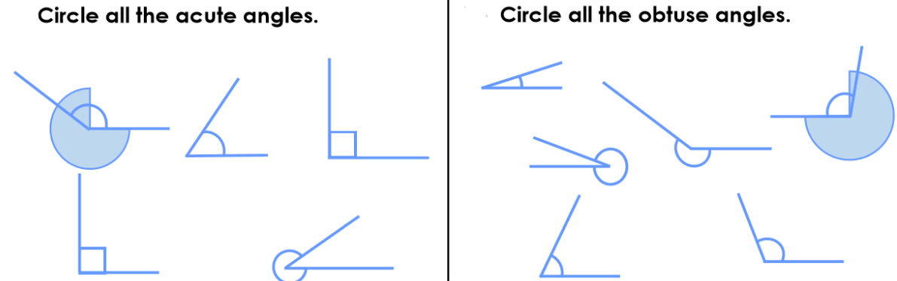
Orange

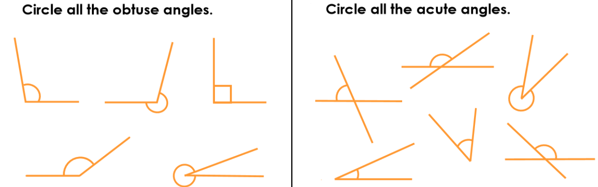
Green

Reasoning & Problem Solving:
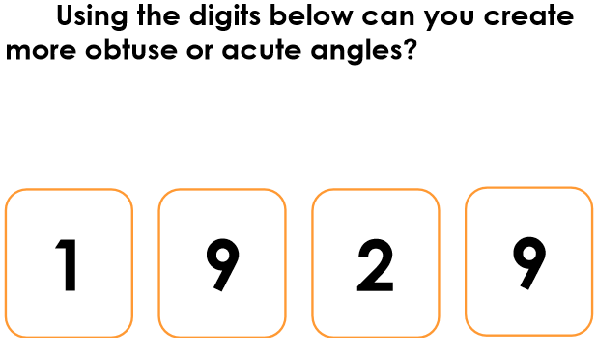

Tuesday –Compare & Order Angles
Red:
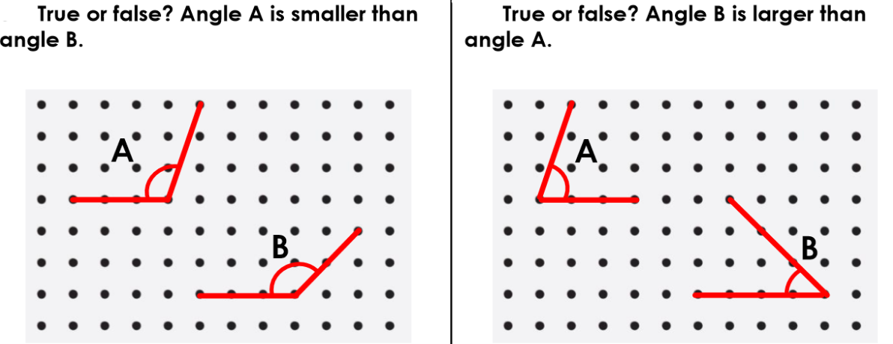

Orange:
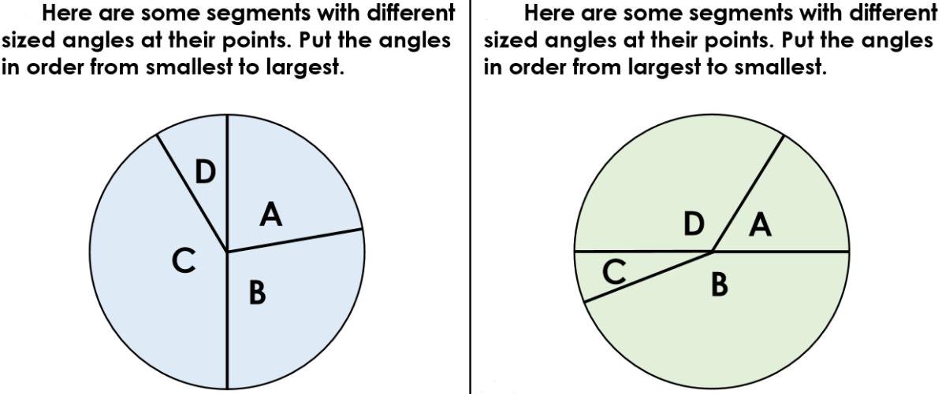

Green:
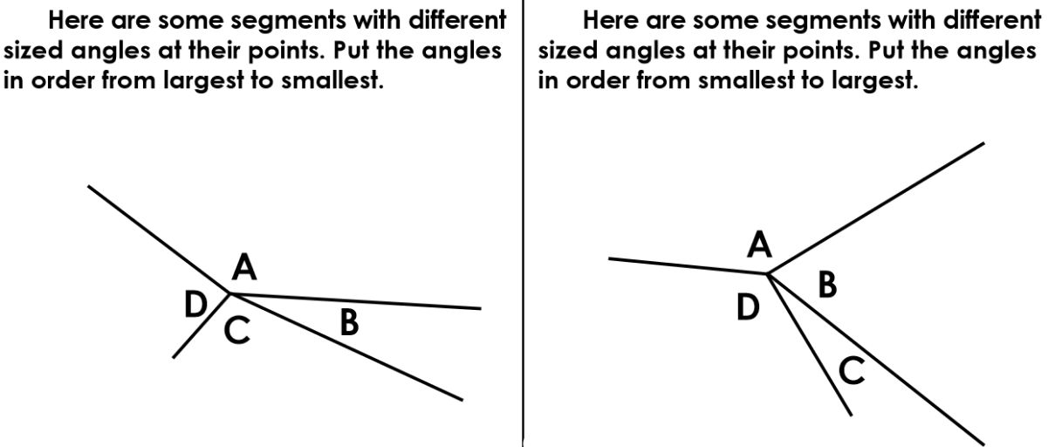

Reasoning & Problem Solving:
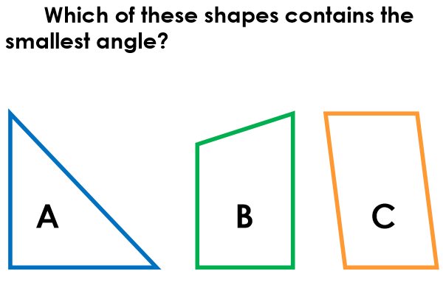

Wednesday- Triangles

Red:
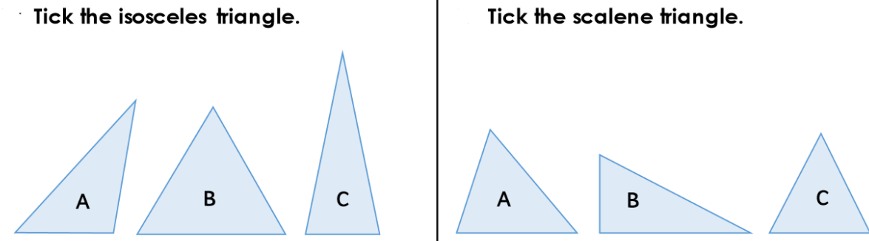

Orange:
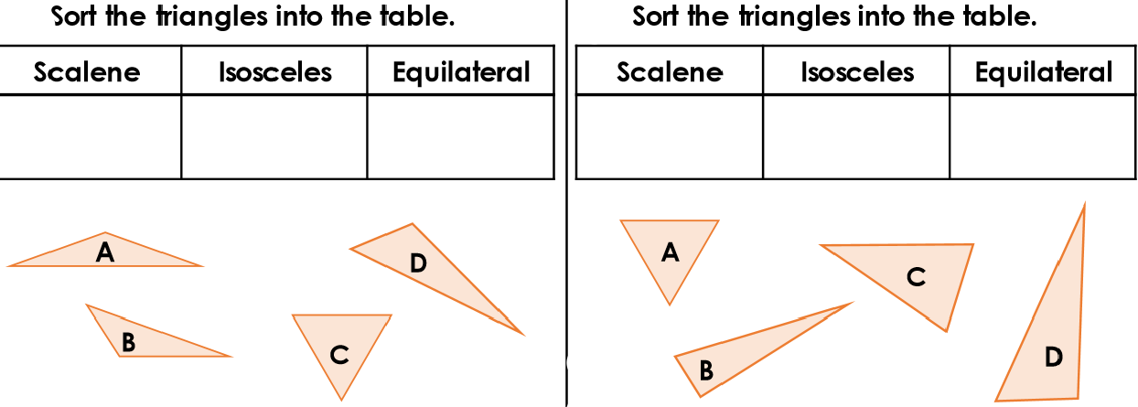

Green:
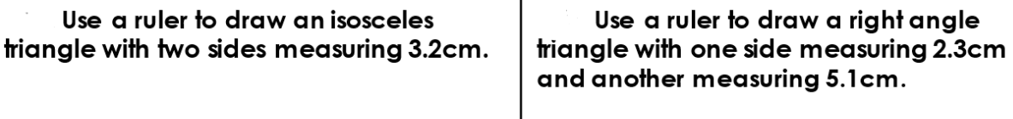

Reasoning & Problem Solving:
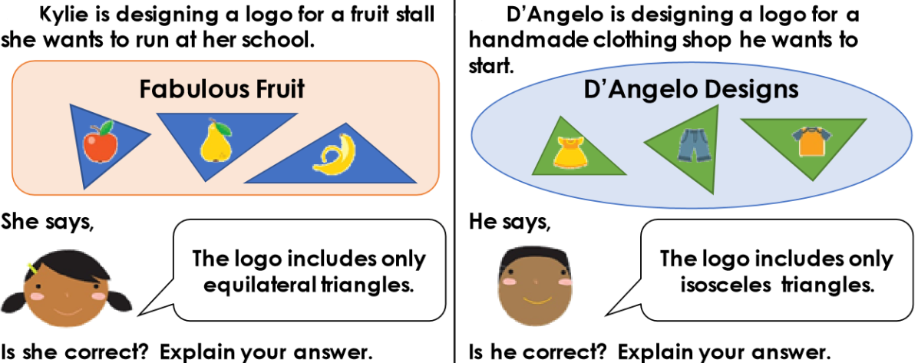

Thursday-Quadrilaterals

Red:
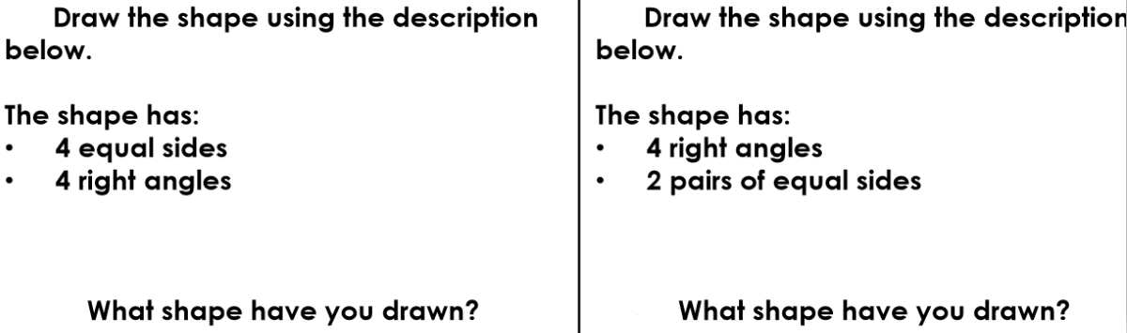

Orange:
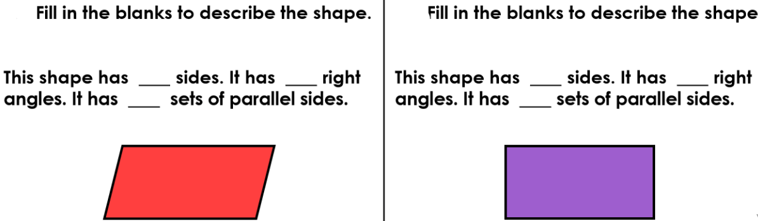

Green:
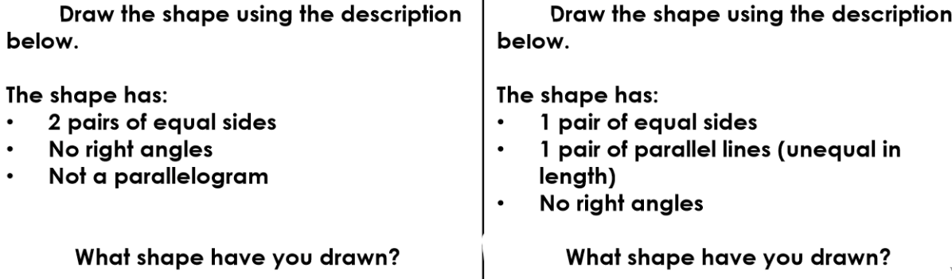

Reasoning & Problem Solving:
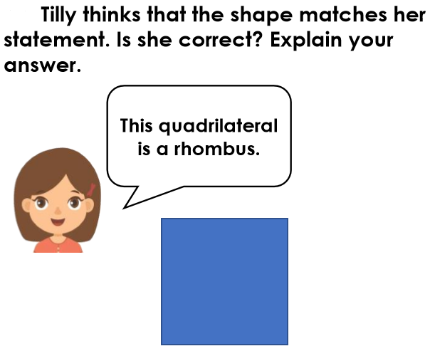

Friday –Lines of Symmetry

Red:
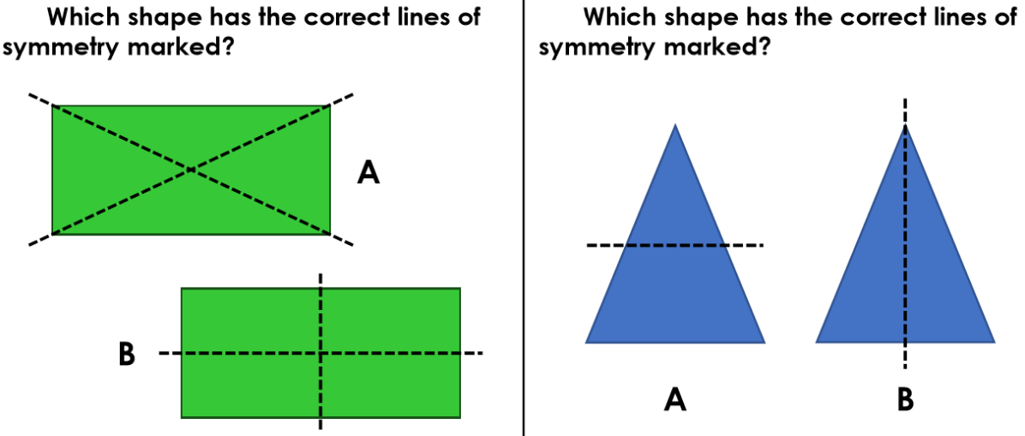

Orange:
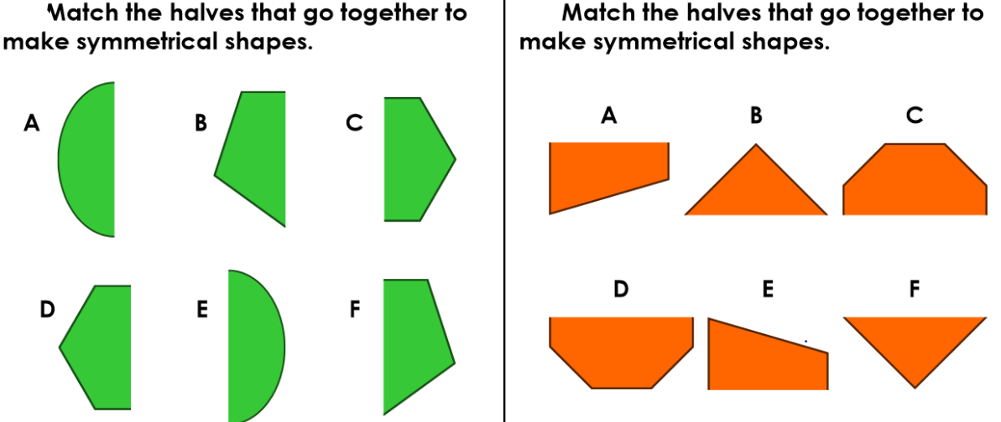

Green:
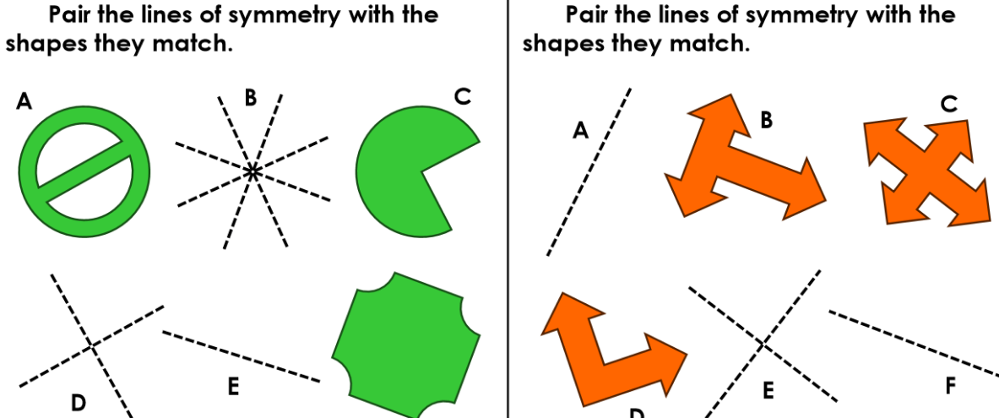

Reasoning & Problem Solving:
