W/C: 15.06.2020
Log in to purple mash where you have 2 maths tasks to complete (Division – whole number and Division with remainders) and also a game (Dividers) to have a go at.
Log in to Rockstars and test yourself on the 7 times tables. Below is also a paper version.
Use the inverse to answer these:
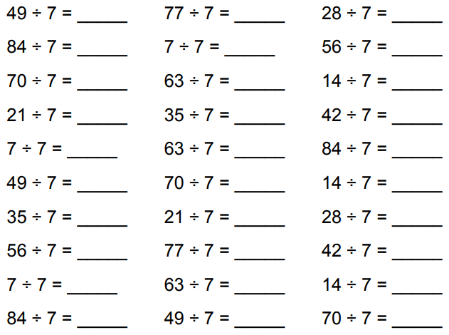
Monday 15th June 2020
Dividing by powers of 10.
Use the video and P.V grid on your class stream to help you solve the following.
Red:
1). 50 ÷ 10 = 2). 90 ÷ 10 = 3). 75 ÷ 10 =
4). 300 ÷ 100 = 5). 875 ÷ 100 =

Orange:
1). 700 ÷ 100 = 2). 284 ÷ 100 = 3). 9,283 ÷ 1,000 =
4). 436.2 ÷ 1,000 = 5). 1,507.04 ÷ 10,000 =

Green:
1). 873 ÷ 100 = 2). 7219 ÷ 1,000 = 3). 105.7 ÷ 1,000 =
4). 437,825 ÷ 10,000 = 5). 4,263 ÷ 100,000 =

Challenge:
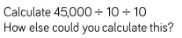

Tuesday 16th June 2020
Short division (bus stop method)
Watch the video on your class stream to help you solve the following.
Red:
1). 44 ÷ 4 = 2). 66 ÷ 3 = 3). 10 ÷ 5 = 4). 246 ÷ 2 = 5). 700 ÷ 70 =
Orange:
1). 312 ÷ 3 = 2). 217 ÷ 7 = 3). 2,408 ÷ 8 =
4). 3,645 ÷ 9 = 5). 9,684 ÷ 4 =

Green:
1). 2,016 ÷ 4 = 2). 3,018 ÷ 6 = 3). 9,114 ÷ 7 =
4). 1,072 ÷ 8 = 5). 19,359 ÷ 9 =

Challenge:

Wednesday 17th June 2020
Task 3: Multiplying with remainders
Watch the video on your class stream to help you solve the following.
Red:
1). 25 ÷ 2 = 2). 87 ÷ 4 = 3). 156 ÷ 5 = 4). 628 ÷ 6 = 5). 131 ÷ 2 =

Orange:
1). 314 ÷ 3 = 2) 1,647 ÷ 4 = 3). 1,468 ÷ 3 =
4). 6,321 ÷ 6 = 5). 3,652 ÷ 7 =
Green:
1). 5,269 ÷ 9 = 2) 3,165 ÷ 4 = 3). 5,256 ÷ 7 =
4). 3,667 ÷ 8 = 5). 23,924 ÷ 3 =

Challenge:
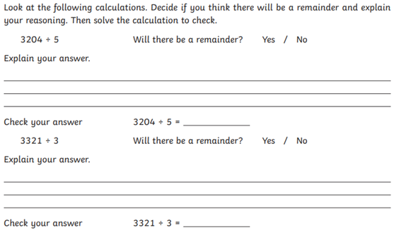

Thursday 18th June 2020
Scaling by fractions
Watch the video on your class stream to help you solve the following.
Red:
1). 2⁄7 of 70 = 2). 2⁄3 of 90 = 3). 4⁄10 of 200 = 4). 1⁄2 of 70 = 5). 3⁄4 of 60 =

Orange:
1). 3⁄6 of 360 = 2) 2⁄3 of 42 = 3). 4⁄12 of 168 = 4). 3⁄4 of 500 = 5). 3⁄6 of 3,600 =
Green:
1). 6⁄7 of 175 = 2) 2⁄3 of 195 = 3). 2⁄6 of 504 =
4). 5⁄6 of 2,658 = 5). 7⁄9 of 8,721 =

Challenge:
Explain 2 methods you could use to solve the following question:
7⁄14 of 1400

Friday 19th June 2020
Division worded questions
Watch the video on your class stream to help you solve the following.
Red
- A teacher asks some children to arrange 36 chairs into rows of three chairs. How many rows will there be?
- A crate holds 24 bottles. How many packs of 2 bottles will be in each crate?
- A photographer prints 84 photographs to arrange in an album. Each page will contain 4 photographs. How many pages will be used?
- Apples are sold in packs of five apples. How many packs can be made from 105 apples?
- A large pack of 132 marbles is shared equally into 12 bags. How many marbles will there be in each bag?

Orange:
- There are 68 tennis balls in a tub. The tennis balls are organised into sets of four tennis balls. How many sets will there be?
- A teacher has 2 boxes of pencils. One has 173 pencils and the other 149 pencils. He puts the pencils together and shares them equally into 7 pots. How many pencils will there be in each pot?
- Bananas are sold in packs of 5. How many complete packs of five bananas can be made from 136 bananas?
- A local charity has 3 fundraising events. The events raise £176, £81 and £309 each. After costs of £92 are deducted, the money is shared equally among 3 local children’s group. How much does each group receive?
- A child has a collection of football cards. They have 107 cards and are given another 58 more. They then decide to share the cards equally between 7 of their friends. How many cards does each friend receive?

Green:
1). How many carriages on a train are needed to carry 530 people when the carriages carry 22 people each?
2). 614 people are sorted into teams of 18 for a competition. How many teams are there?
3). 725 cocktails sausages are bought for a school disco. 32 are put onto each plate. How many plates are needed?
4). Discount vouchers come in sheets of 27. How many sheets are needed for 824 vouchers?
5). 196 adults and 15 children went to a wedding. Coaches seat 57 people. How many coaches were needed?

Challenge:
