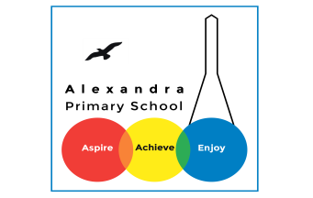**Science Home Learning**

This term is based on: **Electricity!!!**

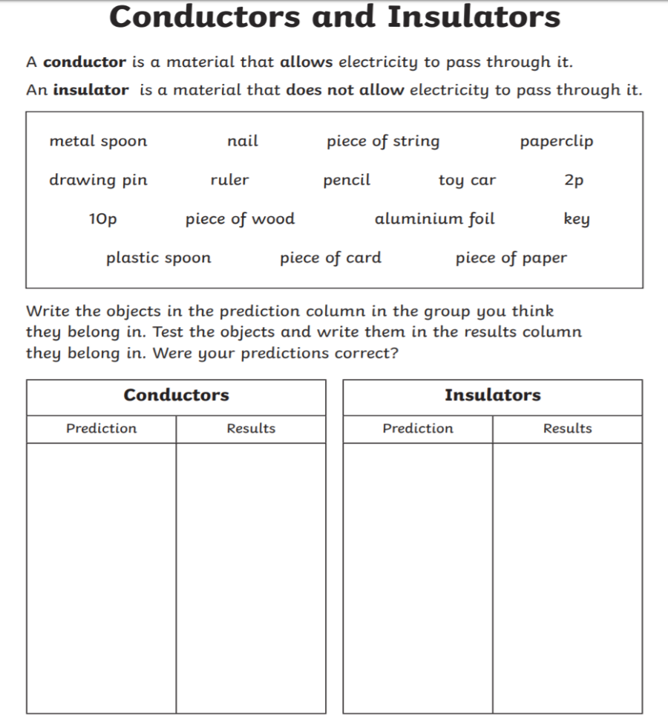

**Activity 1:**

**Watch the video and answer the questions below.**

<https://www.bbc.co.uk/bitesize/topics/z2882hv/articles/zcwnv9q>

What is power?

<https://www.bbc.co.uk/bitesize/topics/z2882hv/articles/zxv482p>

What are conductors and insulators? Are they dangerous?

**Activity 2 :**

Make predictions on all the items on whether you think they are conductors or insulators. Then research or test them to see if your results match your prediction.

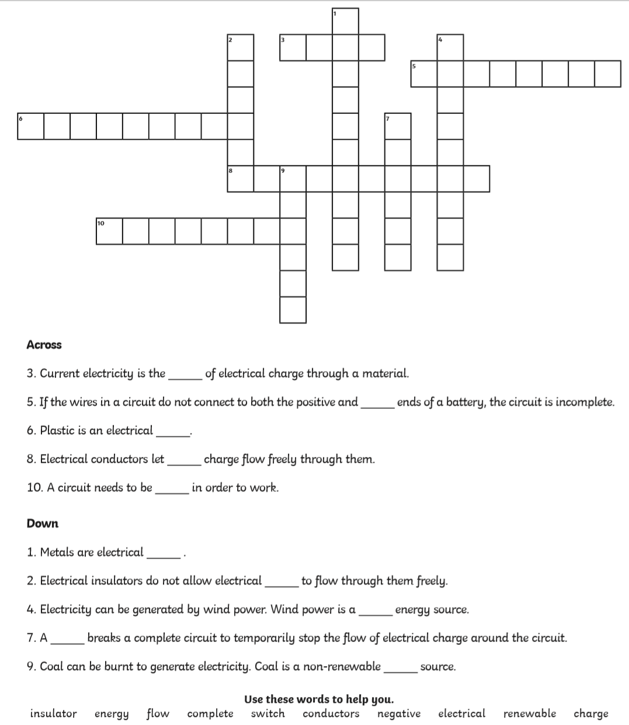

**Activity 3**

**Draw your own version of this cross word and complete the electricity word search.**

Use these words to support you:

* **Insulator**
* **Energy**
* **Flow**
* **Complete**
* **Switch**
* **Conductors**
* **Negative**
* **Electrical**
* **Renewable**
* **Charge**

