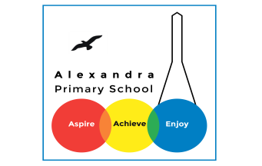**Geography Home Learning**

This term is based on: **Biomes and Vegetation Belts!**

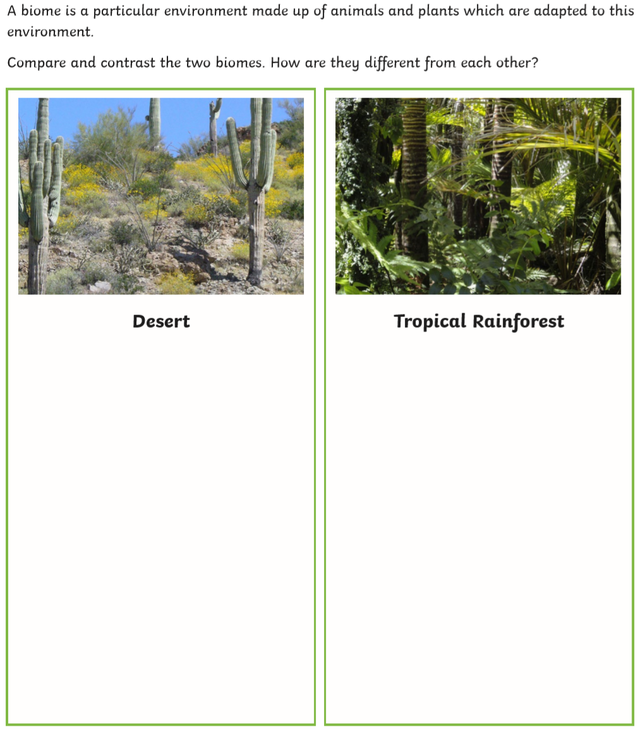

**Activity 1:**

Watch the video and come up with

5 key enquiry questions.

<https://www.youtube.com/watch?v=VExt_o7uM_c>

What?

Where?

How?

Which?

Why?

**Activity 2:**

Compare and contrast the two biomes. How are there characteristics similar or different to each other?

**Activity 3:**

Draw your own world map and name and locate different biomes around the world using a colour coded key.

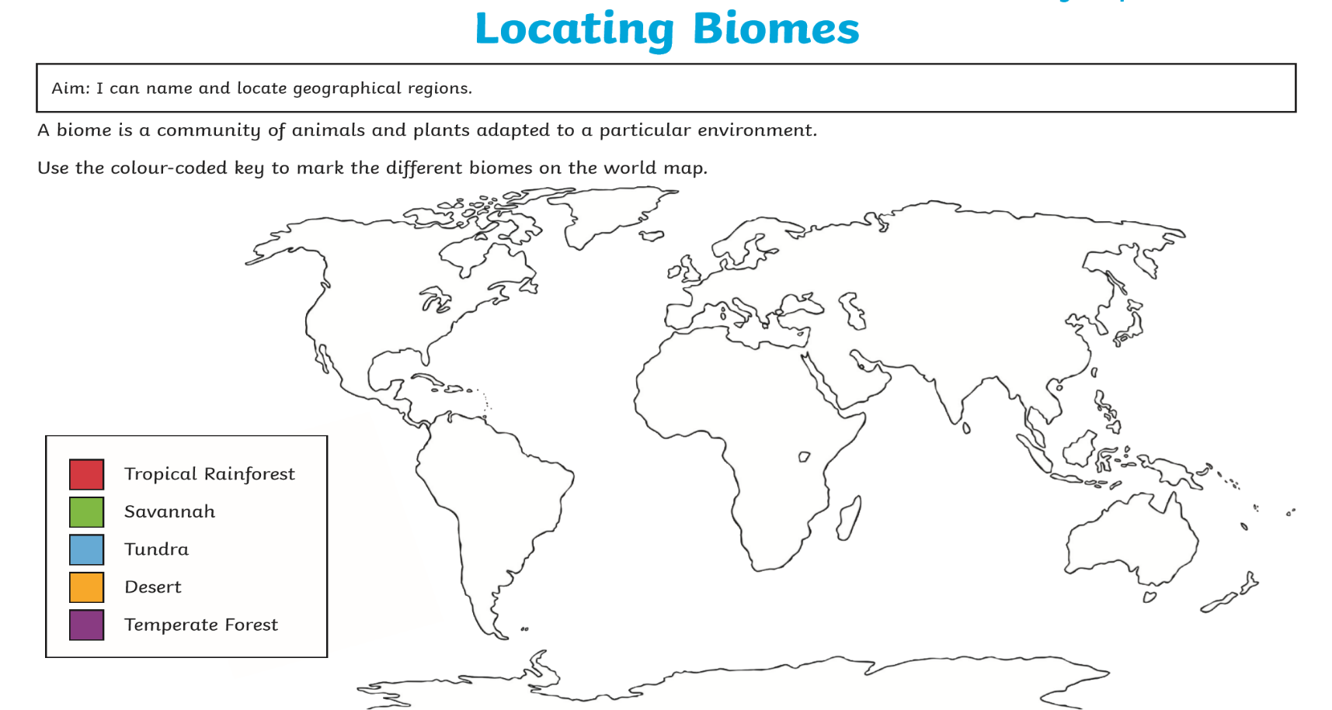

Use this map to support you when drawing your map.

