Home learning - Summer Term - Week 5- Year 4 WC: 29.06.2020
Writing
This week is based on: Electricity!!

Monday 29th June 2020
LO: To gather ideas using research.
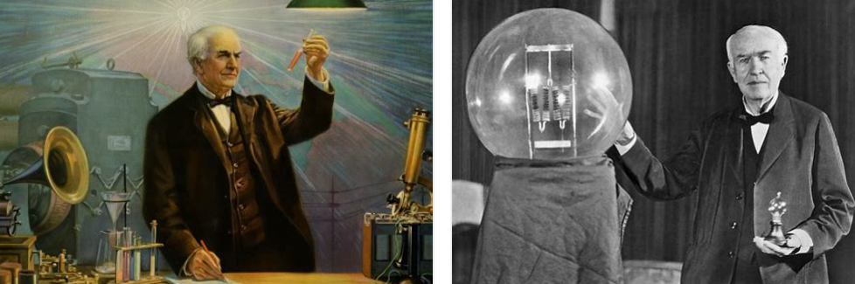
Main Task: Research
Brainstorm key facts about Inventor
Thomas Alva Edison.
What was he famous for?
How has his inventions influenced society?
What inventions did he make?
What was his relationship like with Nikola Tesla?
Which inventions do we still use today?
Which invention do you think is the most important? Why?

https://www.ducksters.com/biography/thomas_edison.php
https://www.theschoolrun.com/homework-help/thomas-edison
https://kids.kiddle.co/Thomas_Edison

Tuesday 30th June 2020
LO: To understand the features of an information leaflet.
Main Activity:
Key features in an information leaflet.

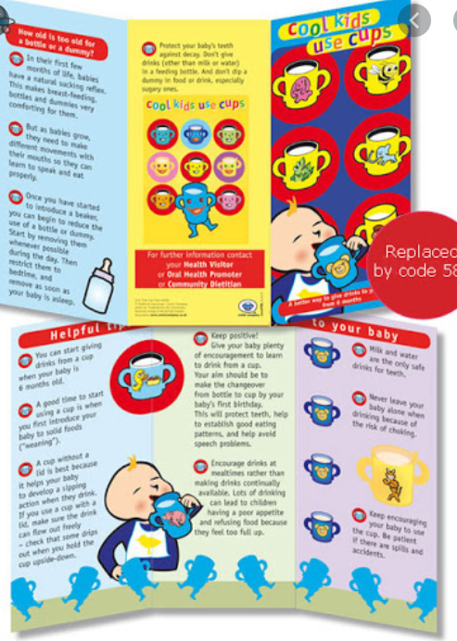
Wednesday 1st July 2020
LO: To plan our writing.
Main Activity:

Briefly outline the key points you would like to
Cover in your final report on Friday.
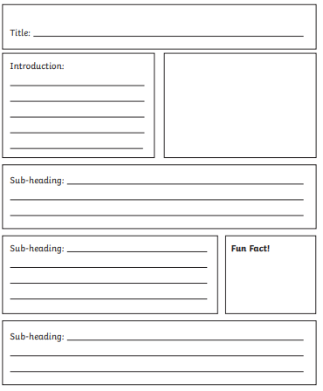
Use notes, key words and phrases – you do not need to write in full sentences.

Thursday 2nd July 2020 Key Focus: Thomas Alva Edison
LO: To write the beginning of an information leaflet
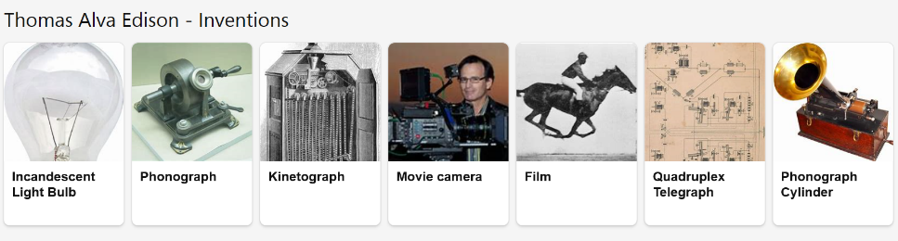
Main Task:
Create your own information leaflet all about Thomas Alva Edison and his inventions.
Features to include in your leaflet:
- Opening Statement
- Third Person: He, she, they, them, they’re…
- Diagrams and images
- Past tense
- Logical and organised order
- Add interest by talking directly to the reader, for example:
Did you know that…
An interesting fact is…
Have you heard of the Nickel-iron Battery?...

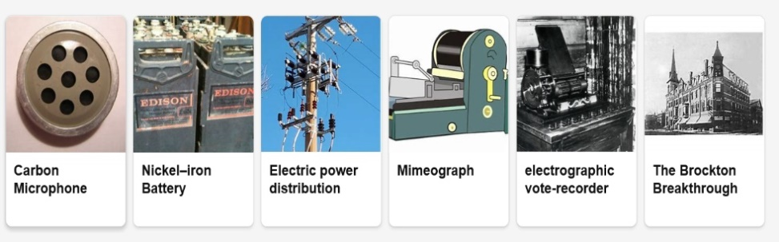

Friday 3rd July 2020
LO: To write the ending of an information leaflet

Main Task:
Create your own information leaflet all about Thomas Alva Edison and his inventions.
Features to include in your leaflet:
- Opening Statement
- Third Person: He, she, they, them, they’re…
- Diagrams and images
- Past tense
- Logical and organised order
- Add interest by talking directly to the reader, for example:
Did you know that…
An interesting fact is…
Have you heard of the Nickel-iron Battery?...

An example:

Thomas Edison
Thomas Alva Edison (February 11, 1847 – October 18, 1931) was an American inventor and businessman who has been described as America's greatest inventor. He developed many devices in fields such as electric power generation, mass communication, sound recording, and motion pictures. Keep reading and you will find out more.
Childhood
Thomas Edison was born in Ohio, America. As a child, he had hearing problems from the illness scarlet fever. His mother was a teacher, so he did not go to school but was taught at home. As a teenager, he sold candy and newspapers on trains. Quickly he became a good businessman, and with four assistants started selling newspapers on the streets.
Getting a job
He first got his job by accident when he saved a three-year old boy from being hit by a train. The boy’s father was so grateful that he gave Thomas a job as a telegraph operator. At 19 years old, Thomas moved to Kentucky to start a new job. He chose to work at night so that he could carry on with his experiments. Unfortunately, he spilt sulphuric acid on the floor and it dripped through the wooden floorboards onto the desk below. Thomas Edison lost his job!
First invention
Thomas Edison’s first invention was invented in 1977 – the phonograph. This was a machine that could record and replay sound. The sound was played through a large horn. Suddenly, Edison became very famous.
The Electric lightbulb
Thomas wanted to invent a light that did not need oils or gas to be lit. After some tests and changes, Thomas created a lightbulb that would stay lit for 13 and a half hours. In 1879, he demonstrated this amazing invention to a group of people in Menlo Park. He then became the ‘Wizard of Menlo Park’.
Did you know facts
- Thomas Edison died in 1931 from problems with diabetes. He was 84 years old.
- Almost everyone in the world has used at least one of his inventions: the electric lightbulb. We are still using them today, over 100 years later!

