Home learning - Summer Term - Week 3 - Year 4 WC: 15.06.2020
Writing
Below are three writing activities for you to do this week.
Make sure you write at least a page for each piece.
This week is based on: Refugee Week!!

Activity 1
Famous Refugee: Mo Farah
Main Task: Write a biography about the life of
Mo Farah.
A long distance and middle-distance runner. Mo Farah was born on 23rd March 1983 in Mogadishu in Somalia. He spent the early years of his childhood in Djibouti and moved to Britain when he was eight years old to join his father. He spoke very little English. At the London 2012 Olympics, he won a gold medal for the 10,000 metres and 5,000 metres and in March 2015, he broke the European record for the half marathon in Lisbon.

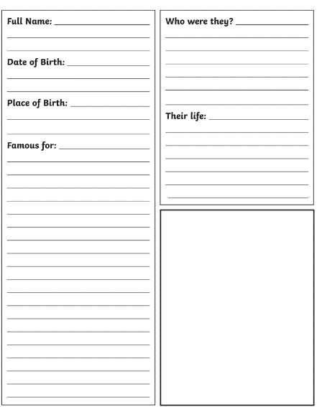

Mo Farah
Example Template
Activity 2
Famous Refugee: Albert Einstein

Main Task: Write a biography about the life of
Albert Einstein.

A famous scientist - he was born in Ulm, in the Kingdom of Württemberg in Germany on 14th March 1879. As an adult, he moved to America in 1933 when Adolf Hitler took over Germany.

Albert Einstein
Example Template
Activity 3
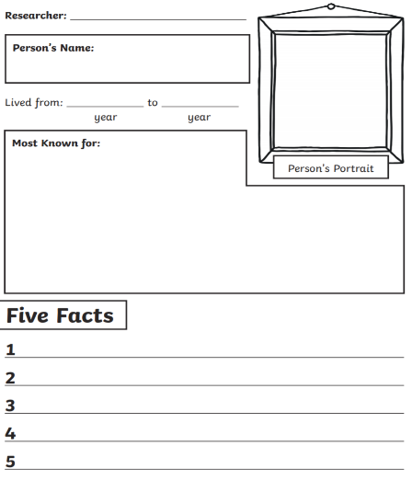
Famous Refugee: Albert Einstein

Main Task: Write a biography about the life of
Albert Einstein.

Anne Frank is famous for the diary that she kept from 12th June 1942 until 4th August 1944. A German-born Jewish girl - she was born on 12th June 1929 in Frankfurt, Germany. Her family moved to Holland in 1933 when the Nazis came to power. On 6th July 1942, Anne and her family, along with four other families, went into hiding. She wrote a diary about her life in hiding, which can be read today.

Example Template Anne Frank

