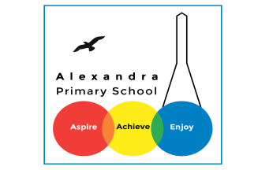
Home learning - Summer Term - Week 4- Year 4 WC: 22.06.2020
Writing
This week is based on: Creativity and Imagination!!

Monday 22nd June 2020

Main Activity:
LO: To build a varied and rich vocabulary.

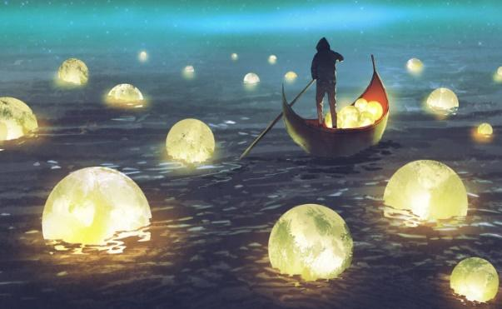
What can you see?
What can you smell?
What can you touch?
What can you hear?
What can you taste?

The Mysterious Man on the Water.

Tuesday 23rd June 2020
LO: To understand the structure of
Key features in a story.
A story.

Main Task:
Brainstorm key features of a creative
story.

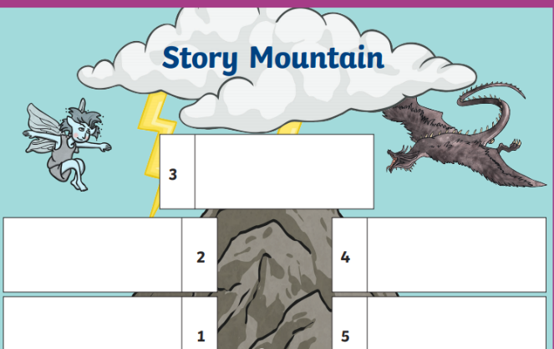
Wednesday 24th June 2020
LO: To plan our writing

Main Activity
Create a story mountain structuring
the main events in your story.
Use key phrases and vocabulary.

Thursday 25th June 2020
LO: To draft our writing using adverbial starters.

Create 5 sentences using adverbial starters.

It all started when,
All of a sudden,
Out of nowhere,

Friday 26th June 2020
LO: To write a creative story.
Man on the Water
Look at this image of the Man on the Water and using your imagination write a creative story.
Think about:
Who is steering the boat?
What is floating in the water – moons, planets, dreams?
Is the person collecting these items or putting them into the water?
What do these objects mean? Are they a route into another dimension?
Where is he going?
Is this character good or bad?

