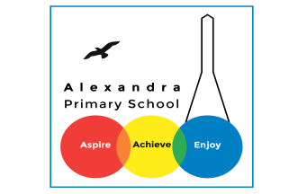
Science Home Learning
This term is based on: Electricity!!!
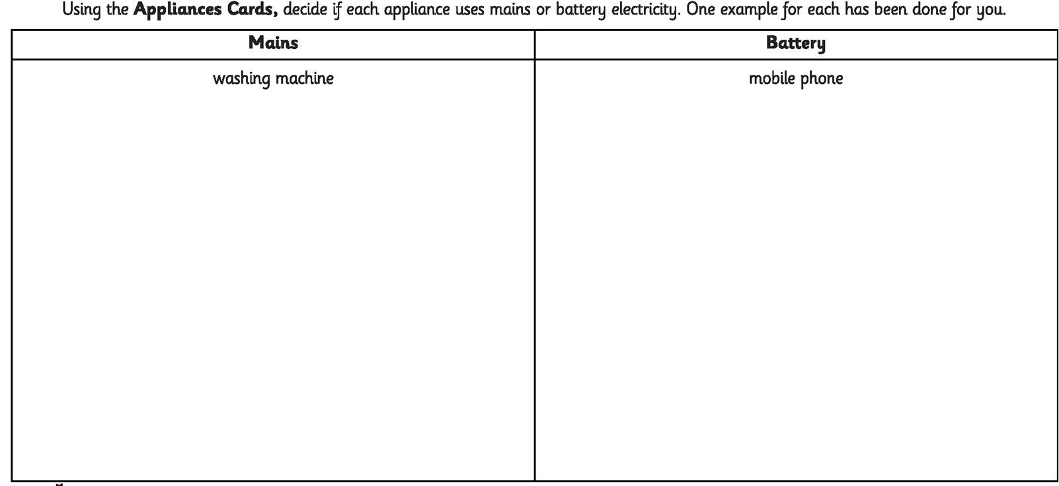
Activity 1
Research applicances and correctly list them in the right column.
Here are some appliance cards to use as an example. Decide if each appliance uses mains or battery electricity.

Activity 2
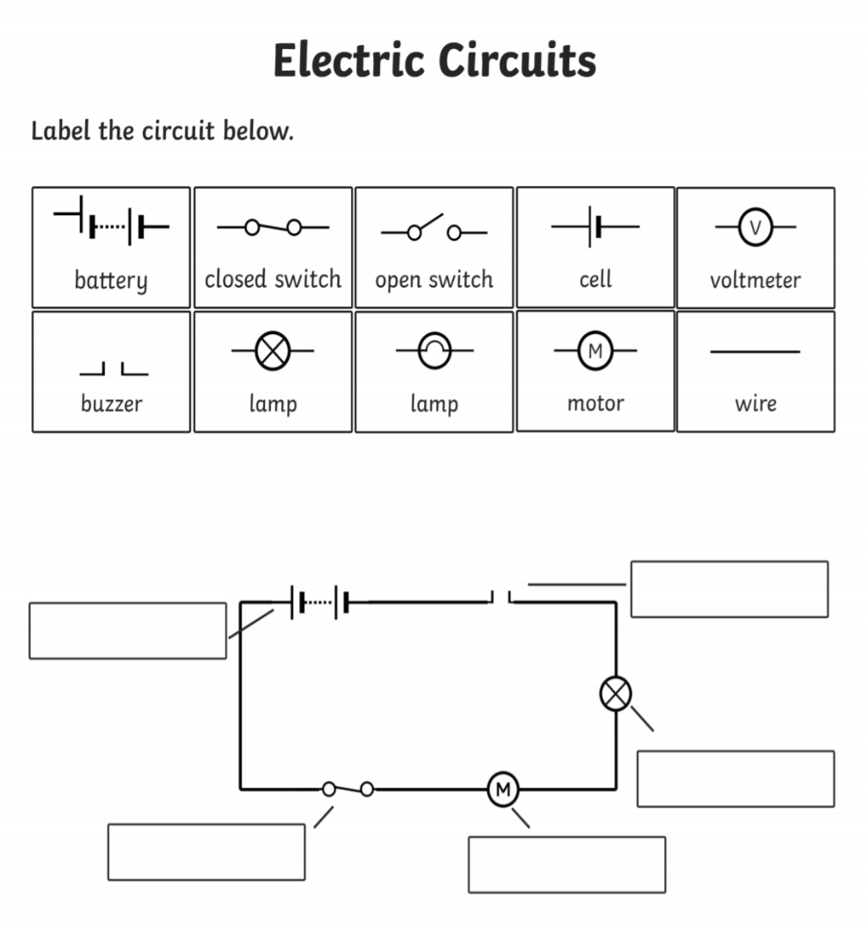
Draw your own circuit and label your diagram correctly using the electrical symbols.
Activity 3:

Watch the video and answer the questions below.

https://www.bbc.co.uk/bitesize/topics/zq99q6f/articles/zt8vg82
What is a circuit?
What does a circuit need?
Do all circuits work? Explain your answer.
https://www.youtube.com/watch?v=MqHsKZNwiMA
Write 5 interesting facts you found in this video.

