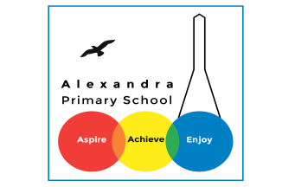
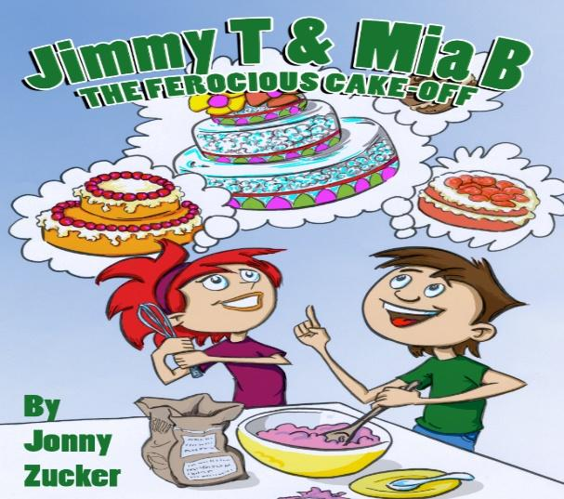
Year 4 Reading: The Ferocious Cake Off by Jonny Zucker

Log in to your Purple Mash account. Visit the page for Animal Boy. If you have trouble signing in, you can access the PDF text if you click here https://www.purplemash.com/mashcontent/applications/serialmash/CakeOffChpt1/JimmyT/JimmyTChpt1.pdf
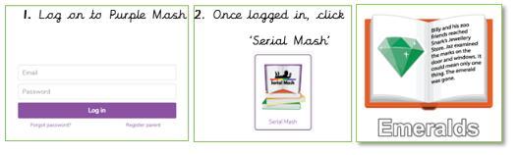

Monday 22nd June : Read Chapter 1 and complete Chapter 1 Quiz
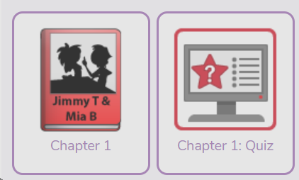
Challenge
Create a poster for a cake-off or a cake sale.

Tuesday 23rd June : Read Chapter 2 and complete the Chapter 2 quiz
Challenge
Write a recipe for making a cake.
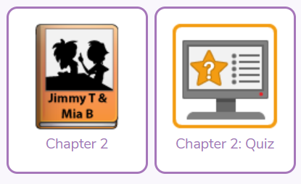

Wednesday 24th June: Read Chapter 3 and complete the Chapter 3 quiz

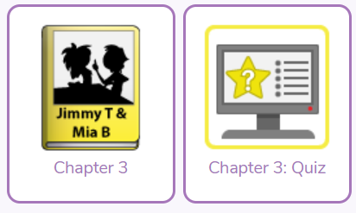
Challenge
Write about a time when you worked as part of a team.

Thursday 25th June: Read Chapter 4 and complete the Chapter 4 quiz
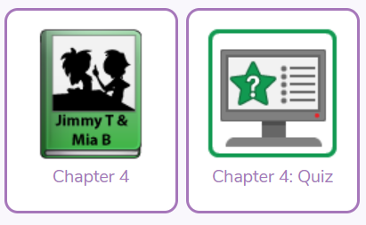
Challenge
Write an informative guide about keeping safe in the kitchen.

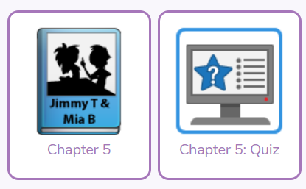
Friday 26th June: Read Chapter 5 and complete the chapter 5 quiz
Challenge
Write a book review about The Ferocious Cake Off.

A blast from the past
Find out about a person in history or an event.
What questions would you ask them?
What would they say?

Bonus!
You could get someone to be that person and then record the interview or write it up as a script!

Daily Activity
You should be reading for at least 30 minutes daily.
If you cannot access Purple Mash, choose a book of your own and use your Destination Reader stems to record your thoughts in your
Name of Book:
Prediction: I wonder if…
Inference: The word __ tells me…
Summary: The key idea is…

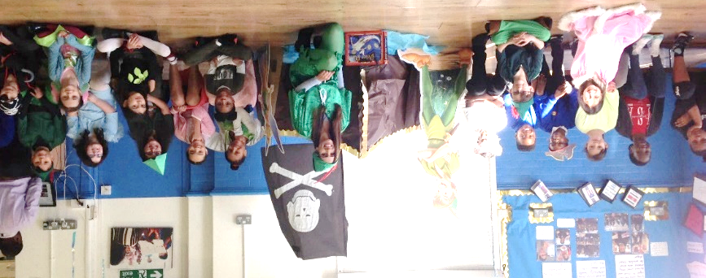

www.worldofdavidwalliams.com
Story Time Ideas

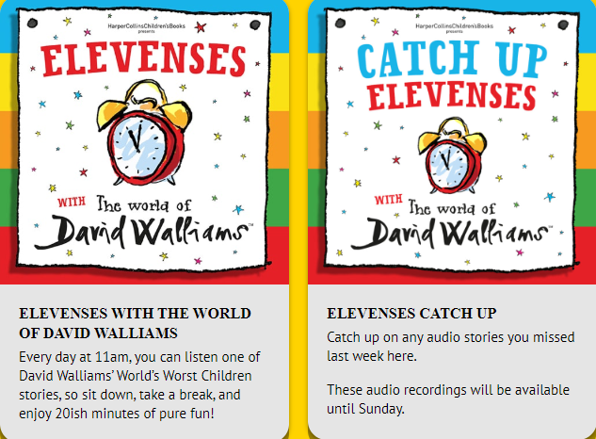

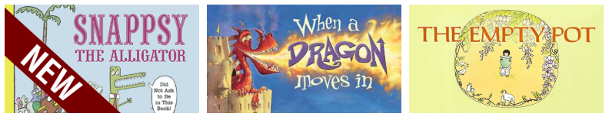

Audiobooks and eBooks are available to borrow for free from Hackney library, using these apps; Overdrive and Borrowbox. You will need to download these apps to a tablet, phone or computer. To use these apps, you will need a library card number from any London library. If you are not a member of the library, you can join for free here: https://hackney.gov.uk/libraries#join. You won’t need to go into the library to provide proof of address as you normally would, but can do everything online
There are also a lot of websites where you can watch authors read their
books for free:
- Storytime Online has hundreds of videos: Click here to view
- For a challenge, Neil Gaiman has posted videos of himself reading his award-winning books The Graveyard Book and Coraline. You could read listen to a chapter a day! Click here to view
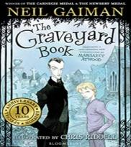
- https://www.getepic.com

