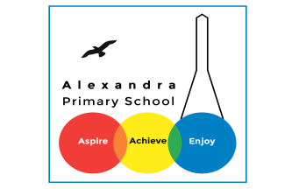
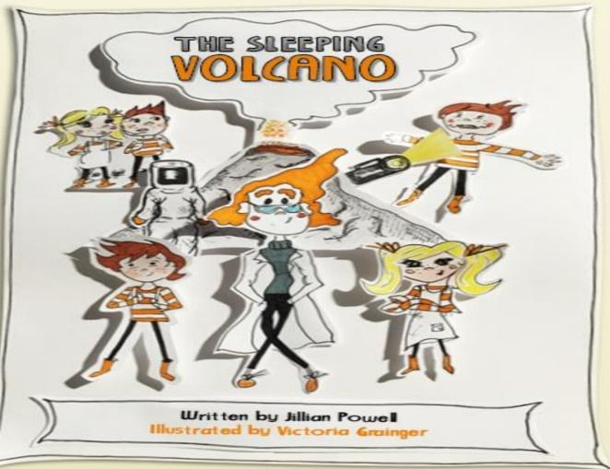
Year 4 Reading: The Sleeping Volcano by Jillian Powell

Log in to your Purple Mash account. Visit the page for Animal Boy. If you have trouble signing in, you can access the PDF text if you click here https://www.purplemash.com/mashcontent/applications/serialmash/SleepingVolcano_Ch1/chapter/SleepingVolcano_Ch1.pdf
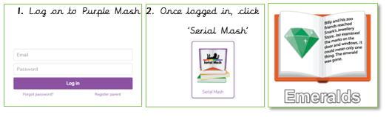

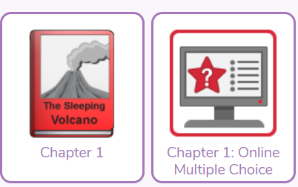
Monday 15th June : Read Chapter 1 and complete Chapter 1 Quiz
Challenge
The chapter is full of lots of information about volcanoes. Read through the chapter again and note down as many volcano facts that you can find. Use books or the internet to find more volcano facts. Write a factual account about volcanoes.

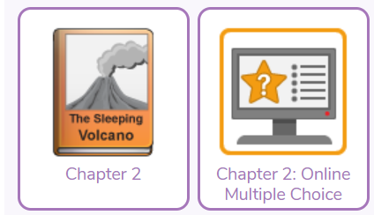
Tuesday 16th June : Read Chapter 2 and complete the Chapter 2 quiz
Challenge
Imagine that you have seen the end of a long ladder. You choose to climb it, even though you can't see where it leads. Where does it take you? Does it lead you to a dangerous place, or to paradise? Write about your adventure.

Wednesday 17th June: Read Chapter 3 and complete the Chapter 3 quiz
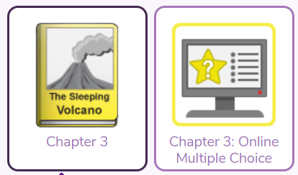
Challenge
The chapter ended with Seb and Ellie being confronted by one of the scientists. Will the children manage to talk their way out of trouble? Use direct speech to continue writing the conversation between the characters.

Thursday 18th June: Read Chapter 4 and complete the Chapter 4 quiz
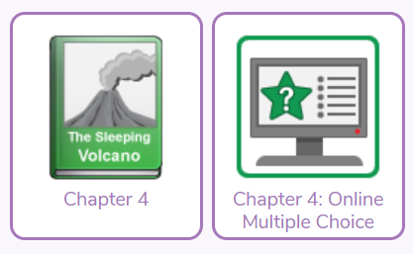
Challenge
Maxim talked about some of the activities on offer at The Volcano Experience: day treks, night treks, abseiling and taking a lift into the heart of the volcano. Create a leaflet to encourage people to visit The Volcano Experience.

Friday 19th June: Read Chapter 5 and complete the chapter 5 quiz
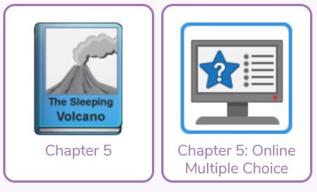
Challenge: Everyone from the school party has been safely evacuated from the volcano. Some of the children are making fun of Seb for saying that the volcano will erupt. Is Seb right? Will the volcano erupt? What happens next? Write the next part of the story.

Daily Activity
You should be reading for at least 30 minutes daily.
If you cannot access Purple Mash, choose a book of your own and use your Destination Reader stems to record your thoughts in your
Name of Book:
Prediction: I wonder if…
Inference: The word __ tells me…
Summary: The key idea is…

Read all about it!
Think of an important event in history or in a book.
Research it then write a newspaper article about it. Include quotes and who, what where when why?
Bonus!
You could write some adverts / letters of advice/ comic strip for a character too that could be in your newspaper!

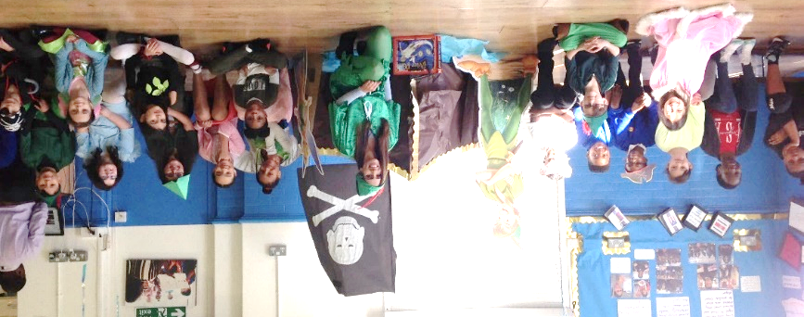

www.worldofdavidwalliams.com
Story Time Ideas

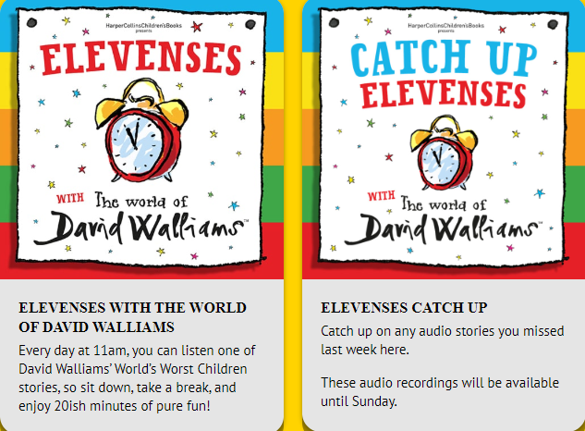

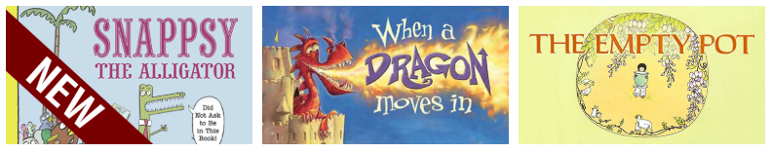

Audiobooks and eBooks are available to borrow for free from Hackney library, using these apps; Overdrive and Borrowbox. You will need to download these apps to a tablet, phone or computer. To use these apps, you will need a library card number from any London library. If you are not a member of the library, you can join for free here: https://hackney.gov.uk/libraries#join. You won’t need to go into the library to provide proof of address as you normally would, but can do everything online
There are also a lot of websites where you can watch authors read their
books for free:
- Storytime Online has hundreds of videos: Click here to view
- For a challenge, Neil Gaiman has posted videos of himself reading his award-winning books The Graveyard Book and Coraline. You could read listen to a chapter a day! Click here to view
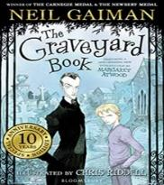
- https://www.getepic.com

