Home learning Summer Term - Year 3 wc 29th June 2020

Writing
Below are five writing activities for you to do every day. The videos on google
classroom will link to these activities.

This week the writing will be all about poetry.

Monday 29th June
LO: To read poetry.

Read through the poems below, making sure you are reading clearly.

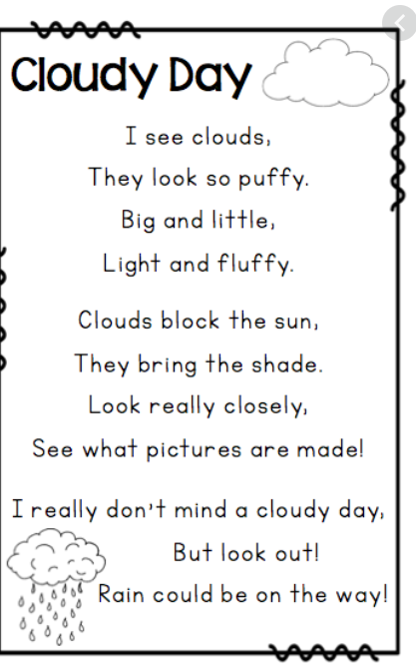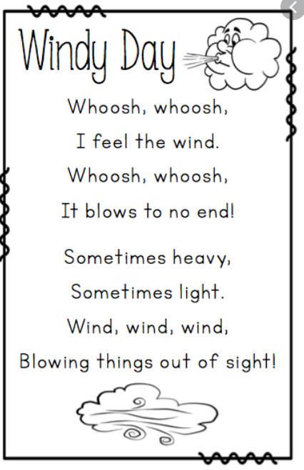
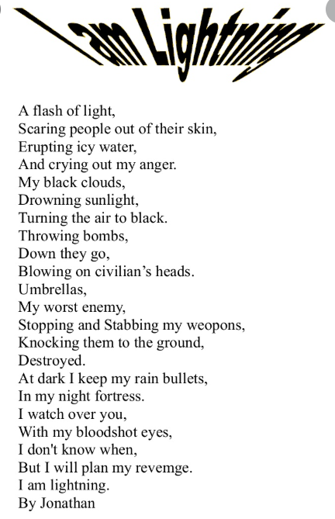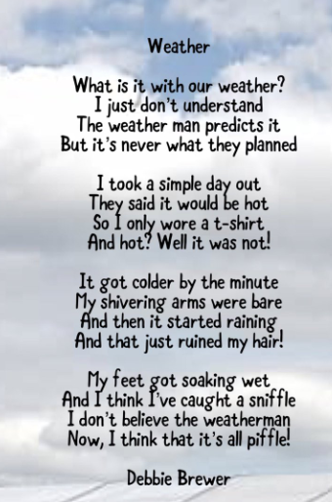

What do you notice with them?
Are there any similarities or differences?
Make sure you are reading clearly.

Watch these videos of how to read poetry:
https://youtu.be/2BSG2QRj_4M

https://www.youtube.com/watch?v=RvV23xoZRkI

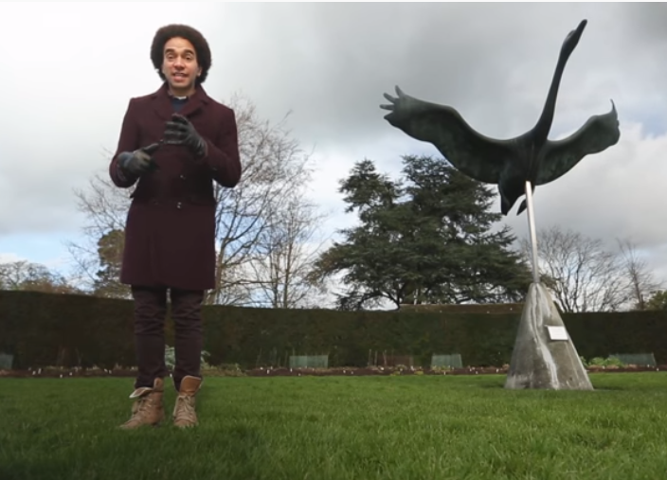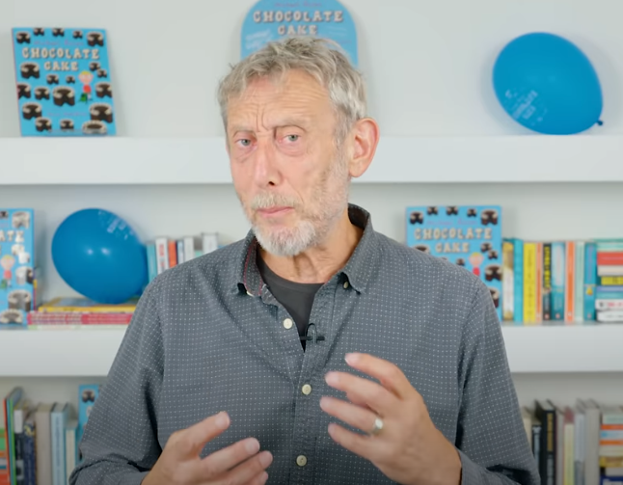

Tuesday 30th June
LO: To find the features in poetry.

Rhyming words | Onomatopoeia | Alliteration
Similes | Stanzas | Imagery

Activity 1
These are the most common features in poetry. What do they all mean?
Feature | What is it? | An example
Rhyming words:

Onomatopoeia:

Alliteration:

Similes:

Stanzas:

Imagery:

Activity 2
Can you find these features in this poem?

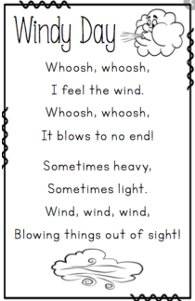

Wednesday 1st July
LO: To plan a rhyming poem.

Activity 1
Which words rhyme?
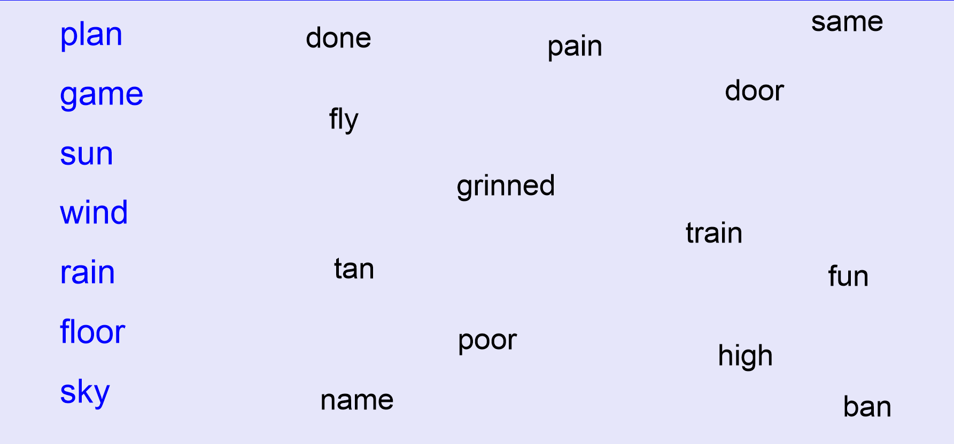

Activity 2

You will be writing a poem about the weather. It could just be about one kind of weather: sun, lightning, rain, wind. Or it could be all about the weather in summer or winter. Or it could be about different weather.

My poem will be about the: | The title will be:
Poetry feature 1: rhyming words | Poetry feature 2:
Poetry feature 3: | Poetry feature 4:

Thursday 2nd July
LO: To write a rhyming poem.

Activity 1
Can you think of any words that rhyme with these words?

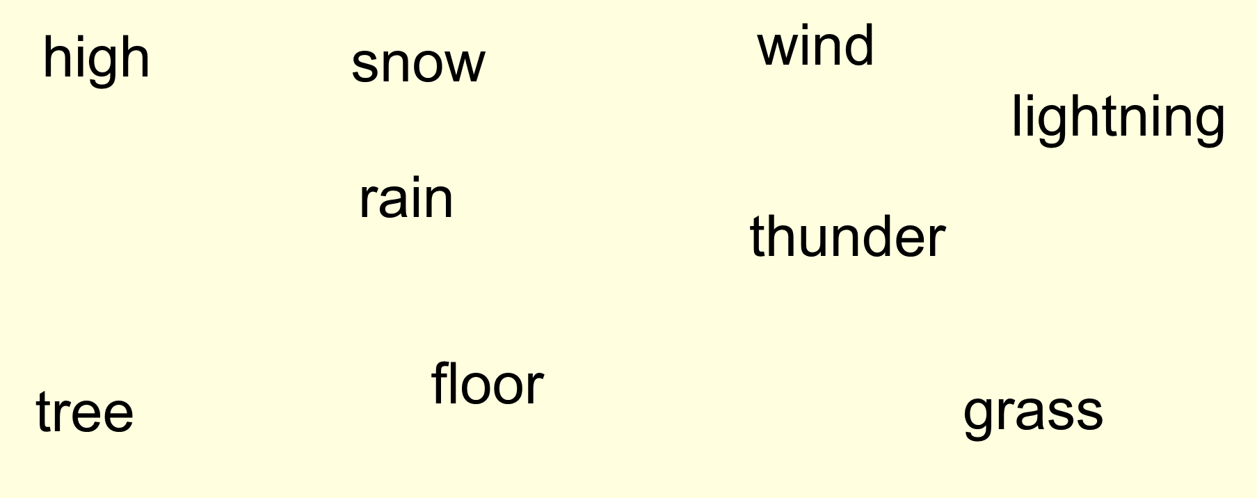

TIME TO WRITE YOUR POEM!

It is not time to write your poem. Make sure it there are 4 lines per stanza and the words at the end of each line rhyme. Try and write at least 3 stanzas. Here is an example:

The sun is shining in the sky
Bright and yellow way up high
Glowing on people down below
Calm and still, with no blow

Everyone smiling in the heat
Happy to see people they meet
The feel of slight breeze
Whistling softly through the trees

Ooooo the light breeze drifts
The sun heats as it lifts
Playing outside all day
Until the sun goes away

Friday 3rd July
LO: To edit my poem and read aloud.

Activity 1
Read through each stanza and check which features you have included:

rhyming words
onomatopoeia
alliteration
repetition
imagery
similes

Now is your chance to edit your poems – maybe some words that don’t rhyme or work. Maybe you can include different adjectives.

Activity 2
Once you are happy with your poem. Read it out aloud. Make sure you are reading with enthusiasm. Read it to your family members!

