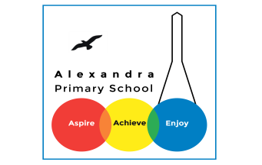
Home learning Summer Term - Year 3 wc 22nd June 2020

Writing
Below are five writing activities for you to do every day. The videos on google classroom
will link to these activities.

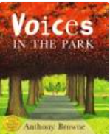
This week the writing will be based on the book: Voices in the Park and you will be writing an informal letter.

Monday 22nd June
To find the features of an informal letter.
Find the features on this letter below. Circle the features and write the name and what its purpose is. Why is there?
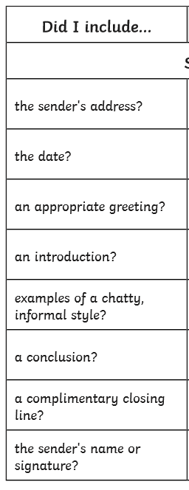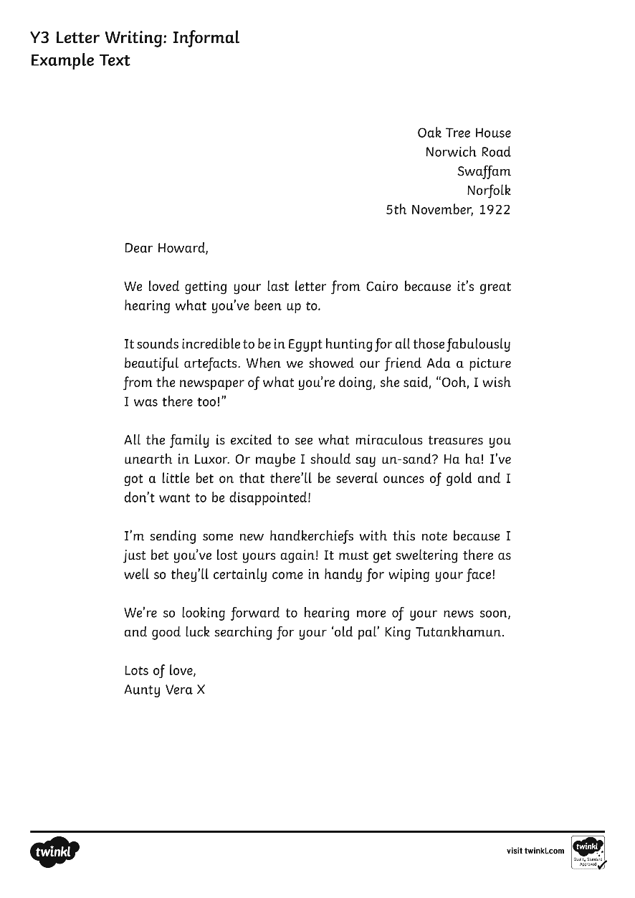

Tuesday 23rd June
LO: To include features of an informal letter.
Write a letter to a friend telling them about what life is like for you now. Tell them about not being at school and what you are doing to keep yourself busy. Remember to use the features in the chart above. Remember it’s your friend so you can write informally. Here is a word bank to help you. Try and write a page.
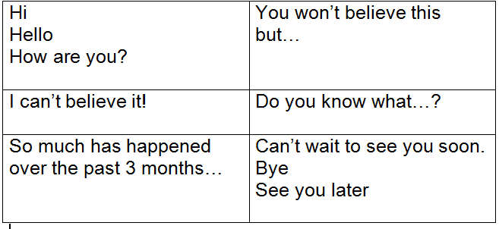
Wednesday 24th June
LO: To plan an informal letter.
Imagine you are one of these characters: Charles or Smudge from Voices in the Park. And you are writing to the other character. You need to tell them about how you were feeling when you met them and how you feel now.
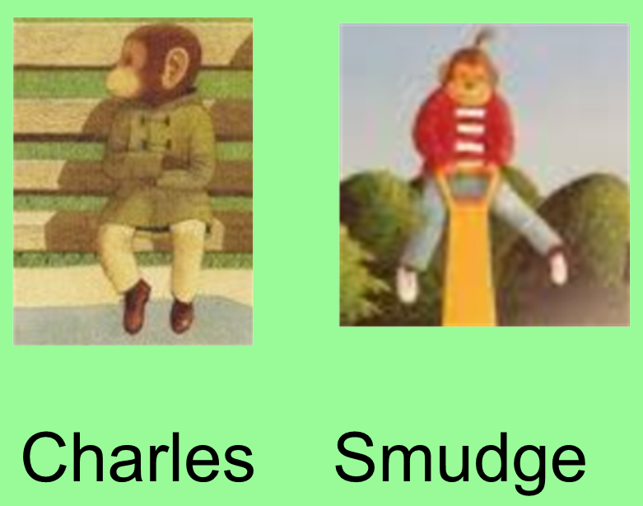

To __________________________ | Address:  Date:
First paragraph: what happened in the park and why you enjoyed playing with them | Second paragraph: what is happening in your life: school, hobbies, home life:
Third paragraph: what you would like to happen? | Signing off

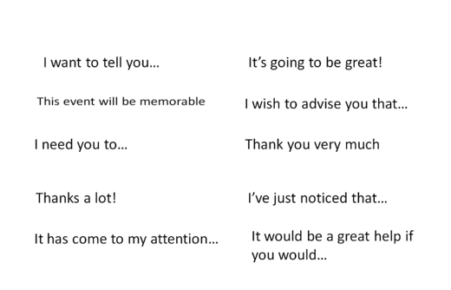
Thursday 25th June
LO: To write the beginning of an informal letter.
Activity 1
Formal or informal language?

Activity 2
Using your planning sheet, you will be writing the first 2 paragraphs of your letter. Make sure you include the word bank and feature list:
The big house.
Western Road
London
N22 6UH
Thursday 18th June 2020

To Smudge,
How are you? I hope you don’t mind me writing you a letter. I thought we could become pen pals and write to each other often?
It was really nice to meet you in the park the other day. I don’t usually speak to anyone when outside of the house. My mum doesn’t let me and she wants me to sit next to her at all times which is hard when I can see my dog, Victoria, playing nicely and happily. I sometimes wish I was the dog, how strange is that? But when you came and sat next to me, I was excited that someone gave me attention. It was fun to play with you also! As you probably noticed, I was upset when my mum said we needed to go home. She had seen us playing and wasn’t happy at all. She didn’t talk to me for the rest of the evening!

Friday 26th June
LO: To write the ending of an informal letter.
Using your planning sheet, write the last 2 paragrapgs of your letter. You are thinking of the future. Would you like to see the other child again? What would you like to happen?
Remember to use the word bank and feature list.

I thought I would tell you a little about myself. My name is Charles. I’m in year 3 at a boring school about 3 miles away. I have hobbies that my mum makes me do but I don’t actually enjoy myself. Mum makes me play piano, play tennis, acrobats, violin, harp, and accordion. All of which are boring. But mum says it’ll be good for me and will help get into a better school. I usually stay home and do work. But what I do enjoy doing is climb trees. I showed you my climbing in the park! Our garden has some great trees and that’s how I spend my ‘outside time’!
It would be great if we could meet up sometime soon. Maybe from afar? Maybe I will run away from my mum again. I really enjoyed playing with you. You took my mind off of everything and it was fun. I don’t know how it will be possible. But we will see!
I hope your dog is alright and happy as ever!
See you soon hopefully.
Bye for now!
Charles

____________________________________________________________________________________

The big house.
Western Road
London
N22 6UH
Thursday 18th June 2020

To Smudge,
How are you? I hope you don’t mind me writing you a letter. I thought we could become pen pals and write to each other often?
It was really nice to meet you in the park the other day. I don’t usually speak to anyone when outside of the house. My mum doesn’t let me and she wants me to sit next to her at all times which is hard when I can see my dog, Victoria, playing nicely and happily. I sometimes wish I was the dog, how strange is that? But when you came and sat next to me, I was excited that someone gave me attention. It was fun to play with you also! As you probably noticed, I was upset when my mum said we needed to go home. She had seen us playing and wasn’t happy at all. She didn’t talk to me for the rest of the evening!
I thought I would tell you a little about myself. My name is Charles. I’m in year 3 at a boring school about 3 miles away. I have hobbies that my mum makes me do but I don’t actually enjoy myself. Mum makes me play piano, play tennis, acrobats, violin, harp, and accordion. All of which are boring. But mum says it’ll be good for me and will help get into a better school. I usually stay home and do work. But what I do enjoy doing is climb trees. I showed you my climbing in the park! Our garden has some great trees and that’s how I spend my ‘outside time’!
It would be great if we could meet up sometime soon. Maybe from afar? Maybe I will run away from my mum again. I really enjoyed playing with you. You took my mind off of everything and it was fun. I don’t know how it will be possible. But we will see!
I hope your dog is alright and happy as ever!
See you soon hopefully.
Bye for now!
Charles

